THE OPEN UNIVERSITY OF KENYA
MODULE TEMPLATE
Programme title | Bachelor of Technology Education
Course title | TED 123 Technical Drawing I
Learning Module number | TED 123-01
Learning module title | Introduction to Technical Drawing
Module Developer | Kinuthia Mugi
Module duration in hours | 8 hrs
Instructional Hour Equivalent (Divide duration by 2) | 3 hrs
Reviewed by
Vision | The Innovative University for Inclusive Prosperity
Audience description | This module is designed for technology students intending to gain a deep understanding of technical drawing for engineering purposes.
Instructions to learners   | Welcome to this module. This is an introductory module Technical drawing Course for the students pursuing Bachelor of Technology Education.  The module contains core reading material references and videos which you are required to read and watch after which, you will have an opportunity to test your understanding of the material through quizzes and assignments. The quizzes and assignments forms the basis of progression from one stage of the module to the next. These activities will help you gauge your progress and identify areas where you may need further review.  You will require, drawing instruments such as assorted pencils, drawing board, T-square, compass set, set square set, eraser, A2 drawing paper, internet connectivity, computing device(s), the required plug-in tools for successful completion of this module.
Learning module description | The module provides a brief overview of the drawing instruments and their use and care , drawing papers and drawing their sizes, types of pencils, types of lines and lettering techniques
Module objectives | The module seeks to facilitate learning of:  - Standards of engineering drawing equipment and tools  - Principles of drawing lines and lettering  - Drawing of letters and different lines  - Interpretation and use of drawing lines and letters
Module learning outcomes | By the end of the module, you should be able to:  - To identify and care for the drawing instruments  - Demonstrate the concepts and principles of usage of drawing tools and papers  - Draw different types of lines and and letters in technical drawing  - Apply the different lines and letters in technical drawings
Planned Learning Resources | Drawing board Assorted pencils, T-square, compass set, set square set, eraser, A2 drawing paper, masking tape, paper clips, Engineering drawing Drafter, Roll and draw Scale and protractor
ACTIVITY 1: PREPARATION  VIDEO 1:   | - Drawing instruments  Watch the videos below that introduces the engineering drawing instruments  https://www.youtube.com/watch?v=z4xZmBpXIzQ  https://www.youtube.com/watch?v=Dy98ueJJBW4
ACTIVITY 1: READING  Learners to engage in self-directed learning  B   | Designer: Create a portal that a learner can use to identify various drawing tools that are highlighted in the video as per the drawing tools document
 |  | Tool Name | Picture
 |  | Drawing board | 
 |  | Drawing paper | 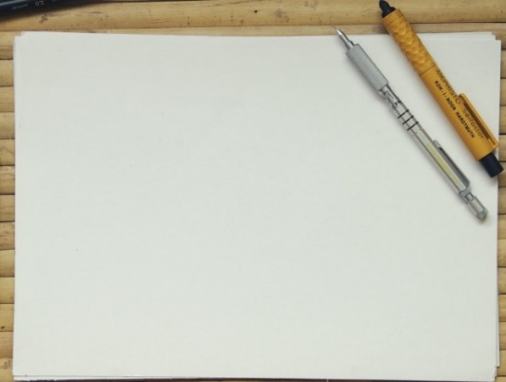
 |  | T Square | 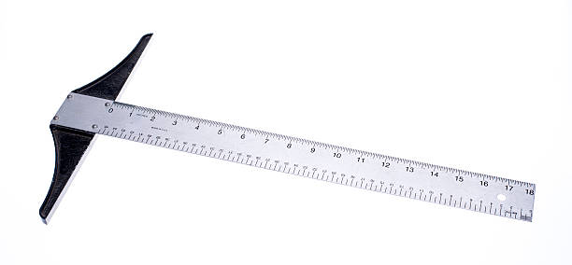
 |  | Pencils | 
 |  | Compasses | 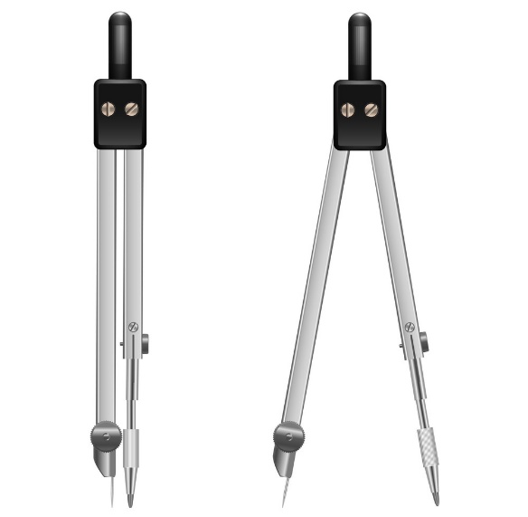
 |  | Set squares | 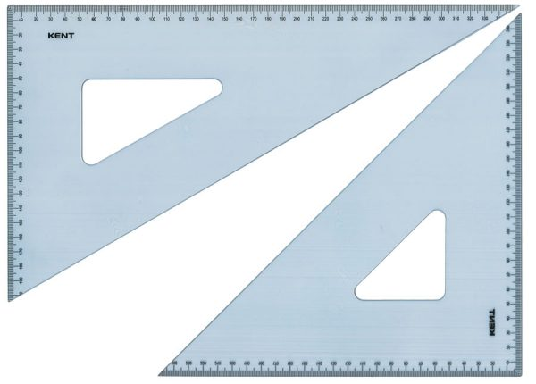
 |  | Erasers | 
 |  | Masking tape | 
 |  | Paper clips | 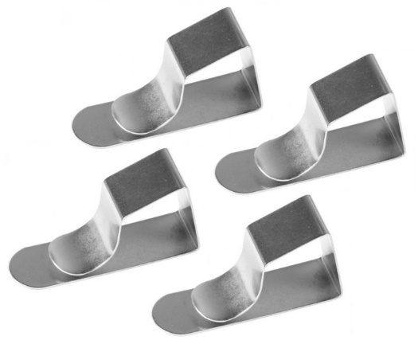
 |  | Engineering drawing Drafter | 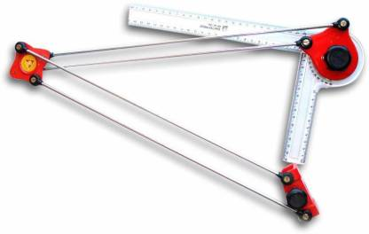
 |  | Roll and draw Scale | 
 |  | Protractor | 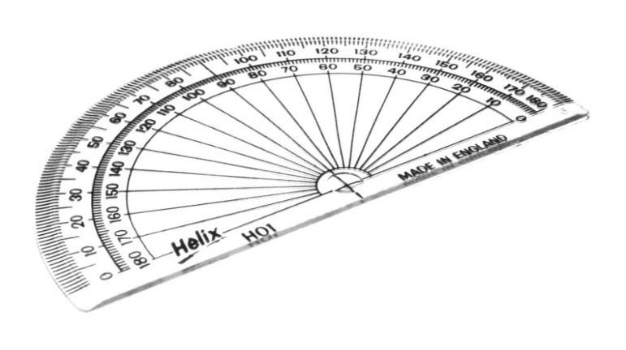
VIDEO 2: (to be developed)   | - Drawing papers  Insert a prerecorded video on the types and sizes of drawing papers as per the script below.  [Introduction] Welcome to our video on engineering drawing paper sizes. In this video, we will explore the different paper sizes that are commonly used in engineering drawing and design.  [Body]  - The ISO Paper Size System: The International Organization for Standardization (ISO) has established a standard system of paper sizes that is used worldwide. This system is based on the ratio of the length to the width of the paper, which is 1:√2. The most common paper size in this system is A4, which is 210mm x 297mm.  - Engineering Drawing Paper Sizes: In engineering drawing and design, there are several paper sizes that are commonly used. These include A0, A1, A2, A3, A4, and A5. A0 is the largest size and has a dimension of 841mm x 1189mm, while A5 is the smallest size and has a dimension of 148mm x 210mm as per the diagram shown.  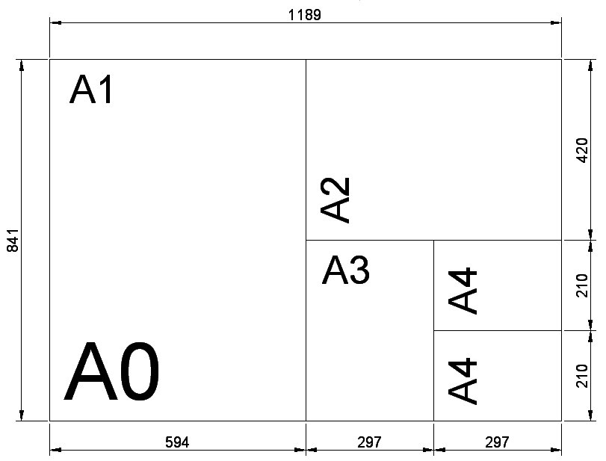  - Common Applications: The different paper sizes are used for different applications in engineering drawing and design. For example, A0 is commonly used for large architectural and engineering drawings, while A4 is used for general documents, such as letters and reports.  - Drawing Sheet Orientation: In addition to the size of the paper, the orientation of the drawing sheet is also important in engineering drawing and design. The two main orientations are portrait and landscape. Portrait orientation has a vertical orientation, while landscape orientation has a horizontal orientation. The orientation of the drawing sheet is determined by the shape and size of the drawing.  [Conclusion] In conclusion, understanding the different paper sizes used in engineering drawing and design is important for creating accurate and efficient drawings. By using the appropriate paper size and orientation, engineers and designers can ensure that their drawings are clear and easy to read. We hope you found this video informative and useful. Thank you for watching.  Create a Wiki for the class. Each learner will upload a short researched write-up on the following topic and comment on at least five presentations.  - Paper sizes used in different countries and cultures. Create a chart that compares the most commonly used sizes, and write a short paragraph about the history and significance of each size.
VIDEO 3 (Youtube, please include link)   | - Types of lines  - Drawing of borders and Title block on a drawing paper  Watch the video by clicking on the link below that will guide you on how to prepare border lines and title block on a drawing paper.  https://www.youtube.com/watch?v=4hb3B-JcbnE  - Drawing of lines  Watch the videos on by clicking on the links below that will guide you on how to draw different lines used in technical drawing  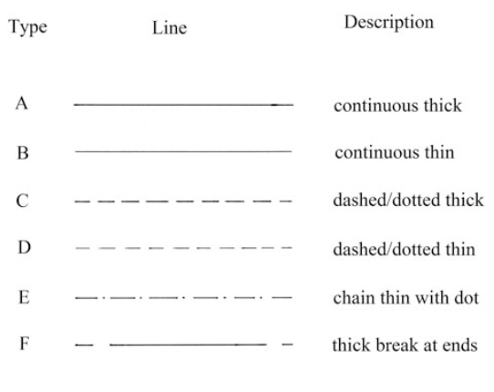  Watch the YouTube videos below and  https://www.youtube.com/watch?v=yk2SynF31cs  https://www.youtube.com/watch?v=6FjOhLUwZd4
  - Continuous thick Line | Used to represent visible outlines, visible edges
  - Continuous thin line | Used to represent projectors, dimension lines, hatching lines, locus lines
  - Dashed/dotted thick line | Used to represent hidden lines, hidden edges
  - Dashed/dotted thin line | Used to represent imaginary lines
  - Chain thin with dot | used to represent centre line, axis of solids
  - Thick break at ends | Used to represent cutting planes
ACTIVITY 2: PRACTICAL SKILLS  VIDEO 1: Demonstration of practical use of knowledge acquired  . | Using the guidance of the videos above carryout the following:  - Place and secure an A3 paper on the drawing board,  - Draw border lines the A3 at 15 mm from the left edge and 10 mm from top, right and bottom edge.  - Select an appropriate place on the paper and draw the following lines:  - Continuous thick Line  - Continuous thin line  - Dashed/dotted thick line  - Dashed/dotted thin line  - Chain thin with dot  - Thick break at ends  Take a photo of the finished work and upload it on your e-portfolio
- Lettering
Watch the videos whose link appear below and the example in the diagram below.
https://www.youtube.com/watch?v=B6jwk4OWyB4
https://www.youtube.com/watch?v=OAAPm5owmsE

For further refer to the reference book Giesecke, F. E., Mitchell, A., Spencer, H. C., Hill, I., Dygdon, J., Novak, J., ... & Johnson, L. (2016). Technical drawing with engineering graphics (Vol. 15). Prentice Hall. Pp 40-42.
ACTIVITY 3: PRACTICAL SKILLS  VIDEO 1: Demonstration of practical use of knowledge acquired  . | Using the guidance of the videos above carryout the following:  - Construct straight lettering of all CAPITAL alphabets and numerals from 0 to 9.  - Construct lettering of all small alphabets  - Construct italic lettering of all CAPITAL alphabets and numerals from 0 to 9.  Take a photo of the finished work and upload it on your e-portfolio
TAKE HOME MESSAGE | To create an engineering drawing, it is essential to follow established standards and conventions, including dimensioning, scaling, and annotation. It is also necessary to use appropriate tools to create accurate and detailed drawings.
Reference list | Branoff, T. (2015). Interpreting engineering drawings. Cengage Learning.  Giesecke, F. E., Mitchell, A., Spencer, H. C., Hill, I., Dygdon, J., Novak, J., ... & Johnson, L. (2016). Technical drawing with engineering graphics (Vol. 15). Prentice Hall.  Madsen, D. A., & Madsen, D. P. (2016). Engineering drawing and design. Cengage Learning.  Morling K. (2010) Geometric and Engineering Drawing,2nd Ed, Butterworth-Heinemann, London ISBN: 978-0-080-96768-4 (hbk); ISBN 13: 978-0-415-53619-6 (pbk)

