THE OPEN UNIVERSITY OF KENYA
MODULE TEMPLATE
Programme title | Bachelor of Technology Education
Course title | TED 123 Technical Drawing I
Learning Module number | TED 123-01
Learning module title | Third Angle Orthographic Projection
Module Developer | Kinuthia Mugi
Module duration in hours | 8 hrs
Instructional Hour Equivalent (Divide duration by 2) | 3 hrs
Reviewed by
Vision | The Innovative University for Inclusive Prosperity
Audience description | This module is designed for technology students intending to gain a deep understanding of technical drawing for engineering purposes.
Instructions to learners   | Welcome to this module. This is an introductory module Technical drawing Course for the students pursuing Bachelor of Technology Education.  The module contains core reading material references and videos which you are required to read and watch after which, you will have an opportunity to test your understanding of the material through quizzes and assignments. The quizzes and assignments forms the basis of progression from one stage of the module to the next. These activities will help you gauge your progress and identify areas where you may need further review.  You will require, drawing instruments such as assorted pencils, drawing board, T-square, compass set, set square set, eraser, A2 drawing paper, internet connectivity, computing device(s), the required plug-in tools for successful completion of this module.
Learning module description | The module provides a brief overview of the drawing instruments and their use and care , drawing papers and drawing their sizes, types of pencils, types of lines and lettering techniques
Module objectives | The module seeks to facilitate learning of:  - Standards of engineering drawing equipment and tools  - Principles of drawing lines and lettering  - Drawing of letters and different lines  - Interpretation and use of drawing lines and letters
Module learning outcomes | By the end of the module, you should be able to:  - Describe principles and conventions of 3rd angle projection  - Describe the concept of orthographic projections  - Construct drawings in 3rd angle projection  - Apply the principles of 3rd angle projection accurately in engineering drawings
Planned Learning Resources | Drawing board Assorted pencils, T-square, compass set, set square set, eraser, A2 drawing paper, masking tape, paper clips, Engineering drawing Drafter, Roll and draw Scale and protractor
ACTIVITY 1: INTRODUCTION  VIDEO 1: Pre-recorded lecture on topic emphasizing LEARNING OUTCOME 1:  Factual knowledge.   | Introduction to 3rd angle orthographic projection  What is third angle Projection?  This is a method of orthographic projection which is a technique in portraying a 3D design using a series of 2D views.  In reference to the previous module on first angle projection, third angle projection refers to a situation where the object is placed in the third in the orthographic projection system. The projection plane is placed between the observer and the object.  Therefore, in the projection process it is necessary to assume the plane of projection to be transparent. Here again the projections are perpendicular to the projection plane  Designer: Insert a video on introduction to 3rd angle projections based on the script below  [Camera fades in to a close-up shot of a pencil drawing a square on a clean sheet of paper. The shot then zooms out to reveal a person sitting at a drawing table, ready to start the video.]  Narrator (voice-over): "Welcome to the world of engineering drawing! Today, we'll be introducing you to the concept of third angle orthographic projection, a fundamental technique used in engineering and design to represent three-dimensional objects on a two-dimensional plane. So, let's dive in!"  [Cut to a visual of a three-dimensional object, such as a cube, appearing on the screen.]  Narrator (voice-over): "In engineering drawing, we use third angle orthographic projection to represent the three-dimensional shape of an object on a two-dimensional drawing. This technique uses a set of orthogonal views, which are projected onto separate planes of projection to create a complete representation of the object."  [Cut to the narrator drawing a box-like object on the paper, showing the top, front, and side views.]  Narrator (voice-over): "The three main views used in third angle orthographic projection are the top view, front view, and side view. These views are projected onto separate planes of projection, with the top view projected onto the horizontal plane, the front view projected onto the vertical plane, and the side view projected onto the profile plane."  [Cut to the narrator explaining the conventions of third angle orthographic projection, such as the use of hidden lines, center lines, and dimension lines.]  Narrator (voice-over): "In third angle orthographic projection, we use specific conventions to represent the different features of an object. Visible lines are used to show the visible edges of the object, hidden lines are used to represent features that are not visible in a particular view, center lines are used to indicate symmetry or axes, and dimension lines are used to provide measurements and annotations."  [Cut to the narrator demonstrating how to create a third angle orthographic projection drawing step by step, using a ruler, compass, and other drafting tools.]  Narrator (voice-over): "Creating a third angle orthographic projection drawing involves several steps, including selecting the appropriate views, projecting the views onto their respective planes, adding hidden lines, center lines, and dimension lines, and providing annotations to indicate the size, shape, and other details of the object."  [Cut to the narrator highlighting the importance of accuracy, precision, and attention to detail in third angle orthographic projection drawings.]  Narrator (voice-over): "Accurate and precise third angle orthographic projection drawings are critical in engineering and design, as they provide a clear and comprehensive representation of the object's shape, size, and features. Attention to detail, proper use of conventions, and adherence to standards are essential in creating professional-quality drawings."  [Cut to the narrator summarizing the key concepts covered in the video.]  Narrator (voice-over): "In summary, third angle orthographic projection is a fundamental technique used in engineering drawing to represent three-dimensional objects on a two-dimensional plane. Understanding the conventions, steps, and importance of accuracy and precision in third angle orthographic projection is crucial in creating accurate and professional-quality drawings."  [Camera fades out, ending the video.]
 | https://www.youtube.com/watch?v=LoCYPZo0NLc&list=UULF06v3q2Khbwtwsdiysh46kA&index=2&ab_channel=TheDTcompanion
ACTIVITY 2: READING  READING MATERIAL 1  ( | Madsen, D. A., & Madsen, D. P. (2016). Engineering drawing and design. Cengage Learning. Pp 248-256  Morling K. (2010) Geometric and Engineering Drawing,2nd Ed, Butterworth-Heinemann, London ISBN: 978-0-080-96768-4 (hbk); ISBN 13: 978-0-415-53619-6 (pbk) pp 117-122.
LEARNING OUTCOME 2: Conceptual knowledge  ACTIVITY 4: Video to be used. | The principles of 3rd angle Orthographic projection  The drawing on the FVP is called the front elevation (FE), the drawing on the EVP is called the end elevation (EE) and the drawing on the HP is called the plan. All three views are linked together: the plan is directly above the FE; the EE is horizontally in line with the FE; and the plan and the EE can be linked by drawing 45° projection lines. This is why orthographic projection is so important; it is not just because several views of the same object can be drawn, it is because the views are linked together  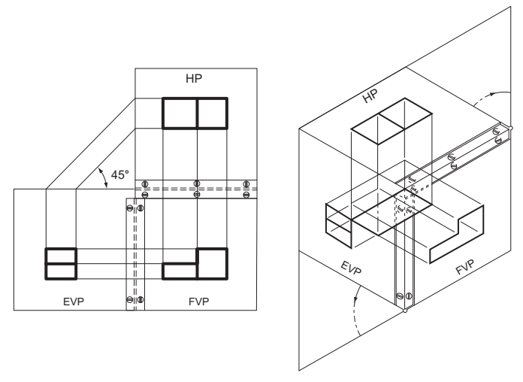  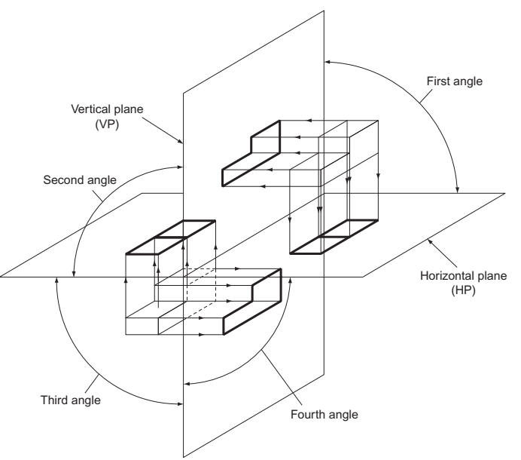  The figure below shows the same shaped block drawn in third angle projection. First, draw the view obtained by looking along the arrow marked FE. This gives you the FE. Now look along the arrow marked EE1 (which points from the left) and draw what you see to the left of the FE. This gives you an EE. Now look along the arrow marked EE2 (which points from the right) and draw what you see to the right of the FE. This gives you another EE. Now look down onto the block, along the arrow marked ‘ plan ’ and draw what you see above the FE. This gives the plan and its exact position is determined by drawing lines from one of the EE at 45 ° .  Note that with third angle projection, what you see from the left you draw on the left, what you see from the right you draw on the right and what you see from above you draw above.  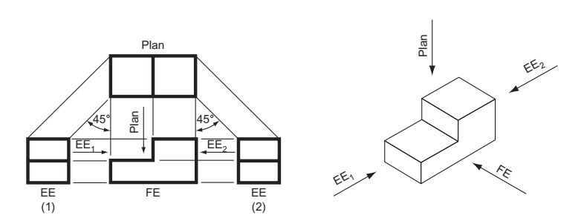  https://www.youtube.com/watch?v=geJt5ctKx6w&ab_channel=folakemiogunmuyiwa
QUIZ | Designer: create a fill in quiz portal that will have the following content  Fill-up the blanks in the following with appropriate words selected from the list  of words given below:  (a) In ___________ projection, the __________ are perpendicular to the _________ of projection.  (b) In first-angle projection method,  (i) the ____________ comes between the and the ________ and the _________  (ii) the ________ view is always _____________ the ____________ view.  (c) In third-angle projection method,  (i) the _____________ comes between the ____________ and the _________  (ii) the ____________ view is always _____________ the __________ view.  List of words for Exercise:  1. Above 5. Object 9. Projectors  2. Below 6. Orthographic 10. Plane  3. Front 7. Observer 1 "I. Side  4. Left 8. Right 12. Top.
ACTIVITY 5: READING MATERIAL | Madsen, D. A., & Madsen, D. P. (2016). Engineering drawing and design. Cengage Learning. Pp 248-256  Morling K. (2010) Geometric and Engineering Drawing,2nd Ed, Butterworth-Heinemann, London ISBN: 978-0-080-96768-4 (hbk); ISBN 13: 978-0-415-53619-6 (pbk) pp 117-122.
ACTIVITY 6: ONLINE DISCUSSION   | Activities based on reading Material 5.  After reading the materials above, post your views on Third angle orthographic projection on the Wiki.  Participate on the wiki by commenting on views of at least three course mates
LEARNING OUTCOME 3: PRACTICAL SKILLS  VIDEO 3:  . | Third angle projection  Watch the video below and  https://www.youtube.com/watch?v=HfxmE57kziY&ab_channel=ADTWlearn
ACTIVITY 7: Learner practice sessions | Watch the video below and redraw the project as shown in the video  https://www.youtube.com/watch?v=LoCYPZo0NLc&t=40s&ab_channel=TheDTcompanion
ASSESSMENT OF PRACTICAL SKILL: | Upload the finished design in your wiki portal and your classmates will review your work. Equally you are also required to review at least three uploads from your course mates.
LEARNING OUTCOME 4: KEY/TRANSFERABLE SKILLS | Provide reading material which emphasizes reinforcement of topic learnt. How to communicate or share acquired knowledge
ACTIVITY 8 | Exercise  Using the skills gained in the previous activities, convert the isometric drawings below to third angle orthographic projection. Record a six minute while constructing third angle projections of the shapes below and upload them in the e-portfolio  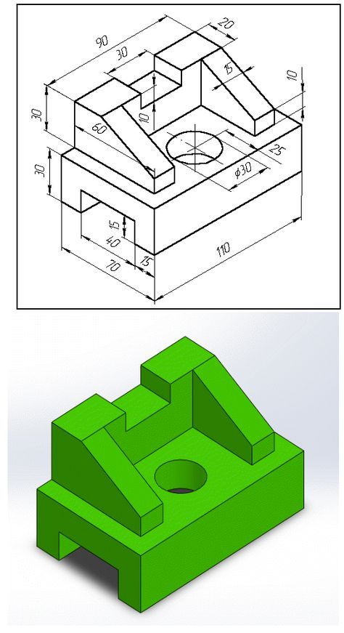  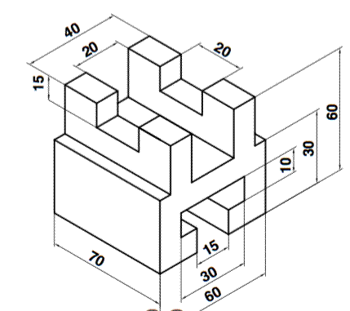
TAKE HOME MESSAGE | Learner to state the take home message from their learning experience.
Reference list | Branoff, T. (2015). Interpreting engineering drawings. Cengage Learning.  Giesecke, F. E., Mitchell, A., Spencer, H. C., Hill, I., Dygdon, J., Novak, J., ... & Johnson, L. (2016). Technical drawing with engineering graphics (Vol. 15). Prentice Hall.  Madsen, D. A., & Madsen, D. P. (2016). Engineering drawing and design. Cengage Learning.  Morling K. (2010) Geometric and Engineering Drawing,2nd Ed, Butterworth-Heinemann, London ISBN: 978-0-080-96768-4 (hbk); ISBN 13: 978-0-415-53619-6 (pbk)  Morling, K., & Danjou, S. (2022). Geometric and engineering drawing. Taylor & Francis.

