THE OPEN UNIVERSITY OF KENYA
MODULE TEMPLATE
Programme title | Bachelor of Technology Education
Course title | TED 123 Technical Drawing I
Learning Module number | TED 123-05
Learning module title | Plane Geometry
Module Developer | Kinuthia Mugi
Module duration in hours | 8 hrs
Instructional Hour Equivalent (Divide duration by 2) | 4 hrs
Reviewed by
Vision | The Innovative University for Inclusive Prosperity
Audience description | This module is designed for technology students intending to gain a deep understanding of technical drawing for engineering purposes.
Instructions to learners   | Welcome to the module  This is a very interesting module for Bachelor of Technology students. In order for you to benefit from this module, you should dedicate sufficient time to study and complete the course materials.  You should participate actively in all aspects of the module, including discussions and assignments. There will be tutorials organized during the module engagement.  Keep on checking in the LMS for the announcement section and on the LMS dashboard.  The live session will be made available in the recorded session folder you are also expected to review the learning objectives and outcomes before beginning the module.  You are expected to engage in all activities as they are presented to achieve the intended learning outcomes.  You will require, drawing instruments such as assorted pencils, drawing board, T-square, compass set, set square set, eraser, A2 drawing paper, internet connectivity, computing device(s), the required plug-in tools for successful completion of this module.
Learning module description | The module introduced the learner on drawing of plane geometry and application in engineering drawing.
Module objectives | The module seeks to facilitate learning of:  - Identification of plane geometries and shapes  - Principles of construction of geometric shapes  - Construction of geometric figures from given data  - Application of principles of construction of geometric shapes
Module learning outcomes | By the end of the module the you should be able to:  - Identify different types of plane geometry and their basic elements;  - Describe the principles and concepts plane geometry construction  - Construct different types of geometrical figures  - Apply methods and rules of construction for different types of geometrical shapes.
Planned Learning Resources | Drawing board Assorted pencils, T-square, compass set, set square set, eraser, A2 drawing paper, masking tape, paper clips, Engineering drawing Drafter, Roll and draw Scale and protractor
ACTIVITY 1: INTRODUCTION  VIDEO 1: Pre-recorded lecture on topic emphasizing LEARNING OUTCOME 1:  Factual knowledge.   | Designer: Create a video based on the script below  Introduction to plane Geometry  [Camera fades in to a close-up shot of a pencil drawing a straight line on a clean sheet of paper. The shot then zooms out to reveal a person sitting at a drawing table, ready to start the video.]  Narrator (voice-over): "Welcome to the world of engineering drawing! Today, we'll be introducing you to the basics of drawing plane geometry, an essential skill for engineers and designers. So, grab a pencil and paper, and let's get started!"  [Cut to a visual of geometric shapes, such as points, lines, angles, triangles, quadrilaterals, and circles, appearing on the screen one by one.]  Narrator (voice-over): "Plane geometry is the study of two-dimensional shapes and their properties. These shapes form the foundation for many engineering designs and are represented using standard conventions in engineering drawing."  [Cut to the narrator drawing a point on the paper, then using a ruler to draw a straight line from the point.]  Narrator (voice-over): "Let's start with the most basic element: a point. A point is a location in space with no size or dimensions. In engineering drawing, we represent a point as a small dot."  [Cut to the narrator drawing a line segment with two points at each end.]  Narrator (voice-over): "A line is a straight path between two points. We can represent a line in engineering drawing by connecting two points with a straight line segment. We use a ruler to ensure the line is straight and accurate."  [Cut to the narrator drawing different types of lines, such as horizontal, vertical, and diagonal lines, using a ruler and a protractor.]  Narrator (voice-over): "Lines can have different orientations. Horizontal lines are parallel to the horizon, vertical lines are perpendicular to the horizon, and diagonal lines slant at an angle. These lines can be used to create various shapes and angles in engineering drawing."  [Cut to the narrator drawing a triangle and labeling its sides and angles.]  Narrator (voice-over): "A triangle is a three-sided polygon. In engineering drawing, we use lines to represent the sides of a triangle and angles to indicate its interior angles. Triangles are essential in many engineering designs, such as trusses and structures."  [Cut to the narrator drawing a circle and labeling its parts, such as center, radius, and diameter.]  Narrator (voice-over): "A circle is a closed curve with a fixed radius and center. In engineering drawing, we use circles to represent cylindrical objects, holes, and rounded shapes. Understanding the parts of a circle, such as radius and diameter, is crucial in accurately depicting circular elements."  [Cut to the narrator drawing a quadrilateral and labeling its sides and angles.]  Narrator (voice-over): "A quadrilateral is a four-sided polygon. In engineering drawing, we use quadrilaterals to represent various shapes, such as rectangles, squares, and parallelograms. Understanding the properties of quadrilaterals, such as their sides, angles, and diagonals, is important in creating accurate drawings."  [Cut to the narrator demonstrating different types of geometric constructions, such as bisecting a line, constructing perpendicular lines, and drawing parallel lines.]  Narrator (voice-over): "Geometric constructions are techniques used in engineering drawing to create precise shapes and angles. These constructions involve using tools such as rulers, compasses, and protractors to bisect lines, construct perpendicular lines, and draw parallel lines. These techniques are essential in creating accurate and proportional drawings."  [Cut to the narrator summarizing the key concepts covered in the video.]  Narrator (voice-over): "In summary, plane geometry is the foundation of engineering drawing, and understanding the basic shapes, lines, angles, and geometric constructions is crucial for creating accurate and precise drawings.
https://www.youtube.com/watch?v=GUOZ_Es_iCE&ab_channel=ArthurGeometry
https://www.youtube.com/watch?v=m1zmWiboxzU&ab_channel=ArthurGeometry
https://www.youtube.com/watch?v=m2sTwTgPs2Y&ab_channel=TechnicalDrawing

ACTIVITY 2: READING  READING MATERIAL 1  ( | Learners engage in self-directed learning of an article, a book chapter or whatever other material assigned.
ACTIVITY 3: Comprehension questions:   | Questions are based on the lecture and reading material.  1  2  3  4  5
LEARNING OUTCOME 2: Conceptual knowledge  ACTIVITY 4: Video to be used. | Learner is required to use factual knowledge acquired to answer question “Why”?  The Case Method, (E-Case or written case) role play or any other visual aid to be used. An E-Case of a situation for the learner to solve possible problems using facts acquired.  Learners will engage in online discussion either live or on forum to answer ‘Why’ questions.
CASE 1:   | Describe case here.
ACTIVITY 5: READING MATERIAL | Material to reinforce the Learning Outcome 2  Learner writes blog. Others respond
ACTIVITY 6: ONLINE DISCUSSION   | Activities based on reading Material 5.  Use chats, discussion forum, question/answer, message my teacher to engage others.  Show how participation will be assessed.
LEARNING OUTCOME 3: PRACTICAL SKILLS  VIDEO 3:  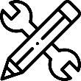. | Show video which displays practical use of knowledge acquired.  https://www.youtube.com/watch?v=PBJxdZrdgqc&ab_channel=KEYTECHNIQUES
ACTIVITY 7: Learner practice sessions | Learner practices the learnt skills. Learner to be given task to demonstrate mastery of the skill.
ASSESSMENT OF PRACTICAL SKILL: | Learner records practiced skill and uploads video on E-Portfolio  OR  Learner engages in original creative /design activity to demonstrate practical application of knowledge.  Assessment of tasks described.
LEARNING OUTCOME 4: KEY/TRANSFERABLE SKILLS | Provide reading material which emphasizes reinforcement of topic learnt. How to communicate or share acquired knowledge
ACTIVITY 8 | Learner to engage in communication, collaboration, problem solving, research, leadership activities. Examples, preparation of a poster to communicate new knowledge acquired, written essay, debate, audio recording …etc.
QUIZZ:   | Short questions to put knowledge to the test.  Make it game like  Challenge learners  Questions of MCQ, T/F, short answer questions etc.
TAKE HOME MESSAGE | Learner to state the take home message from their learning experience.
Reference list
Reference list | Branoff, T. (2015). Interpreting engineering drawings. Cengage Learning.  Giesecke, F. E., Mitchell, A., Spencer, H. C., Hill, I., Dygdon, J., Novak, J., ... & Johnson, L. (2016). Technical drawing with engineering graphics (Vol. 15). Prentice Hall.  Madsen, D. A., & Madsen, D. P. (2016). Engineering drawing and design. Cengage Learning.  Morling K. (2010) Geometric and Engineering Drawing,2nd Ed, Butterworth-Heinemann, London ISBN: 978-0-080-96768-4 (hbk); ISBN 13: 978-0-415-53619-6 (pbk)
ACTIVITY 1:  INTRODUCTORY NOTES : | - Introduction  This chapter is concerned with the construction of plane geometric figures. Plane geometry is the geometry of figures that are two-dimensional, i.e. figures that have only length and breadth. Solid geometry is the geometry of three-dimensional figures. Circles are part of two dimensional figures and thus belong to this category  There are an endless number of plane figures but we will concern ourselves only with the more common ones, such as the triangle, the quadrilaterals, also known as polygons  - Circle  A circle is a plane figure bounded by a curved line called the circumference, which is always equidistant from the centre.  Characteristics of a circle  - A diameter is a straight line drawn through the centre meeting the circumference at both ends.  - A radius is a straight line drawn from the centre to the circumference.  - An arc is part of the circumference.  - A chord is any straight line drawn across the circle meeting the circumference at both ends.  - A tangent is a straight line which touches the circumference. It is always at right angles to the radius.  - A segment is part of a circle bounded by an arc and a chord.  - A sector is a part of a circle bounded by two radii and an arc.  - A quadrant is part of a circle bounded by two radii at right angles and an arc.  - Concentric circles are circles of the same centre but different radii  - Eccentric circles are circles of different centres  - Triangle  The triangle is a plane figure bounded by three straight sides.  A scalene triangle is a triangle with three unequal sides and three unequal angles.  An isosceles triangle is a triangle with two sides, and hence two angles, equal.  An equilateral triangle is a triangle with all the sides, and hence all the angles, equal.  A right-angled triangle is a triangle containing one right angle. The side opposite the right angle is called the ‘ hypotenuse ’  (Attempt the exercises in the Activity 1 Section below
ACTIVITY 2: PRACTICAL SKILLS: Demonstration of practical use of knowledge acquired  . | Exercises: Construct the exercises below and upload your answer on the e-portfolio  Construct a circle or radius 40 mm and take a photo of your construction and upload it on your e-portfolio.
ACTIVITY 2: DEMOSNTRATION OF TRAINGLE CONSTRUCTION | - Triangles  The triangle is a plane figure bounded by three straight sides.  A scalene triangle is a triangle with three unequal sides and three unequal angles.  An isosceles triangle is a triangle with two sides, and hence two angles, equal.  An equilateral triangle is a triangle with all the sides, and hence all the angles, equal.  A right-angled triangle is a triangle containing one right angle. The side opposite the right angle is called the ‘ hypotenuse ’  Steps of Constructing an equilateral triangle, given one of the sides  - Draw a line AB, equal to the length of the side.  - With compass point on A and radius AB, draw an arc as shown.  - With compass point on B, and with the same radius, draw another arc to cut the first arc at C.  - Triangle ABC is equilateral  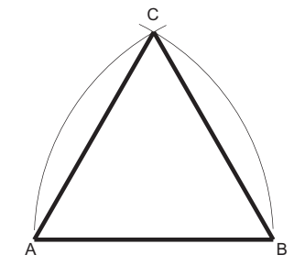  Steps of constructing an isosceles triangle given the perimeter and the altitude.  - Draw line AB equal to half the perimeter.  - From B erect a perpendicular and make BC equal to the altitude.  - Join AC and bisect it to cut AB in D.  - Produce DB so that BE=BD. CDE is the required triangle.  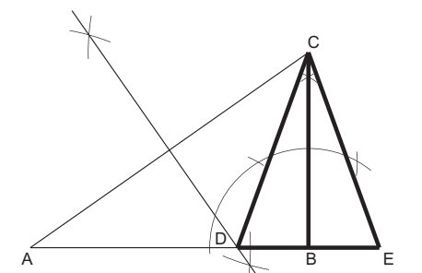  Steps to construct a triangle given the perimeter and the ratio of the sides  - Draw the line AB equal in length to the perimeter.  - Divide AB into the required ratio (e.g. 4:3:6).  - With centre C and radius CA, draw an arc.  - With centre D and radius DB, draw an arc to intersect the first arc in E.  ECD is the required triangle  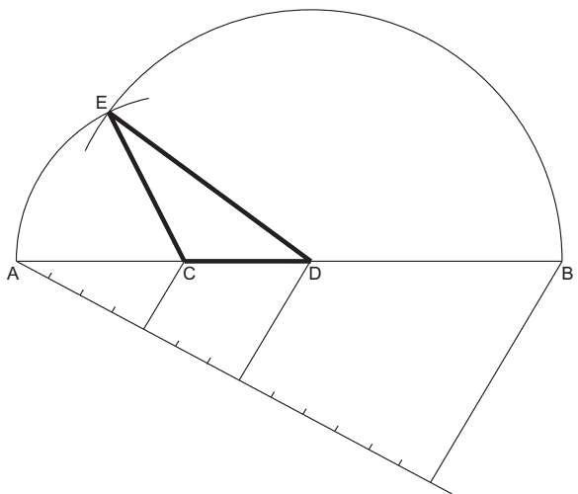  For further reading on this topic read  Morling K. (2010) Geometric and Engineering Drawing,2nd Ed, Butterworth-Heinemann, London ISBN: 978-0-080-96768-4 (hbk); ISBN 13: 978-0-415-53619-6 (pbk)  (Attempt the exercises in the Activity 2 Section below )
ACTIVITY 2: PRACTICAL SKILLS: Demonstration of practical use of knowledge acquired  . | Exercises: Construct the exercises below and upload your answer on the e-portfolio  - Construct the triangles below and upload your answer to the e-portfolio:  - Construct an equilateral triangle with sides 60mm long.  - Construct an isosceles triangle that has a perimeter of 135mm and an altitude of 55 mm.  - Construct a triangle with base angles 60 ° and 45 ° and an altitude of 76 mm.  - Construct a triangle with a perimeter measuring 160 mm and sides in the ratio 3:5:6.
ACTIVITY 3: DEMONSTRATION ON CONSTRUCTION OF QUADRILATERAL | - Quadrilaterals  The quadrilateral is a plane figure bounded by four straight sides.  - A square is a quadrilateral with all four sides of equal length and one of its angles (and hence the other three) a right angle.  - A rectangle is a quadrilateral with its opposite sides of equal length and one of its angles (and hence the other three) a right angle.  - A parallelogram is a quadrilateral with opposite sides equal and therefore parallel.  - A rhombus is a quadrilateral with all four sides equal.  - A trapezium is a quadrilateral with one pair of opposite sides parallel.  - A trapezoid is a quadrilateral with all four sides and angles unequal.  Steps to construct a square given the length of the side  - Draw the side AB.  - From B erect a perpendicular.  - Mark off the length of side BC.  - With centres A and C draw arcs, radius equal to the length of the side of the square, to intersect at D.  Steps to construct a square given the diagonal  - Draw the diagonal AC.  - Bisect AC.  - With centre O and radius OA (= OC), draw a circle to cut the bisecting line in B and D.  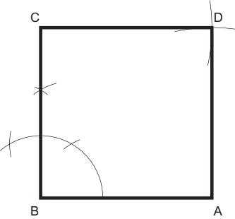  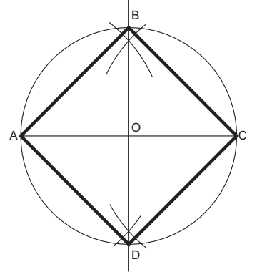  Steps to Construct a rectangle given the length of the diagonal and one of the sides  - Draw the diagonal BD.  - Bisect BD.  - With centre O and radius OB (= OD), draw a circle.  - With centre B and radius equal to the length of the known side, draw an arc to cut the circle in C.  - Repeat step 4 with centre D to cut at A.  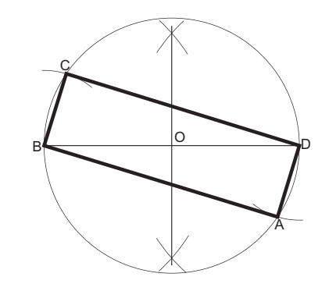  Steps to construct a trapezium given the lengths of the parallel sides, the perpendicular distance between them and one angle  1. Draw one of the parallels AB.  2. Construct the parallel line.  3. Construct the known angle from B to intersect the parallel line in C.  4. Mark off the known length CD.  ABCD is the required trapezium.  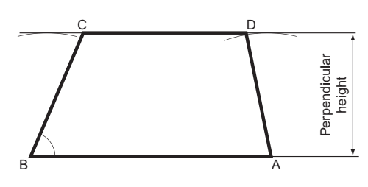  (Attempt the exercises in the Activity 3 Section below )
ACTIVITY 3: PRACTICAL SKILLS: Demonstration of practical use of knowledge acquired  . | Exercises: Construct the exercises below and upload your answer on the e-portfolio  - Draw a triangle whose sides are 76mm, 85mm, and 65mm.  - Draw a triangle whose two sides are 45 mm and 60mm and included angle is 75°.  - Draw a triangle whose side is 60mm and included angles are 60° and 75°  - Draw a square whose sides are 55 mm long by all methods discussed.  - Draw a rhombus whose sides are 40mm and an interior angle is 50°.  - Draw a trapezium ABCD such that AB = 60mm, BC = 48mm, AD = 50mm, CBA=105°, and BAD =120°
ACTIVITY 4: DEMONSTRATION ON CONSTRUCTION OF POLYGONS | - Polygons  A polygon is a plane figure bounded by more than four straight sides. Polygons that are frequently referred to have particular names. Some of these are listed below.  A pentagon is a plane figure bounded by five sides.  A hexagon is a plane figure bounded by six sides.  A heptagon is a plane figure bounded by seven sides.  An octagon is a plane figure bounded by eight sides.  A nonagon is a plane figure bounded by nine sides.  A decagon is a plane figure bounded by ten sides.  A regular polygon is one that has all its sides equal and therefore all its exterior angles equal and all its interior angles equal.  It is possible to construct a circle within a regular polygon so that all the sides of the polygon are tangential to that circle. The diameter of that circle is called the ‘diameter of the polygon’. If the polygon has an even number of sides, the diameter is the distance between two diametrically opposed faces. This dimension is often called the ‘across-flats’ dimension.  To construct a regular hexagon given the length of the sides  - Draw a circle, radius equal to the length of the side.  - From any point on the circumference, step the radius around the circle six times. If your construction is accurate, you will finish at exactly the same place that you started.  - Connect the six points to form a regular hexagon.  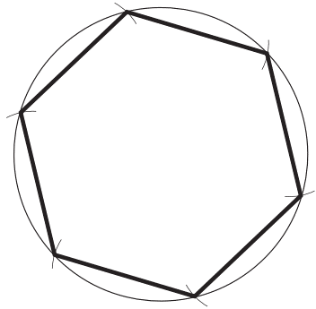  To construct a regular octagon given the diagonal, i.e. within a given circle  - Draw the circle and insert a diameter AE.  - Construct another diagonal CG, perpendicular to the first diagonal.  - Bisect the four quadrants thus produced to cut the circle in B, D, F and H.  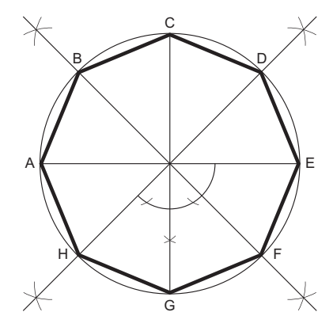  To construct a regular octagon given the diameter, i.e. within a given square  - Construct a square PQRS, length of side equal to the diameter.  - Draw the diagonals SQ and PR to intersect in T.  - With centres P, Q, R and S draw four arcs, radius PT (= QT = RT = ST) to cut the square in A, B, C, D, E, F, G and H.  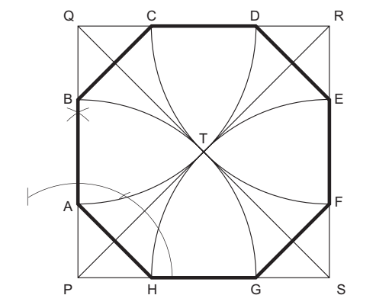  Constructing any regular polygon with a given length of side (approximate method)  - Draw the given side AB.  - With radius equal to AB and centers at A and B draw arcs that intersect at point 6.  - Draw a perpendicular to line AB through point 6 and extend it upward beyond point 6.  - Draw 45° line from either A or B to intersect the perpendicular line at point 4.  - Bisect the distance 4-6 to locate point 5.  - Step up (lay off) distance equal to 5-6 beyond point 6 to get points 7, 8, 9….  - With center at 8 and radius 8-A or 8-B, draw a circle that will inscribe the polygon.  - Adjust your compass to AB and divide the circle into eight equal parts and connect the division points to complete the construction of the regular polygon (in this case octagon)  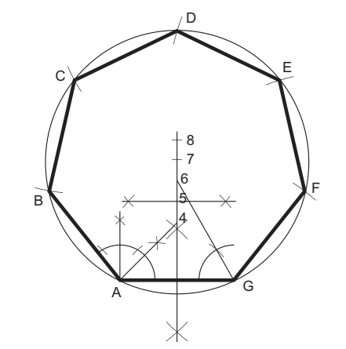  For further reading on this topic read  Morling K. (2010) Geometric and Engineering Drawing,2nd Ed, Butterworth-Heinemann, London ISBN: 978-0-080-96768-4 (hbk); ISBN 13: 978-0-415-53619-6 (pbk)
TAKE HOME MESSAGE | To create an engineering drawing, it is essential to follow established standards and conventions, including dimensioning, scaling, and annotation. It is also necessary to use appropriate tools to create accurate and detailed drawings.
Reference list | Designer: Kindly create a link to the following reading materials  Branoff, T. (2015). Interpreting engineering drawings. Cengage Learning.  Giesecke, F. E., Mitchell, A., Spencer, H. C., Hill, I., Dygdon, J., Novak, J., ... & Johnson, L. (2016). Technical drawing with engineering graphics (Vol. 15). Prentice Hall.  Madsen, D. A., & Madsen, D. P. (2016). Engineering drawing and design. Cengage Learning.  Morling K. (2010) Geometric and Engineering Drawing,2nd Ed, Butterworth-Heinemann, London ISBN: 978-0-080-96768-4 (hbk); ISBN 13: 978-0-415-53619-6 (pbk)

