THE OPEN UNIVERSITY OF KENYA
MODULE TEMPLATE
Programme title | Bachelor of Technology Education
Course title | TED 123 Technical Drawing I
Learning Module number | TED 123-08
Learning module title | First angle Orthographic Projection
Module Developer | Kinuthia Mugi
Module duration in hours | 8 hrs
Instructional Hour Equivalent (Divide duration by 2) | 3 hrs
Reviewed by
Vision | The Innovative University for Inclusive Prosperity
Audience description | This module is designed for technology students intending to gain a deep understanding of technical drawing for engineering purposes.
Instructions to learners   | Welcome to this module. This is the eighth module of the first Technical drawing Course for the students pursuing Bachelor of Technology Education.  The module contains core reading material references and videos which you are required to read and watch after which, you will have an opportunity to test your understanding of the material through quizzes and assignments. The quizzes and assignments forms the basis of progression from one stage of the module to the next. These activities will help you gauge your progress and identify areas where you may need further review.  You will require, drawing instruments such as assorted pencils, drawing board, T-square, compass set, set square set, eraser, A2 drawing paper, internet connectivity, computing device(s), the required plug-in tools for successful completion of this module.
Learning module description | The module provides a brief overview of the rules of projections and the application of projections in engineering drawing.
Module objectives | The module seeks to facilitate learning of:  - Principles and conventions of 1st angle projection  - The concept of orthographic projections  - Construction of drawings in 1st angle projection  - Application of 1st angle projection principles accurately in engineering drawings
Module learning outcomes | By the end of the module, you should be able to:  - Describe principles and conventions of 1st angle projection  - Describe the concept of orthographic projections  - Construct drawings in 1st angle projection  - Apply the principles of 1st angle projection accurately in engineering drawings
Planned Learning Resources | Drawing board Assorted pencils, T-square, compass set, set square set, eraser, A2 drawing paper, masking tape, paper clips, Engineering drawing Drafter, Roll and draw Scale and protractor
ACTIVITY 1: INTRODUCTION  VIDEO 1: Pre-recorded lecture on topic emphasizing LEARNING OUTCOME 1:  Factual knowledge.   | Introduction to 1st angle orthographic projection  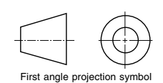  Have you ever seen a building drawn on a blueprint, plan paper? What do you understand from drawing?  Multi-view drawings are conventional projections of a three dimensional object on a two dimensional plane. Anything which is going to be produced or constructed is based on the proposal given by multi-view drawings. For example, buildings, machines, office equipment and so on. By this projection convention engineers, architects, draftsman can communicate with each other even if they don’t speak common language. The basic rules and principles of orthographic projection will be discussed on this module.  Types of projection  A projection is a drawing of an object which is three dimensional on a two-dimensional surface or plane. The two-dimensional surface used for the projection is called plane of projection or the picture plane.  There are different types of projections which are classified depending on:  - The angle the lines of sight (projection line) make with the projection plane,  - The angle the lines of sight make with each other,  - The relative position of the object to be projected with respect to the projection plane.  Planes of Projection  There are three planes perpendicular to each other, which are the basis of multi-view projection. These are:  - Horizontal projection plane.  - Frontal projection plane.  - Profile projection plane.  The position of these planes is illustrated on the figure below. The lines of intersection of these three planes are called reference lines  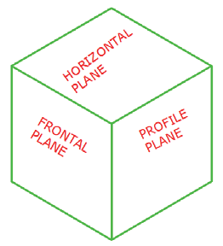  In multi-view projections, lines of sight (projectors) are perpendicular to the planes of projection. The projection of an object on the vertical/frontal projection plane is commonly known as front view. Similarly, horizontal projection of an object is called top view and the profile projection of an object is known as side view.  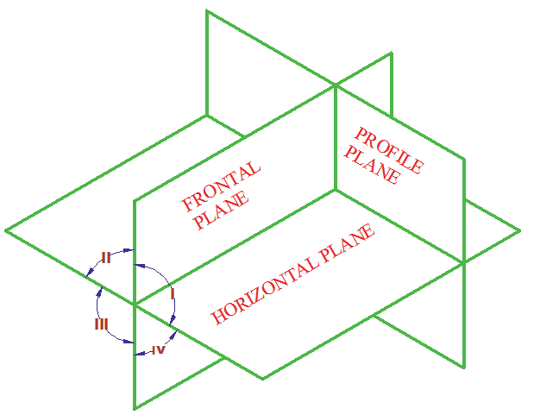  Designer: Insert a video on introduction to 1st angle projections based on the script below  [Camera fades in to a close-up shot of a pencil drawing a square on a clean sheet of paper. The shot then zooms out to reveal a person sitting at a drawing table, ready to start the video.]  Narrator (voice-over): "Welcome to the world of engineering drawing! Today, we'll be introducing you to the concept of first angle orthographic projection, a fundamental technique used in engineering and design to represent three-dimensional objects on a two-dimensional plane. So, let's dive in!"  [Cut to a visual of a three-dimensional object, such as a cube, appearing on the screen.]  Narrator (voice-over): "In engineering drawing, we use first angle orthographic projection to represent the three-dimensional shape of an object on a two-dimensional drawing. This technique uses a set of orthogonal views, which are projected onto separate planes of projection to create a complete representation of the object."  [Cut to the narrator drawing a box-like object on the paper, showing the top, front, and side views.]  Narrator (voice-over): "The three main views used in first angle orthographic projection are the top view, front view, and side view. These views are projected onto separate planes of projection, with the top view projected onto the horizontal plane, the front view projected onto the vertical plane, and the side view projected onto the profile plane."  [Cut to the narrator explaining the conventions of first angle orthographic projection, such as the use of hidden lines, center lines, and dimension lines.]  Narrator (voice-over): "In first angle orthographic projection, we use specific conventions to represent the different features of an object. Visible lines are used to show the visible edges of the object, hidden lines are used to represent features that are not visible in a particular view, center lines are used to indicate symmetry or axes, and dimension lines are used to provide measurements and annotations."  [Cut to the narrator demonstrating how to create a first angle orthographic projection drawing step by step, using a ruler, compass, and other drafting tools.]  Narrator (voice-over): "Creating a first angle orthographic projection drawing involves several steps, including selecting the appropriate views, projecting the views onto their respective planes, adding hidden lines, center lines, and dimension lines, and providing annotations to indicate the size, shape, and other details of the object."  [Cut to the narrator highlighting the importance of accuracy, precision, and attention to detail in first angle orthographic projection drawings.]  Narrator (voice-over): "Accurate and precise first angle orthographic projection drawings are critical in engineering and design, as they provide a clear and comprehensive representation of the object's shape, size, and features. Attention to detail, proper use of conventions, and adherence to standards are essential in creating professional-quality drawings."  [Cut to the narrator summarizing the key concepts covered in the video.]  Narrator (voice-over): "In summary, first angle orthographic projection is a fundamental technique used in engineering drawing to represent three-dimensional objects on a two-dimensional plane. Understanding the conventions, steps, and importance of accuracy and precision in first angle orthographic projection is crucial in creating accurate and professional-quality drawings."  [Camera fades out, ending the video.]  https://www.youtube.com/watch?v=9tBU7ojO6MQ&ab_channel=TheDTcompanion  https://www.youtube.com/watch?v=1OTtBQXug5Q&list=UULF06v3q2Khbwtwsdiysh46kA&index=5&ab_channel=TheDTcompanion  https://www.youtube.com/watch?v=heIobpUVZqc&ab_channel=ADTWlearn
ACTIVITY 2: READING  READING MATERIAL 1  ( | Morling K. (2010) Geometric and Engineering Drawing,2nd Ed, Butterworth-Heinemann, London ISBN: 978-0-080-96768-4 (hbk); ISBN 13: 978-0-415-53619-6 (pbk) pp 117-122
ACTIVITY 3: Comprehension questions:   | Designer: make a portal of multiple-choice questions below and a learner is required to answer only five questions correctly to proceed to the next topic  - In a first angle orthographic projection, where is the front view located?  a) Above the top view  b) Below the top view  c) To the left of the top view  d) To the right of the top view  Answer: b) Below the top view  - Which plane is not shown in a first angle orthographic projection?  a) Top plane  b) Front plane  c) Right plane  d) Back plane  Answer: d) Back plane  - What is the purpose of a first angle orthographic projection?  a) To show the 3D shape of an object  b) To show the size of an object  c) To show the shape of an object in 2D  d) To show the location of an object  Answer: c) To show the shape of an object in 2D  - In a first angle orthographic projection, which view is the smallest?  a) Front view  b) Top view  c) Side view  d) They are all the same size  Answer: c) Side view  - Which of the following is true about first angle orthographic projection?  a) It is commonly used in the United States  b) It is commonly used in Europe  c) It is not commonly used anymore  d) It is only used for small objects  Answer: b) It is commonly used in Europe  - Which line type is used to represent hidden edges in a first angle orthographic projection?  a) Solid lines  b) Dashed lines  c) Dotted lines  d) Center lines  Answer: b) Dashed lines  - In a first angle orthographic projection, where is the top view located?  a) Above the front view  b) Below the front view  c) To the left of the front view  d) To the right of the front view  Answer: a) Above the front view  - Which of the following is not a view in a first angle orthographic projection?  a) Top view  b) Front view  c) Side view  d) Isometric view  Answer: d) Isometric view  - Which projection method is the opposite of first angle orthographic projection?  a) Third angle orthographic projection  b) Second angle orthographic projection  c) Oblique projection  d) Perspective projection  Answer: a) Third angle orthographic projection  - In a first angle orthographic projection, where is the right view located?  a) To the right of the front view  b) To the left of the front view  c) Above the front view  d) Below the front view  Answer: a) To the right of the front view
LEARNING OUTCOME 2: Conceptual knowledge  ACTIVITY 4: Video to be used. | First Angle Projection  The three principal planes of projection form four quadrants as shown below.  The multi-view of an object can be done by placing the object on one of the quadrants. But usually, the first and the third quadrants are the conventional quadrants used. When the object is assumed to be placed in the first quadrant it is known as first angle projection system. In this case the observer is placed in front of the vertical plane, the object will appear to be between the observer and the projection plane.  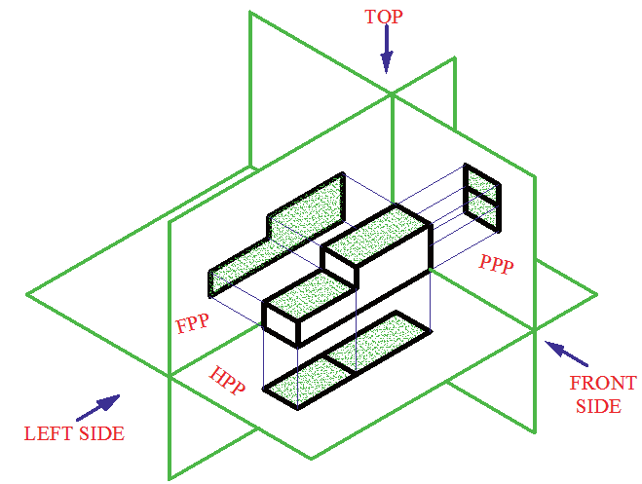  In the figure above the three views of a simple object on the three principal planes of projection are shown pictorially. Then to represent all the views in one plane, the horizontal plane and the profile plane are rotated to the vertical  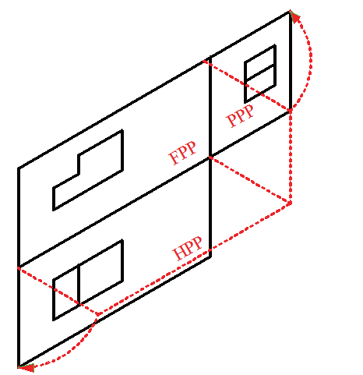  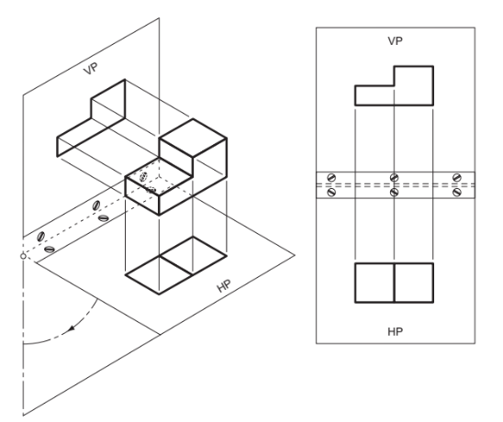  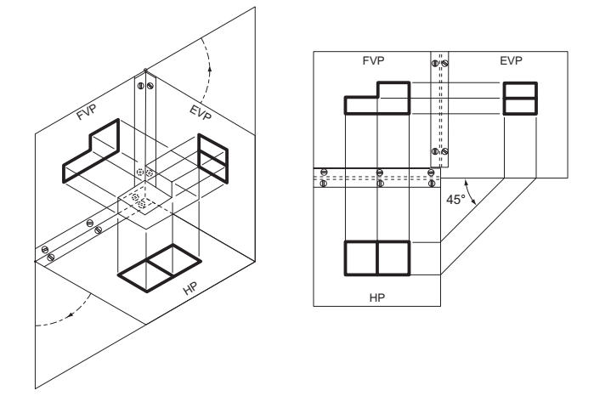  For more understanding on this concept, watch the video below  https://www.youtube.com/watch?v=dKNnTxwSS-Q&ab_channel=ADTWlearn
ACTIVITY 5: READING MATERIAL | Morling K. (2010) Geometric and Engineering Drawing,2nd Ed, Butterworth-Heinemann, London ISBN: 978-0-080-96768-4 (hbk); ISBN 13: 978-0-415-53619-6 (pbk) pp 117-122
LEARNING OUTCOME 3: PRACTICAL SKILLS  VIDEO 3:  . | Construction of 1st angle orthographic projection  Stage 1 (Fig. 4.11): Estimate the space required for each of the views from the overall dimensions in each plane, and position the views on the available drawing sheet so that the spaces between the three drawings are roughly the same.  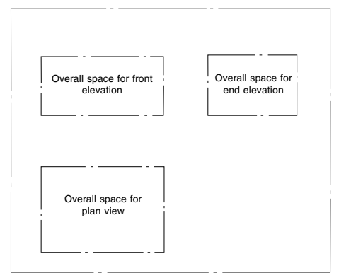  Stage 2: In each view, mark out the main centre-lines. Position any complete circles, in any view, and line them from the start, if possible. Here complete circles exist only in the plan view. The heights of the cylindrical features are now measured in the front view and are projected over to the end view.  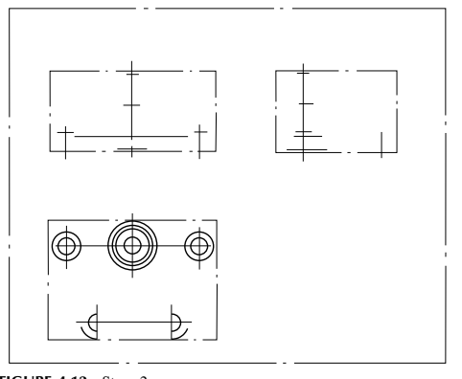  Stage 3: Complete the plan view and project up into the front view the sides of the cylindrical parts.  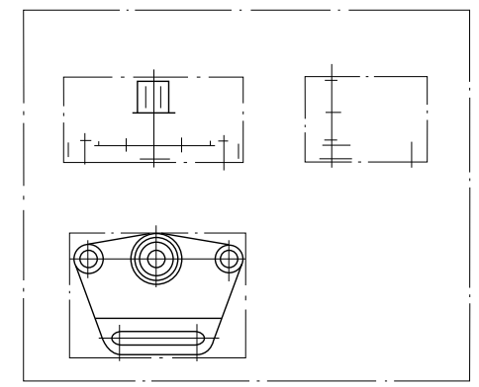  Stage 4: Complete the front and end views. Add dimensions, and check that the drawing (mental check) can be redrawn from the dimensions given; otherwise, the Show video which displays practical use of knowledge acquired.  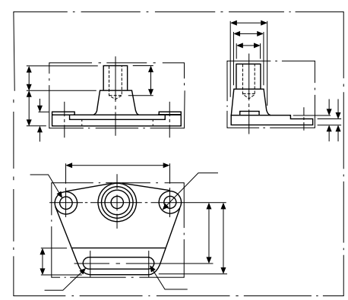
ACTIVITY 7: Learner practice sessions | Watch the video below on demonstration of 1st angle projection. Stop the video at appropriate stages and redraw the object being demonstrated in the video. Once done upload the drawn views in your e-portfolio.  https://www.youtube.com/watch?v=HfxmE57kziY&ab_channel=ADTWlearn
ASSESSMENT OF PRACTICAL SKILL: | You are required to draw the following drawings and upload the same to your class discussion wiki. You are required to review at least three drawings uploaded by your classmates. This forms part of your assessment  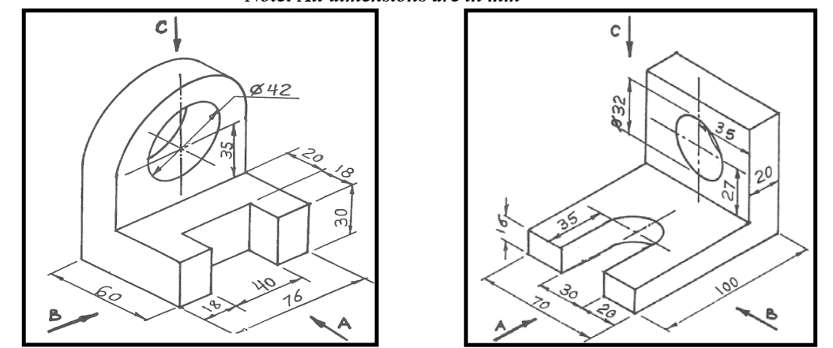
LEARNING OUTCOME 4: KEY/TRANSFERABLE SKILLS | Provide reading material which emphasizes reinforcement of topic learnt. How to communicate or share acquired knowledge  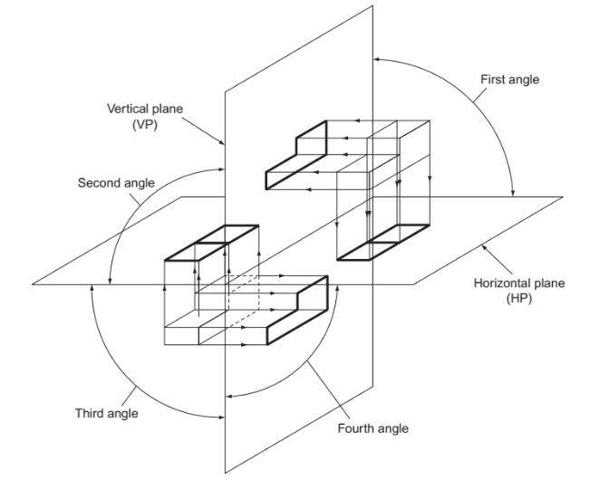
ACTIVITY 8 | - The figure below is a shaped block in insometric projection.  Construct a 1st angle orthographic projection of the block  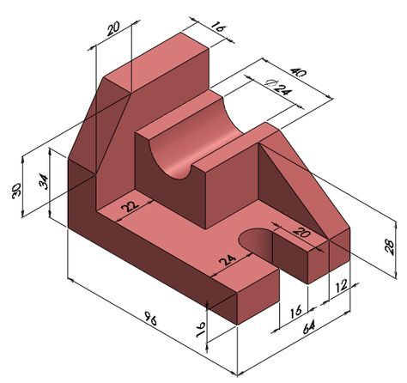  2. Construct a 1st angle orthographic projection of the figure below with the front elevation on the direction of the arrow  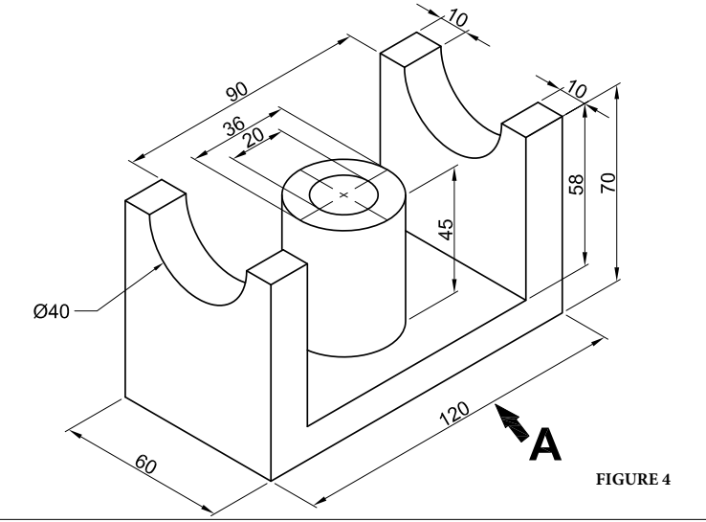
TAKE HOME MESSAGE | Learner to state the take home message from their learning experience.
Reference list | Branoff, T. (2015). Interpreting engineering drawings. Cengage Learning.  Giesecke, F. E., Mitchell, A., Spencer, H. C., Hill, I., Dygdon, J., Novak, J., ... & Johnson, L. (2016). Technical drawing with engineering graphics (Vol. 15). Prentice Hall.  Madsen, D. A., & Madsen, D. P. (2016). Engineering drawing and design. Cengage Learning.  Morling K. (2010) Geometric and Engineering Drawing,2nd Ed, Butterworth-Heinemann, London ISBN: 978-0-080-96768-4 (hbk); ISBN 13: 978-0-415-53619-6 (pbk)

