THE OPEN UNIVERSITY OF KENYA

DESIGN PLAN

The Design Plan presented below reflects the CUE suggested Plan but goes beyond that to specify how each outcome will be handled. All modules are based on this Design Plan.
Note: The principle of constructive alignment informs this Design Plan.

Programme title | COMMON COURSE
Course title | PHL 111: INTRODUCTION TO PHILOSOPHY AND CRITICAL THINKING
Learning Module number | #4
Learning module title | Philosophical methods
Module Developer | Musi Philip N.
Module duration in hours | 8 hours
Instructional Hour Equivalent (Divide duration by 2) | 3 hours
Reviewed by
Vision | The innovative university for inclusive prosperity
Audience description | Prepared for learners at the Open University of Kenya to pursue various degree courses.
Instructions to learners   | Greetings and a warm welcome to this module that will cover the Methods of Philosophy. It is a beginners’ level module for learners pursuing various courses at institutions of higher learning.  You are expected to have an open mind and interest in critically and creatively thinking about and understanding the universe and what goes on therein. In addition, you will also be expected to read, understand (seek clarification where you have difficulty) and attend to all instructions and requirements of a learner, as stated in the module.  Kindly note that all individual and group activities will be assessed and will form part of the summative score at the end of the module.
Learning module description | This is the fourth of the introductory modules to Philosophy. In this module, you will be exposed to the various methods used in philosophy: Socratic, Analytical, Speculative, Transcendental, Dialectic, Cartesian, Pragmatic and phenomenological methods. Their application to intellectual discipline..
Module objectives: | The module intents to cover:  - Methods of philosophy;  - Main characteristics various methods of philosophy  - Relevance of the methods of philosophy to the learner; and  - Application of the methods of philosophy.
Module learning outcomes: | By the end of this module, you are expected be able to:  - Understand the meaning of the various methods of Philosophy.  - Illustrate different characteristics of the methods of philosophy  - Demonstrate the complementarity of the methods of philosophy  - Explain the core nature of the methods to philosophy.
Planned Learning Resources | - Online resources  - Videos  - Written case examples
Assessment | 10% - contribution to the group discussion  10% - e-portfolio assignments  10% - Journal, Wiki & SCORMs  70% - Summative End of Course Assessment
ACTIVITY 1: INTRODUCTION  VIDEO 1: Pre-recorded lecture on topic emphasizing LEARNING OUTCOME 1:  Factual knowledge.   | METHODS IN PHILOSOPHY  Discussion of the methods used in philosophy. This is done by the course instructor and recorded.  Speculative Method  Philosophical speculation involves use of conceptual thought, critical analysis, reflection, and dialectic.  Dialectic and Socratic Method  As employed by Socrates and Plato, it was essentially a method of discussion and debate in which the participants progressed from one point to another, each one disputing the point of the other until they could reach an undisputable point. It consisted in reasoning through rigorous dialogue as a method of intellectual investigation intended to expose false beliefs and elicit truth. To practice philosophy in the dialectic method was continually to subject one’s thoughts to the criticism of reason in earnest dialogue with others. Genuine knowledge was not something that could simply be received from another, but was rather a personal achievement, won only at the cost of constant intellectual struggle and self-critical reflection.  In Hegel, Dialectic takes a different turn. The method of dialectic involves thesis-antithesis-synthesis in which thesis, antithesis and synthesis are only different ‘moments’ in the movement of thought resulting in both continuity and difference.  Cartesian Method  Developed by Rene Descartes, a leading French philosopher. He wanted to arrive at a truth that cannot be doubted. Being a mathematician by training, he settled on method as the only way of discovering truth. Cartesian method is the methodic or systematic doubt until you arrive at indubitable truth. (Cogito ergo sum – I think therefore I am)  Critical Method  Developed by Immanuel Kant, a German Philosopher. Thinking during the rivalry between empiricism and rationalism as sources of true knowledge, he settled for a method that acknowledged both, but went beyond them. The critical method does not stop at the appearance of reality, but goes beyond because things are not what they appear, but what they are in themselves.  Analytical Method  This is a contemporary method. Analytical philosophy refers to various contemporary methods of analyzing the language. The analytic philosophers content that the most important tool of a philosopher is analysis of language. Getting to the core meaning of things.  Pragmatic Method  Pragmatism is a philosophical method founded by three American philosophers: Charles Sanders Peirce, William James and John Dewey. They insisted on the functionality of usefulness of thought to determine its truthfulness. In other words, what is true is that which has practical outcomes.  Phenomenological Method  The Phenomenological method aims at enlarging and deepening the range of our immediate experience under the watchword ‘to the things themselves’. Having a personalized experience of reality is the method of knowing things.  Transcendental Method  This is a way of reflecting upon and interpreting the previous conditions of the possibility of an act of knowledge. Means going beyond what’s already known, to the unknown. Transcendental means that which goes beyond particular experiences by being present in all experiences as their principle.  A video should be provided to support the lecture content.
ACTIVITY 2: READING  READING MATERIAL 1  ( | https://egyankosh.ac.in/bitstream/123456789/38045/1/Unit-3.pdf - . Methods of Philosophy  Read these short papers on the definition and nature methods of philosophy to supplement the above notes. These materials give an introduction to, and origin the methods of philosophy.
ACTIVITY 3: Comprehension questions:   | To recap your experience with the module, you’re requested to respond to the short questions below.  - What’s the difference between Socratic and Hegelian dialectical method?  - Name the various methods of philosophy and their proponents  - Enumerate two main features of each method of Philosophy?  - Outline any five applications the methods to your area of study of philosophy.  Post your responses to the above questions in your wiki
LEARNING OUTCOME 2: Conceptual knowledge  ACTIVITY 4: Video to be used. | Read Case 1 below.  In the group discussion on the LMS, identify the talking points form the case.  Which methods are applied by Socrates in the case below.
CASE 1:  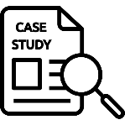 | CASE 1  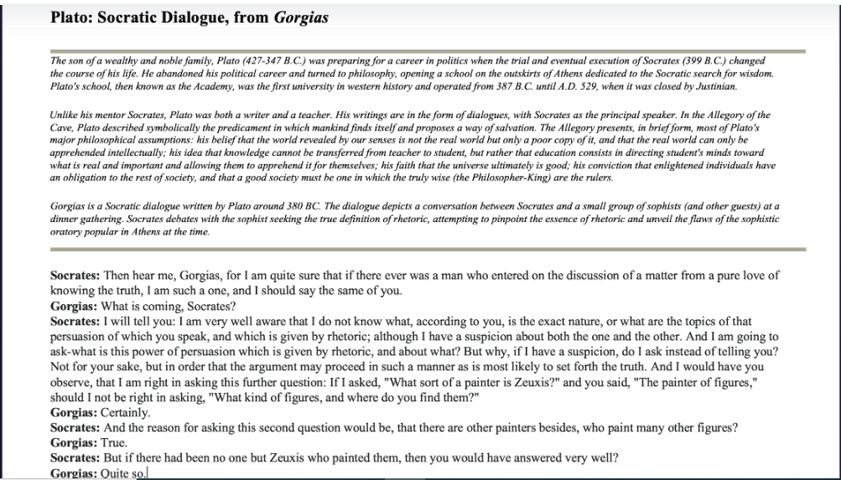
ACTIVITY 5: READING MATERIAL | Jesper Kallestrup (2023). Methods and Skills for Philosophy: An Advanced Guide  (get the book for exact pages on introduction)  Read the above articles and make brief notes on the following in the LMS blog:  - What’s the role of methods of philosophy?  - From the methods above, is philosophy a science or and art? Justify your response.  - What role does methods of philosophy play in society?
ACTIVITY 6: ONLINE DISCUSSION   | Based on the two articles above, write a short essay, of about 500 words, on what you regard as the role of methods of philosophy in your area of study. Post the essay to your e-portfolio for assessment.
LEARNING OUTCOME 3: PRACTICAL SKILLS  VIDEO 3:  . | https://www.youtube.com/watch?v=DcpZkCwstlA Methods of Philosophy  Watch the above Youtube video on the practical methods of philosophy. Note down the crucial methods that can be applied in your life to get through his situation. Post the response to this on your e-portfolio.
ACTIVITY 7: Learner practice sessions | Think of a difficult or challenging situation you have found yourself in. most of the time such situations put you in a dilemma, on what is the best choice of action. State how knowledge of methods of philosophy could have been relevant in such situation. Post this activity on your LMS discussion forum for grading.
ASSESSMENT OF PRACTICAL SKILL: | Assume you have an audience to address. Record a video of your speech to the audience about your understanding of at least four methods of philosophy. Personalize it by citing examples from your context. Upload the video on your E-Portfolio
LEARNING OUTCOME 4: KEY/TRANSFERABLE SKILLS | https://www.youtube.com/watch?v=pDmT68TpfhI - Methods of Philosophy  From the video above, state and explain how methods of philosophy are related and relevant to each other. Post your response to the journal on our LMS
ACTIVITY 8 | Design a concept map of the relationship between the Socratic and Hegelian Dialectical. Post the drawing to your e-portfolio
QUIZZ:   | Answer the following questions in the assignment section of LMS.  - List and define six methods of philosophy  - Who are the proponents of the above methods of philosophy?  - Which method is more applicable to your area of study and why?
TAKE HOME MESSAGE | Briefly state your take home idea or content that you have learnt from this module. Post is on your e-portfolio.
Reference list | Williamson, T. (2020). Philosophical Method: A Very Short Introduction. United Kingdom: Oxford University Press.  SMITH, Nathan (2022), Introduction to Philosophy, Houston Community College, Houston. https://openstax.org/details/books/introduction-philosophy?Book%20details  Marcin Będkowski (2020). Formal and Informal Methods in Philosophy. Netherlands: Brill Rodopi.  Montague, W. P. 1. (2021). The Ways of Knowing: Or, The Methods of Philosophy. United States: Creative Media Partners, LLC.  Shaffer, M. J. (2018). The Experimental Turn and the Methods of Philosophy. United Kingdom: Routledge.  Baggini, J., Fosl, P. S. (2010). The Philosopher's Toolkit: A Compendium of Philosophical Concepts and Methods. United Kingdom: Wiley.  Kallestrup, J. (2023). Methods and Skills for Philosophy: An Advanced Guide. United Kingdom: Taylor & Francis Limited.

