THE OPEN UNIVERSITY OF KENYA

DESIGN PLAN

The Design Plan presented below reflects the CUE suggested Plan but goes beyond that to specify how each outcome will be handled. All modules are based on this Design Plan.
Note: The principle of constructive alignment informs this Design Plan.

Programme title
Course title | PSYCHOLOGY OF LEARNING
Learning Module number | 3
Learning module title | LEARNING
Module Developer | Prof. Luke Odiemo
Module duration in hours | 6
Instructional Hour Equivalent (Divide duration by 2) | 3
Reviewed by | Mr. X
Vision | The innovative university for inclusive prosperity
Audience description | This module targets people who have interest in the area of skill development such as sports instructors and teachers.
Instructions to learners   | This is an online learning module. This means that most of the course work will be conducted online. Expectations for performance in an online course are the same as for a traditional course; in fact, online courses might be more demanding because they require self-motivation, self-discipline, and technology skills.  Online courses are not independent study courses. You will be expected to interact online with the instructor and your peers, keep up with all readings, and adhere to the reading and exam schedule. You will have to post your discussions and complete all assessments by the given deadline date. In addition, you will have to adhere to exam time allotment constraints.  As adults, students, and working professionals, they must manage competing time demands. Should a student need additional time to complete an assignment he or she must contact his or her professor before the due date so the situation can be reviewed, and a resolution determined. Not all delayed assignment request will be approved.  The module covers cutting edge topics that require critical thinking skills, and therefore the module assignments are designed for you to apply those skills.  The module will be assessed and scored as follows:  - Participation in Online Discussion Forums- 10%  - E-portfolio………………10%  - Online comprehension questions……10%  4.End of semester examinations………… 70%  TOTAL…………… 100%  Detailed course expectations:  - Practice “netiquette”: Courtesy and respect are expected at all times. Be polite and respectful in all your postings.  - A week is designated as Monday through Sunday  - Weekly Discussion board entries in e-portfolios must be completed by 11:59PM on Sunday night. You will not be able to post discussions after the deadline.  - Keep up with Course announcements.  - Keep up with the weekly text and other assigned readings or video assignments.  - Use good grammar and spelling in all your communication. Text speak is not allowed.  - Exams and quizzes must be taken within the specific dates and times that are allocated.  - Do not write in all caps (it makes it seem as though you are shouting).  - Sign your name to correspondence
Learning module description | This module intends to facilitate learning about the meaning and definition of learning.
Module objectives: | The objectives of this module are to promote learning about the:  - Definition, meaning and characteristics of the concept of learning and types of learning  - Nature of learning  - Process of learning  - Concept of the learning curve
Module learning outcomes: | By the end of the module, the learner is expected to:  - Explain the concept, nature of learning, types of learning, the meaning and types of learning curve  - Analyze the steps involved in the process of learning  - Apply the different stages of learning curve to the process of learning  - Evaluate the importance of learning curve to the process of learning
Planned Learning Resources | - Watch videos and video clips  - Visit different web sites  - Read original surveys, research, and news articles  - Online Discussion Boards  - Adobe Connect live chats. Chats will be scheduled once a week.  - TRUE/FALSE and Multiple choice quizzes based on text readings.  - Multiple choice exams based on text chapters.  - Quizzes will not be scheduled during the weeks in which the exams are given.  - Weekly discussion board postings in response to questions I will provide based on text readings, videos or additional articles  With very few exceptions, all supplementary material including PowerPoint slides, videos, articles, and link to websites will be posted on Learning Management System (LMS).
ACTIVITY 1: INTRODUCTION  VIDEO 1: Pre-recorded lecture on topic emphasizing LEARNING OUTCOME 1:  Factual knowledge.   | Topic content is fully presented here. The lecture will deal with factual knowledge, expounding on threshold concepts, if any.  Every moment of our life is a learning moment. We learn how to read, ride a bicycle, avoid danger and relate to people. One key indicator that learning has taken place is a change is behavior. This change in behavior brought about by experience is called as learning. But what is learning in essence? In the module, I am going to enlighten your about nature of learning as a psychological phenomenon.  For more details on the meaning of learning, read : De Houwer, J. and Hughes, S. (2020). The Psychology of Learning; An Introduction from a Functional-Cognitive Perspective. Cambridge, Massachusetts, London, England: The MIT Press. Chapter one, pg.1-11  This book can be accessed at: https://psychologyoflearning.be/onewebmedia/The%20Psychology%20of%20Learning.pdf  A video should be provided to support the lecture content.  As a teacher, it is always important that you develop a view of learning that serves your teaching objectives and the intended learning outcomes. I would like you to watch the two short videos by clicking on the links below to understand the importance having a conception of learning as a teacher:  https://www.youtube.com/watch?v=DuA80Y7wN3s  https://www.youtube.com/watch?v=Okm8ojzYYms
ACTIVITY 2: READING  READING MATERIAL 1  ( | Learners engage in self-directed learning of an article, a book chapter or whatever other material assigned.  - Having watched the above videos, I would like you to immerse yourself deeper in the question of the meaning of learning as a concept in order for you to start thinking about what learning means to you. This conception is very important to your professional development as a teacher.  - You can click on the following link to access some notes on the concept of learning then proceed to Activity 3.  CREATE HYPERTEXT
ACTIVITY 3: Comprehension questions:   | Questions are based on the lecture and reading material.  - In the following quiz, you are required to attempt the flip card quiz before flipping the cards.  - Remember that this quiz will contribute to your course work.  - Flipping the cards before attempting the questions will automatically block you from proceeding further and this will affect your course work score.  - You can proceed with the quiz  Create Flip Cards  QUIZ  1. Define learning___________  Learning, in psychology, the process by which a relatively lasting change in potential behavior occurs because of practice or experience. Learning is also a process of acquiring modifications in existing knowledge, skills, habits, or tendencies through experience, practice, or exercise.  3. Explain the concept of learning and state its characteristics.  1. Learning is a continuous modification of behavior continues throughout life  2. Learning is pervasive. It reaches into all aspects of human life.  3. Learning involves the whole person, socially, emotionally & intellectually.  4. Learning is often a change in the organization of behavior.  5. Learning is developmental. Time is one of its dimensions.  6. Learning is responsive to incentives. In most cases positive incentives such as rewards are most effective than negative incentives such as punishments.  7. Learning is always concerned with goals. These goals can be expressed in terms of observable behavior.  8. Interest & learning are positively related. The individual learns bet those things, which he is interested in learning. Most boys find learning to play football easier than learning to add fractions.  9. Learning depends on maturation and motivation.  4. List the different types of learning.  A) Learning can be classified as Informal, formal and non-formal learning: Depending on the way of acquiring it learning may be informal, formal or non-formal.  • Informal learning is incidental. It takes place throughout life. It is not planned.  • Formal learning is intentional and organized. It takes place in formal educational institution.  • Non-formal is also intentional & organized. It is flexible.  - Individual or Group learning: Learning is called either individual or group learning depending upon the number of individuals involved in the learning process.  - Finally learning can be classified depending on the type of activity involved namely:  (i) Motor learning: - when learning involves primarily the use of muscles it is called as motor learning. e.g.: learning to walk, to operate a typewriter  (ii) Discrimination learning: - Learning which involves the act of discrimination is called discrimination learning. e.g. infant discriminates between mother and aunt, milk and water.  (iii) Verbal learning: - when learning involves the use of words it is called as verbal learning.  (iv) Concept learning: - when learning involves the formation of concept it is called as concept learning.  (v) Sensory learning: - when learning is concerned with perception and sense it is sensory learning.  5. Outline the nature of learning.  - Learning is adaptation or adjustment  - Learning is often considered as a process of improvement with practice or training  - Learning is not mere addition of knowledge. It is the reorganization of experience  - Learning brings behavioral changes  - Learning is active  - Learning is goal oriented  - Learning is universal and continuous  - Learning can be accelerated or slowed down  6. Explain the process of learning  i) A motive or a drive: Motive is the dynamic force that energizes behavior and compels an individual to act. We do any activity because of our motives or our needs.  ii) Goal: Every individual has to set a definite goal for achievement. We should always have a definite goal for achieving anything. If a definite goal is set, then learning becomes purposeful and interesting  iii) Obstacle /block /barrier: The obstacle or block or the barrier is equally important in the process of learning. The obstacle or the barriers keep us away from attaining the goal. If you face difficulty or challenge of any kind in attaining the goal, you will not bring any change in your present behavior or stock of knowledge or skills.
LEARNING OUTCOME 2: Conceptual knowledge  ACTIVITY 4: Video to be used. | Learner is required to use factual knowledge acquired to answer question “Why”?  The Case Method, (E-Case or written case) role play or any other visual aid to be used. An E-Case of a situation for the learner to solve possible problems using facts acquired.  Learners will engage in online discussion either live or on forum to answer ‘Why’ questions.
CASE 1:   | Describe case here.  - I would like you to CLICK on the link below and read the following case of classroom interaction between students and the teacher.  - After reading, write a brief analysis of less 100 words on whether Elizabeth was successful in her intended teaching goal.  - Include this writeup in your portfolio. It will account for 10% of your coursework  - Make sure to read before clicking on the flip card for the analysis of the situation  CREATE HYPERTEEXT TO THE WRITTEN CASE:  LEARNING IS NOT ALWAYS WHAT IT SEEMS:  After weeks of working with her cooperating teacher in an eighth-grade social studies class, Elizabeth was ready to take over on her own. As she moved to the front of the room, she saw another adult approach the classroom door. It was Mr. Ross, her supervisor from college. Elizabeth’s neck and facial muscles suddenly became very tense.  “I’ve stopped by for my first observation,” Mr. Ross said. “I couldn’t reach you last night to tell you.”  Elizabeth tried to hide her reaction, but her hands trembled as she gathered the notes for the lesson. She turned to face her students and introduced the day’s topic.  “Let’s start today with a kind of game. I will say some words, then I want you to  tell me the first words you can think of, and I will write them on the board. Don’t all speak at once, though. Wait until someone else has finished before you say your word.  Okay, here is the first word: Slavery.”  “Civil War.” “Lincoln.” “Freedom.” “Emancipation Proclamation.” The answers came  quickly, and Elizabeth was relieved to see that the students understood the game.  “All right, very good,” she said. “Now try another one: South.”  “South Carolina.” “South Dakota.” “South Park,” “No, the Confederacy, you dummy.”  “Slavery,” “Free State of Jones,” “Matthew McConaughey.” With this last answer, a ripple  of laughter moved across the room.  “Matthew McConaughey!” Elizabeth sighed dreamily. Then she laughed too. Soon  all the students were laughing. “Okay, settle down,” Elizabeth said. “Here is another  word: North.”  “Bluebellies.” The students continued to laugh. “Jelly Bellies.” “Belly-dancers.”  More laughter and a few inappropriate gestures.  “Just a minute,” Elizabeth pleaded. “These ideas are getting a little off base!”  “Off base? Baseball,” shouted the boy who had first mentioned Matthew  McConaughey. He stood up and started throwing balls of paper to a friend in the back  of the room, simulating the style of Clayton Kershaw.  “The San Francisco Giants.” “No, the LA Dodgers, dummy.” “Ball games.” “Hot dogs.” “Popcorn.” “Movies.” “Free State of Jones.” “Matthew McConaughey.” The  responses now came too fast for Elizabeth to stop them. For some reason, the “Matthew  McConaughey” line got an even bigger laugh the second time around, and Elizabeth  suddenly realized she had lost the class.  “Okay, because you know so much about the Civil War, close your books and take  out a pen,” Elizabeth said, obviously angry. She passed out the worksheet that she had  planned as a cooperative, open-book project. “You have 20 minutes to finish this test!”  “You didn’t tell us we were having a test!” “This isn’t fair!” “We haven’t even covered this stuff yet!” “I didn’t do anything wrong!” There were moans and disgusted  looks, even from the most mellow students. “I’m reporting you to the principal; it’s a  violation of students’ rights!”  This last comment hit hard. The class had just finished discussing human rights as  preparation for this unit on the Civil War. As she listened to the protests, Elizabeth felt  terrible. How was she going to grade these “tests”? The first section of the worksheet  involved facts about events during the Civil War, and the second section asked students  to create a news-style program interviewing ordinary people touched by the war.  “All right, all right, it won’t be a test. But you do have to complete this worksheet  for a grade. I was going to let you work together, but your behavior this morning tells  me that you are not ready for group work. If you can complete the first section of the  sheet working quietly and seriously, you may work together on the second section.”  Elizabeth knew that her students would like to work together on writing the script for  the news interview program.  Elizabeth was afraid to look back at her supervisor. What was he writing on his  observation form?  (This case is adapted from: Ormord, J. Anderman, E.M. & Anderman, L.H. Educational Psychology: Developing Learner. Pearson Education. Chapter 7, pg291-292)  CREATE FLIP CARD FOR THIS analysis:  ANALYSIS OF THE CASE:  It appears, on the surface at least, that very little learning of any sort was taking place in Elizabeth’s classroom. Elizabeth had some good ideas, but she also made some mistakes in her application of learning principles.  To get us started, four events can be singled out, each possibly related to a different learning process.  First, the students were able to associate the words Carolina, Dakota, and Park  with the word South.  Second, Elizabeth’s hands trembled when her college supervisor entered the room.  Third, one student continued to disrupt the class with inappropriate responses.  And fourth, after Elizabeth laughed at a student’s comment, the class joined in her laughter.
ACTIVITY 5: READING MATERIAL   | Material to reinforce the Learning Outcome 2  Learner writes blog. Others respond  - I would like you to read chapter one of: Woolfolk, A. (2020) Educational Psychology, 14th Edition. Pearson Education Limited  - I would now like you to create your blog  - In this blog, in not more than 600 words, describe the characteristics of what you consider to be your own conception of good quality learning for your future students.  - Summarize in one sentence your definition of what learning is.  - Include this write-up in your ePortfolio as it will contribute to 10% of your course work.
ACTIVITY 6: ONLINE DISCUSSION   | Activities based on reading Material 5.  Use chats, discussion forum, question/answer, message my teacher to engage others.  Show how participation will be assessed.  - I am glad you have now outlined your conception of learning and described the characteristics of what you consider to be good quality learning in the preceding activity.  - In this activity, I would like you to either join a WIKI discussion forum established by one of your colleagues or simply establish your forum and invite colleagues for a discussion.  - Topic of discussion is: Personal conceptions of learning.  Colleagues will share their conceptions of learning and justify why they hold such conceptions.  - Justify your arguments using psychological arguments.  - Your participation to this discussion will contribute 10% to your course work.  - Failure to contribute at all will earn you no marks.  7 Anti-social behavior such as using abusive language, disrespect to colleagues and being socially insensitive to gender, religious beliefs, ethnic diversity will reduce your score by half.
LEARNING OUTCOME 3: PRACTICAL SKILLS  VIDEO 3:  . | Show video which displays practical use of knowledge acquired.
ACTIVITY 7: Learner practice sessions | Learner practices the learnt skills. Learner to be given task to demonstrate mastery of the skill.  - In this activity, I would like you to watch this video about the education in Finland.  https://www.youtube.com/watch?v=HsdFi8zMrYI  - To what extent is the finish view of learning similar to your view of learning?  - In less than 100 words, summaries your conception of the finish conception of learning.  - Include your write up in your ePortfolio as it will contribute to 10% of your course work
ASSESSMENT OF PRACTICAL SKILL: | Learner records practiced skill and uploads video on E-Portfolio  OR  Learner engages in original creative /design activity to demonstrate practical application of knowledge.  Assessment of tasks described.
LEARNING OUTCOME 4: KEY/TRANSFERABLE SKILLS | Provide reading material which emphasizes reinforcement of topic learnt. How to communicate or share acquired knowledge
ACTIVITY 8 | Learner to engage in communication, collaboration, problem solving, research, leadership activities. Examples, preparation of a poster to communicate new knowledge acquired, written essay, debate, audio recording …etc.  - On the basis of your own conception of learning that you have just presented in Activity 5 and 6 above, write a one-page letter to your fellow student-teachers advising them the kind of teaching practice they should embrace in order for them to realize the kind of learning you have envisioned in the learners. Remember to justify your reasons by making references to some authorities in educational psychology.  - Include this letter in your ePortfolio as it will contribute to 10% of your course work.
QUIZZ:   | Short questions to put knowledge to the test.  Make it game like  Challenge learners  Questions of MCQ, T/F, short answer questions etc.  - In the following quiz, you are required to attempt the flip card quiz before flipping the cards.  - Remember that this quiz will contribute to your course work.  - Flipping the cards before attempting the questions will automatically block you from proceeding further and this will be affecting your course work score.  - You can proceed with the quiz  Create Flip Cards  QUIZ  - What is a learning curve?  Learning curve is a graphic representation of how learning  takes place in a particular situation.  - Describe a typical learning curve.  The curve is divided into 5 stages namely:  - Period of slow progress  - Period of rapid progress  - Period of no progress or plateau  - Period of sudden rise  - Levelling  - What are the different types of learning curve?  - Convex curve  - Concave curve  - Mixed convex and concave curve  - State any two causes of plateau  (i) The learner may be reorganizing the previous learning into  a new pattern before further progress is possible.  (ii) The learner may have hit upon bad habits  (iii) Lack of progress may be due to decrease in motivation.  (iv) The task may not be of uniform difficulty.  (v) Loss of interest.  (vi) The onset of fatigue is also one of the causes of a plateau.  - Explain the educational importance of a learning curve.  - In acquiring the basic skills in various subjects, the learner at times appears to show no progress. At such moments, the teacher can diagnose the reasons for the lack of progress.  - A student’s progress may be arrested because the work is too complex for him. The teacher can observe the student’s work and detect the part that gives him trouble. The teacher should see if the student has developed any faulty study habits, which impede his progress  - The plateau may be due to the lack of motivation. The teacher should provide encouragement in order to maintain motivation at a high level  - The learning curves give a graphic evidence of one’s progress, which is an effective motivational device for the learner.  - Occurrence of plateaus can be minimized by using superior teaching methods.  - State the important characteristics of a learning curve.  (i) Slow initial progress.  (ii) Spurt-like learning after some time.  (iii) Declination in the rate of learning.  (iv) Plateaus of learning.  (v) Sudden increase in learning.  (vi) Gradual levelling at the end.
TAKE HOME MESSAGE | Learner to state the take home message from their learning experience.
Reference list | De Houwer, J. and Hughes, S. (2020). The Psychology of Learning; An Introduction from a Functional-Cognitive Perspective. The MIT Press Cambridge, Massachusetts, London, England

HYPERTEXT
CONCEPT OF LEARNING
Meaning and Definitions of learning
Learning, in psychology, the process by which a relatively lasting change in potential behavior occurs because of practice or experience. Learning is also a process of acquiring modifications in existing knowledge, skills, habits, or tendencies through experience, practice, or exercise. Gates and others “Learning is the modification of behavior through experience”
Henry, P smith “Learning is the acquisition of new behavior or strengthening or weakening of old behavior as a result of experience”.
Crow and Crow “Learning is the acquisition of habits, knowledge and attitudes. It involves new ways of doing things, and it operates in an individual’s attempt to overcome obstacles or to adjust to new situations.”
Skinner “Learning is the process of progressive behavior adaptation.”
Munn “To learn is to modify behavior and experience.”
M. L. Bigge “Learning may be considered as change in insights, behavior, perception, motivation or a combination of these.”
The above definitions emphasize four attributes of learning...
• As Process: the first is that learning is permanent change in behavior.
• It does not include change due to illness, fatigue, maturation and use of intoxicant.
• The learning is not directly observable but manifests in the activities of the individual.
• Learning depends on practice and experience.

Characteristics of Learning
Yoakum & Simpson have stated the following general characteristics of learning: Learning is growth, adjustment, organization of experience, purposeful, both individual and social, product of the environment.
Types of Learning
Learning has been classified in many ways.
I. Informal, formal and non-formal learning: Depending on the way of acquiring it learning may be informal, formal or non-formal.
• Informal learning is incidental. It takes place throughout life. It is not planned.
• Formal learning is intentional and organized. It takes place in formal educational institution.
• Non-formal is also intentional & organized. It is flexible.
II. Individual or Group learning: Learning is called either individual
or group learning depending upon the number of individuals involved in the learning process.
III. Another classification involves the types of activity involved
(a) Motor learning: - when learning involves primarily the use of muscles it is called as motor learning. e.g.: learning to walk, to operate a typewriter
(b) Discrimination learning: - Learning which involves the act of discrimination is called discrimination learning. e.g. infant discriminates between mother and aunt, milk and water.
(c) Verbal learning: - when learning involves the use of words it is called as verbal learning.
(d) Concept learning: - when learning involves the formation of concept it is called as concept learning.
(e) Sensory learning: - when learning is concerned with perception and sense it is sensory learning.
NATURE OF LEARNING
a. Learning is adaptation or adjustment: Friends, we all continuously interact with our environment. We often make adjustment and adapt to our social environment. Through a process of continuous learning, the individual prepares himself for necessary adjustment or adaptation. That is why learning is also described as a process of progressive adjustment to ever changing conditions, which one encounters.
b. Learning is improvement: Learning is often considered as a process of improvement with practice or training. We learn many things, which help us to improve our performance.
c. Learning is organizing experience: Learning is not mere addition of knowledge. It is the reorganization of experience.
d. Learning brings behavioral changes: Whatever the direction of the changes may be, learning brings progressive changes in the behavior of an individual. That is why he is able to adjust to changing situations.
e. Learning is active: Learning does not take place without a purpose and self-activity. In any teaching learning process, the activity of the learner counts more than the activity of a teacher.
f. Learning is goal directed: when the aim and purpose of learning is clear, an individual learns immediately. It is the purpose or goal, which determines what, the learner sees in the learning situations and how he acts. If there is no purpose or goal learning can hardly be seen.
g. Learning is universal and continuous: All living creatures learn. Every moment the individual engages himself to learn more and more. Right from the birth of a child till the death learning continues.
PROCESS OF LEARNING
Learning is a process. It is carried out through steps. Learning
process involves –
(a) A motive or a drive.
(b) An attractive goal.
(c) A block to the attainment of the goal.

Let us see the steps one by one –
(a) A motive or a drive: Motive is the dynamic force that energizes behavior and compels an individual to act. We do any activity because of our motives or our needs. When our need is strong, enough we are compelled to strive for its satisfaction. Learning takes place because of response to some stimulation. As long as our present behavior, knowledge, skill and performance are adequate to satisfy all our needs, use do not feel any necessity to change our behavior or acquire new knowledge and skills. It is this requirement, which initiates a learner to learn something.
(b) Goal: Every individual has to set a definite goal for achievement. We should always have a definite goal for achieving anything. If a definite goal is set, then learning becomes purposeful and interesting.
(c) Obstacle /block /barrier: The obstacle or block or the barrier is equally important in the process of learning. The obstacle or the barriers keep us away from attaining the goal. Now, you will think how the obstacle can be important in the process of learning. So let me tell you if you face no difficulty of any kind in attaining the goal, you will not bring any change in your present behavior or stock of knowledge or skills. Thus, the block or the barrier is an essential step in the learning process. Let us clear the above views by taking an example. Suppose you wish to be included in your college hockey team. You want to have the esteem of your colleagues, your teachers. You are also motivated try the interesting experiences that you many enjoy. But you are blocked by your lack of skill in dodging, tackling and handling the ball. The obstacles in the path of goal achievement will set you make up your deficiency and acquire essential skill through sufficient practice and coaching.
LEARNING CURVE Learning curve is a graphic representation of how learning takes place in a particular situation. In all type of learning situations, the course of learning can be depicted and described graphically by drawing learning curves against x and y axis

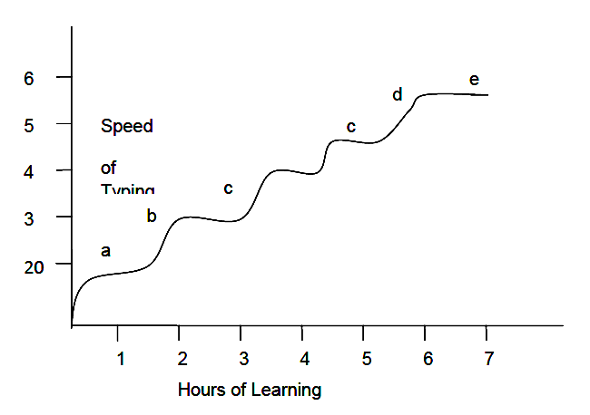
The above figure shows a typical learning curve of many types of learning. The curve consists of a number of irregularities, as the progress is not constant. For the convenience, the curve is divided into 5 stages – a, b, c, d and e.
(a) Period of slow progress: Generally when a person has to start a learning of a given activity from a scratch, his early progress will be slow. E.g., an infant’s progress in learning to walk is very negligible in the beginning.
(b) Period of rapid progress: In this stage, the learner’s output raises rapidly. e.g. In typing once the learner has developed coordination of the movement of fingers he shows rapid progress.
(c) Period of no apparent progress: Learning curves frequently display a period of no apparent progress. It is also known as plateau. A period of no visible learning progress, preceded and followed by improvement is called as plateaus. E.g. In typing, a person may after having made rather consistent progress for some time, reach a point where perhaps for weeks no further progress is made.
Causes of plateau
(i) The learner may be reorganizing the previous learning into a new pattern before further progress is possible.
(ii) The learner may have hit upon bad habits
(iii) Lack of progress may be due to decrease in motivation.
(iv) The task may not be of uniform difficulty.
(v) Loss of interest.
(vi) The onset of fatigue is also one of the causes of a plateau.

(d) Period of sudden rise: At the end of a plateau, there is generally a spurt in achievement. While on the plateau, the learner acquires better techniques, which help him later on to show rapid progress.
(e) Levelling: All learning will finally slow down to such an extent that it will ultimately reach a period of no improvement. No one can continue to improve indefinitely in any given situation. The learning curve will eventually reach a limit, where no further improvement is possible. This limit is known as physiological limit.
Characteristics of Learning Curve.
(i) Slow initial progress.
(ii) Spurt-like learning after some time.
(iii) Declination in the rate of learning.
(iv) Plateaus of learning.
(v) Sudden increase in learning.
(vi) Gradual levelling at the end.
Types of Learning Curve.
We get different types of learning curves depending upon –
(a) The nature of the learner
(b) The nature of the task/learning material
(c) Time available.
(d) Conditions under which the learning takes place.
It is difficult to classify these learning curves. However, three
common types of curves are there,
(i) Negatively accelerated or the convex curve.
(ii) Positively accelerated learning curve or the concave curve.
(iii) Combination of convex-concave curve.
Convex curve
It depicts rapid initial improvement in learning that slows down with time. When the task is simple, and the learner has previous practice on a similar task, we get this type of learning curve.

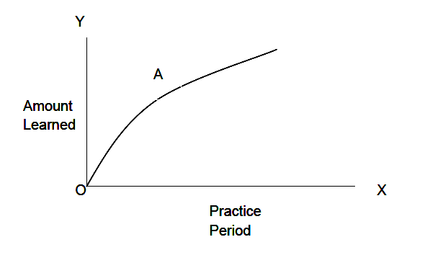
Concave curve
There is slow initial improvement and learning increases with
time. When the task is difficult, we get such type of learning curve.

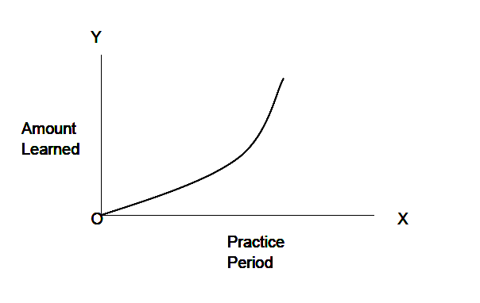

Combination of convex concave curve
It looks like the capital letter ‘S’. The curve takes concave or convex shape in the beginning depending upon the nature of the task.

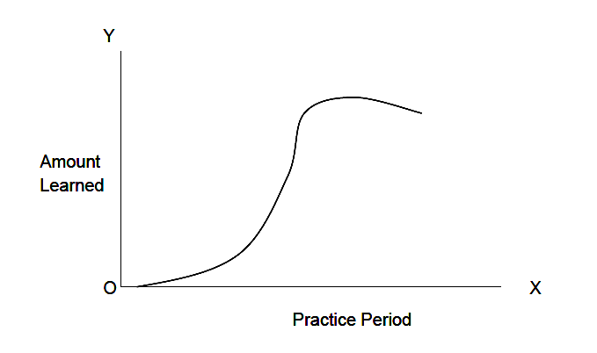
In actual practical situations, such smooth curves are rarely found. Usually there are ups and downs (fluctuation).
Educational importance of learning curve
1. In acquiring the basic skills in various subjects, the learner at times appears to show no progress. At such moments, the teacher can diagnose the reasons for the lack of progress.
2. A student’s progress may be arrested because the work is too complex for him. The teacher can observe the student’s work and detect the part that gives him trouble. The teacher should see if the student has developed any faulty study habits, which impede his progress.
3. The plateau may be due to the lack of motivation. The teacher should provide encouragement in order to maintain motivation at a high level.
4. The learning curves give a graphic evidence of one’s progress, which is an effective motivational device for the learner.
5. Occurrence of plateaus can be minimized by using superior teaching methods.

