THE OPEN UNIVERSITY OF KENYA
MODULE TEMPLATE
Programme title | Bachelor of Technology Education
Course title | TED 123 Technical Drawing I
Learning Module number | TED 123-02
Learning module title | Linear and Diagonal Scales
Module Developer | Kinuthia Mugi
Reviewed by
Vision | The Innovative University for Inclusive Prosperity
Audience description | This module is designed for technology students intending to gain a deep understanding of technical drawing for engineering purposes.
Instructions to learners   | Welcome to this module. This is a module Technical drawing Course for the students pursuing Bachelor of Technology Education.  The module contains core reading material references and videos which you are required to read and watch after which, you will have an opportunity to test your understanding of the material through quizzes and assignments. The quizzes and assignments forms the basis of progression from one stage of the module to the next. These activities will help you gauge your progress and identify areas where you may need further review.  You will require, drawing instruments such as assorted pencils, drawing board, T-square, compass set, set square set, eraser, A3 drawing paper, internet connectivity, computing device(s), the required plug-in tools for successful completion of this module.
Learning module description | The module introduces to the learner on drawing scales, how to develop scales and application in engineering drawing.
Module objectives | The module seeks to facilitate learning of:  - Plain and diagonal scales in engineering drawing  - concepts and principles of scales  - construction of accurate and legible plain scales and diagonal scales on technical drawings  - Application of plain and diagonal scales in drawings
Module learning outcomes | By the end of the module you should be able to:  - Identify plain and diagonal scales  - Explain underlying concepts in plain and diagonal scales  - Construct plain and diagonal scales from given data  - Apply the scales developed in construction of drawings
ACTIVITY 1: PREPARATION  VIDEO 1:   | - Introduction to scales  Generally, it is easier to produce and understand a drawing if it represents the true size of the object drawn. This is of course not always possible due to the size of the object to be drawn, that is why it is often necessary to draw enlargements of very small objects and reduce the drawing of very large ones, this is called “SCALE”.  However, it is important when enlarging or reducing a drawing that all parts of the object are enlarged or reduced in the same ratio, so that the general configuration of the object is saved.  Thus, scales are multiplying or dividing of dimensions of the object.  The scale is the ratio between the size represented on the drawing and the true size of the object, that is otherwise referred to as Representative Fraction  $$Scale=\frac{Dimension to Carry in the Drawing }{True Dimension of the Object}$$  For example, if an actual length of 4 metres of an object is represented by a line of 20 mm length on the drawing  $$RF=\frac{20 mm}{4 m}=\frac{20 mm}{4×1,000}=\frac{1}{200} or 1:200$$  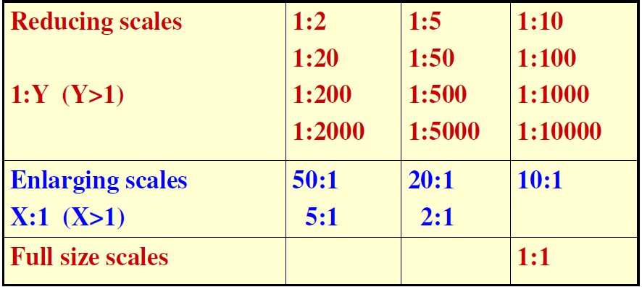  - Plain Scales  A plain scale consists of a line divided into suitable number of equal units. The first unit is subdivided into smaller parts. The requirements of plain scale are:  - The plain scales give only two dimensions, such as a unit and it’s subunit or it’s fraction.  - The zero should be placed at the end of the 1st main unit.  - From the zero mark, the units should be numbered to the right and the sub-divisions to the left.  - The units and the subdivisions should be labelled clearly.  - The R.F. should be mentioned below the scale.  Video 1  https://www.youtube.com/watch?v=n9iQcttWHAo&t=3s  Video 2  https://www.youtube.com/watch?v=ao00TP3QreQ&t=128s
ACTIVITY 1: PRACTICAL SKILLS: Demonstration of practical use of knowledge acquired  . | After watching the above videos, answer the following questions.  - To construct a plain scale, 30 mm 10 mm, 50 mm long to read to 1 mm  - Construct a plain scale of 1:4 to show centimeters and long enough to show up to 50 cm.  Take a photo of your constructed answers and upload them to your e-portfolio.
VIDEO 2: (Introduction and YouTube video)   | - Diagonal Scales  There is a limit to the number of divisions that can be constructed on a plain scale. For instance trying to divide 10 mm into 50 parts; you will find that it is almost impossible. A diagonal scale allows you to divide into smaller units.  Watch the videos below for further understanding of the topic  https://www.youtube.com/watch?v=_PHul1YFxrI&t=382s  https://www.youtube.com/watch?v=zz65fPypG_c
ACTIVITY 1: PRACTICAL SKILLS: Demonstration of practical use of knowledge acquired  . | After watching the above videos, answer the following questions.  - Construct a diagonal scale of 50 mm = 200 mm, 600 mm long to read a minimum of 0.02 mm.  - Using the scale in i) above, construct a quadrilateral PQRS which stands on a base PQ of length 354 mm and having QR = 266 mm, PS = 312 mm, <PQR = 1200 and <PSR = 900. Measure the state by printing the length of the two diagonals. (Take a video of not more than 3 minutes while doing this question ) Upload a photo of your assignment and video to your e-portfolio
TAKE HOME MESSAGE | To create an engineering drawing, it is essential to follow established standards and conventions, including dimensioning, scaling, and annotation. It is also necessary to use appropriate tools to create accurate and detailed drawings.
Reference list | Designer create a link to the following reading materials  Branoff, T. (2015). Interpreting engineering drawings. Cengage Learning.  Giesecke, F. E., Mitchell, A., Spencer, H. C., Hill, I., Dygdon, J., Novak, J., ... & Johnson, L. (2016). Technical drawing with engineering graphics (Vol. 15). Prentice Hall.  Madsen, D. A., & Madsen, D. P. (2016). Engineering drawing and design. Cengage Learning.  Morling K. (2010) Geometric and Engineering Drawing,2nd Ed, Butterworth-Heinemann, London ISBN: 978-0-080-96768-4 (hbk); ISBN 13: 978-0-415-53619-6 (pbk)

