THE OPEN UNIVERSITY OF KENYA
MODULE TEMPLATE
Programme title | Bachelor of Technology Education
Course title | TED 123 Technical Drawing I
Learning Module number | TED 123-10
Learning module title | LINES IN SPACE
Module Developer | Kinuthia Mugi
Module duration in hours | 8 hrs
Instructional Hour Equivalent (Divide duration by 2) | 3 hrs
Reviewed by
Vision | The Innovative University for Inclusive Prosperity
Audience description | This module is designed for technology students intending to gain a deep understanding of technical drawing for engineering purposes.
Instructions to learners   | Welcome to this module. This is a module technical drawing Course for the students pursuing Bachelor of Technology Education.  The module contains core reading material references and videos which you are required to read and watch after which, you will have an opportunity to test your understanding of the material through quizzes and assignments. The quizzes and assignments forms the basis of progression from one stage of the module to the next. These activities will help you gauge your progress and identify areas where you may need further review.  You will require, drawing instruments such as assorted pencils, drawing board, T-square, compass set, set square set, eraser, A2 drawing paper, internet connectivity, computing device(s), the required plug-in tools for successful completion of this module.
Learning module description | The module provides an guidance on the lines and planes in space and their projections in vertical and horizontal view.
Module objectives | The module seeks to facilitate learning of:  - Different types of lines and planes in space  - Fundamental principles and concepts of lines and planes in space  - Construction of clear and precise drawings of lines and planes in space  - Application of skills, standards and in construction of lines and planes in space accurately in engineering drawing
Module learning outcomes | By the end of the module, you should be able to:  - Define and describe different types of lines and planes in space  - Describe different fundamental principles and concepts of lines and planes in space  - Construct clear and precise drawings of lines and planes in space  - Apply skills, standards and in construction of lines and planes in space accurately in engineering drawing
Planned Learning Resources | Drawing board Assorted pencils, T-square, compass set, set square set, eraser, A2 drawing paper, masking tape, paper clips, Engineering drawing Drafter, Roll and draw Scale and protractor
ACTIVITY 1: INTRODUCTION  VIDEO 1: Pre-recorded lecture on topic emphasizing LEARNING OUTCOME 1:  Factual knowledge.   | Introduction of lines and planes in space  A straight line is the shortest distance between two points. Hence, the projections of a straight line may be drawn by joining the respective projections of its ends which are points.  The position of a straight line may also be described with respect to the two reference planes. It may be:  1. Parallel to one or both the planes.  2. Contained by one or both the planes.  3. Perpendicular to one of the planes.  4. Inclined to one plane and parallel to the other.  5. Inclined to both the planes.  The object to be drawn is suspended between three planes called the Front View Plane (FVP) , the End View Plane (EVP) and the horizontal plane HP. These planes are at right angles, and a view of the object is projected onto each of the planes. These views are called the Front Elevation FE, the End Elevation EE and the plan. Two of the planes are then swung back, as if on hinges, until all three planes are in the same plane, i.e. they would all lie on the same flat surface. This system of swinging the planes until they are in line is called ‘ rabatment ’.  The nomenclature of the planes may change if the there are only two planes involved. They are otherwise known as Horizontal plane, HP and Vertical Plane, VP.  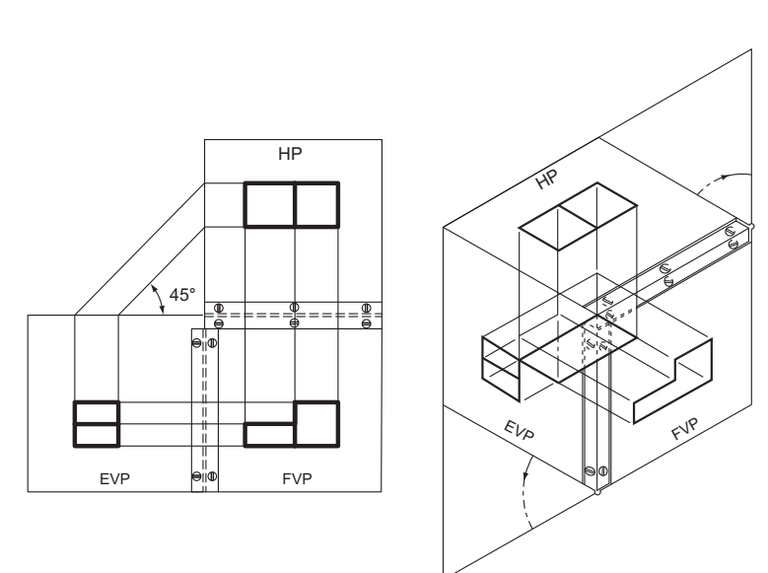  3rd Angle projection  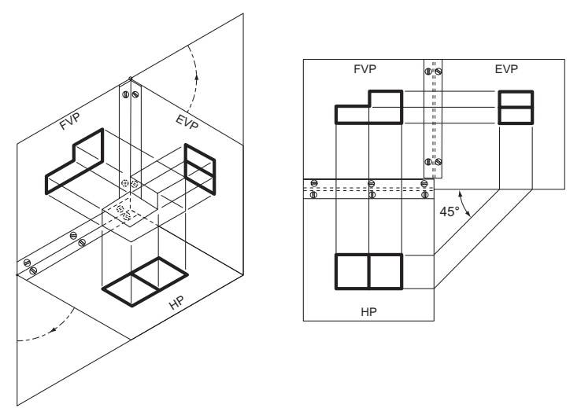  First angle projection  Understanding the above concepts will enable you deal with the concepts of lines in space.
Auxiliary views
In general, auxiliary views are used for determining:
- • the true length and inclinations of a line,
- the point view of a line and edge view of a plane,
- the true shape and size of a plane,
- the distance between two skew lines,
- the projections of solids,
- the true shapes of sections of solids,
- Curves of intersections, etc
ACTIVITY 2: READING  READING MATERIAL 1  ( | Morling K. (2010) Geometric and Engineering Drawing,2nd Ed, Butterworth-Heinemann, London ISBN: 978-0-080-96768-4 (hbk); ISBN 13: 978-0-415-53619-6 (pbk) chapter 13
LEARNING OUTCOME 2: Conceptual knowledge  ACTIVITY 4: Video to be used. | Projection of points and lines in space  Designer: Kindly insert an introductory video on lines and planes in space based on the following script  [Opening Scene: Show an engineer using drafting tools, such as rulers, compasses, and protractors, to create precise drawings on a drafting board.]  [Background Music Begins: Energetic and Upbeat]  Narrator (Voiceover): "Welcome to the world of engineering drawing! In this video, we will explore the construction of lines and planes in space, an essential skill for engineers and designers. Lines and planes in space form the basis for creating accurate and detailed three-dimensional representations of objects. Let's dive in!"  [Cut to a Close-up Shot of a Line Being Drawn on a Drafting Board.]  Narrator (Voiceover): "Lines in space can have different orientations and characteristics. For example, parallel lines never meet, intersecting lines cross each other at a point, perpendicular lines meet at right angles, and oblique lines have other angles of intersection."  [Cut to a Demonstration of Constructing Parallel and Perpendicular Lines in Space.]  Narrator (Voiceover): "To construct parallel lines in space, we use the method of offsets, where we transfer equal distances from an original line to create parallel lines. And to construct perpendicular lines, we use the method of bisecting angles, where we bisect an angle to create two lines that are perpendicular to each other."  [Cut to a Demonstration of Constructing Intersecting and Oblique Lines in Space.]  Narrator (Voiceover): "To construct intersecting lines in space, we use the method of locating points, where we determine the points of intersection by measuring the distances from known points or lines. And to construct oblique lines, we use the method of inclined lines, where we draw lines at a known angle and distance from a given line or point."  [Transition: Change to a Different Scene Showing Planes in Space.]  Narrator (Voiceover): "Now, let's move on to planes in space. Planes are two-dimensional surfaces that can have different orientations, such as parallel planes, intersecting planes, and inclined planes."  [Cut to a Demonstration of Constructing Parallel and Intersecting Planes in Space.]  Narrator (Voiceover): "To construct parallel planes in space, we use the method of offsets, similar to constructing parallel lines. We transfer equal distances from an original plane to create parallel planes. And to construct intersecting planes, we use the method of intersecting lines, where we draw lines that intersect at known points on the planes to determine their orientation."  [Cut to a Demonstration of Constructing Inclined Planes in Space.]  Narrator (Voiceover): "To construct inclined planes in space, we use the method of inclined lines, similar to constructing oblique lines. We draw lines at a known angle and distance from a given plane or point to determine the orientation of the inclined planes."  [Transition: Wrap up the Video.]  Narrator (Voiceover): "And that's an introduction to the construction of lines and planes in space in engineering drawing! By mastering these techniques, engineers and designers can create accurate three-dimensional representations of objects, which are essential in fields such as civil engineering, mechanical engineering, architecture, and more. We hope you found this video helpful as you embark on your journey of mastering engineering drawing. Thank you for watching!"  [Closing Scene: Show a completed drawing of lines and planes in space on a drafting board, with the engineer's hand holding a drafting pen, signifying the completion of the construction process.]  [Background Music Fades Out]  [End of Video]  Watch the video below and that explains the concepts of lines in space  https://www.youtube.com/watch?v=rCcLJ3_4EXo&ab_channel=EzEdChannel  Lines in Space  There are several scenarios tat present themselves in relation to lines in space and the plane. These are:  - A line that is parallel to both VP and HP  - A line that is parallel to HP but inclined to VP  - A line that is parallel to VP but inclined to HP  - A line that is perpendicular to either HP or VP  - A line that is inclined to HP and VP  In the above circumstances there is need to resolve the true length of these lines and consequently the inclination of these lines to the planes. This will be delt with in subsequent part of this module.  Watch the video below for more explanation of these concepts  https://www.youtube.com/watch?v=sjskQLbK0Kk&list=PLgwJf8NK-2e5glnKO4gTQCVufyg_Gbx7C&ab_channel=EngineeringFunda
CASE 1:   | https://www.youtube.com/watch?v=fK4h5gM73w8&ab_channel=ManasPatnaik  https://www.youtube.com/watch?v=LTl3nBdOUGQ&ab_channel=EzEdChannel
ACTIVITY 5: READING MATERIAL | Morling K. (2010) Geometric and Engineering Drawing,2nd Ed, Butterworth-Heinemann, London ISBN: 978-0-080-96768-4 (hbk); ISBN 13: 978-0-415-53619-6 (pbk) chapter 13
ACTIVITY 6: ONLINE DISCUSSION   | Designer: Create a multiple choice portal that the student can answer five questions before he/she proceed to the next part of the module based on the questions below:  - Which of the following best describes a line in space?  a) A set of points that extends infinitely in both directions  b) A set of points that extends infinitely in one direction  c) A set of points that ends at a specific point in space  d) A set of points that forms a closed loop  Answer: a) A set of points that extends infinitely in both directions  - How many points are needed to uniquely determine a line in space?  a) One  b) Two  c) Three  d) Four  Answer: b) Two  - Which of the following is not a way to describe a line in space?  a) Vector equation  b) Parametric equation  c) Cartesian equation  d) Polar equation  Answer: d) Polar equation  - What is the direction vector of a line in space?  a) A vector that is perpendicular to the line  b) A vector that lies on the line  c) A vector that is parallel to the line  d) A vector that points towards the origin  Answer: c) A vector that is parallel to the line  - Which of the following is true about two lines in space that are parallel?  a) They intersect at a single point  b) They intersect at infinitely many points  c) They do not intersect  d) They intersect only if they are in the same plane  Answer: c) They do not intersect  - Which of the following is true about two lines in space that are skew?  a) They intersect at a single point  b) They intersect at infinitely many points  c) They do not intersect  d) They intersect only if they are in the same plane  Answer: c) They do not intersect  - What is the shortest distance between a point and a line in space?  a) The distance between the point and the closest point on the line  b) The distance between the point and the furthest point on the line  c) The distance between the point and the midpoint of the line  d) The distance between the point and the origin  Answer: a) The distance between the point and the closest point on the line  - Which of the following is true about a line in space and a plane?  a) They always intersect at a single point  b) They always intersect at infinitely many points  c) They do not intersect  d) They intersect only if the line is parallel to the plane  Answer: d) They intersect only if the line is parallel to the plane  - Which of the following is true about the intersection of two planes in space?  a) They always intersect at a single point  b) They always intersect at infinitely many points  c) They do not intersect  d) They intersect only if they are parallel  Answer: d) They intersect only if they are parallel  - Which of the following is not a way to determine if two lines in space are perpendicular?  a) Check if their direction vectors are parallel  b) Check if their direction vectors are perpendicular  c) Check if a vector that is perpendicular to one line is perpendicular to the other line  d) Check if a vector that is parallel to one line is perpendicular to the other line  Answer: d) Check if a vector that is parallel to one line is perpendicular to the other line
LEARNING OUTCOME 3: PRACTICAL SKILLS  VIDEO 3:  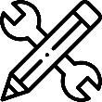. | Projection of lines in space  Construct the lines below as illustrated  - Line parallel to both H.P and V.P  A 50mm long line AB is parallel to both H.P and V.P. The line is 25mm in front of V.P and 60mm above H.P, draw the projections of the line  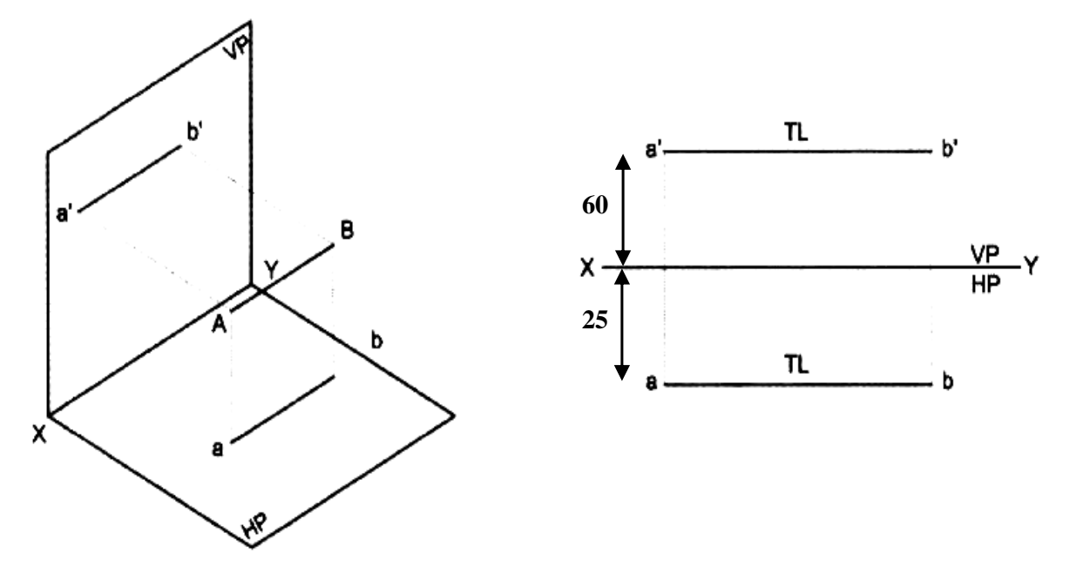  - Line perpendicular to H.P  A 60mm long line AB has its end A at a distance of 20mm above the H.P. The line is perpendicular to the H.P and 40mm in front of V.P, draw the projections of the line.  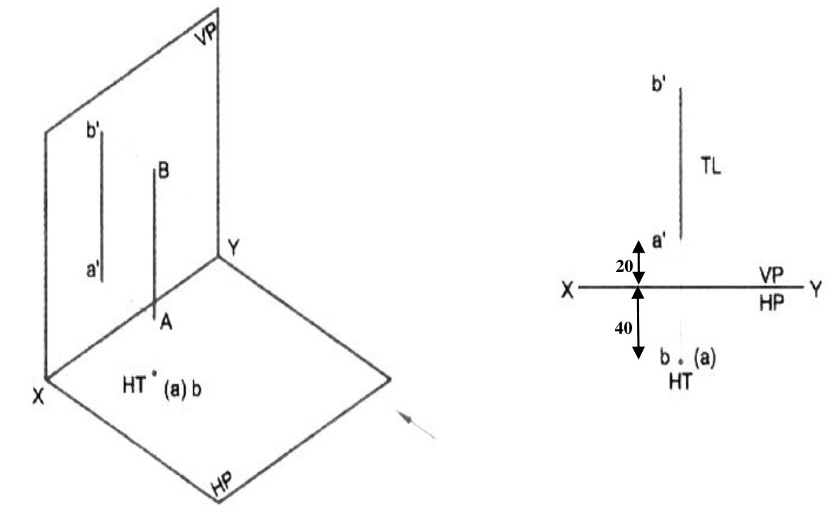  - Line perpendicular to V.P  A 60mm long line AB, has its end A at a distance of 20mm in front of the V.P. the line is perpendicular to V.P and 40mm above H.P, draw the projection of the line.  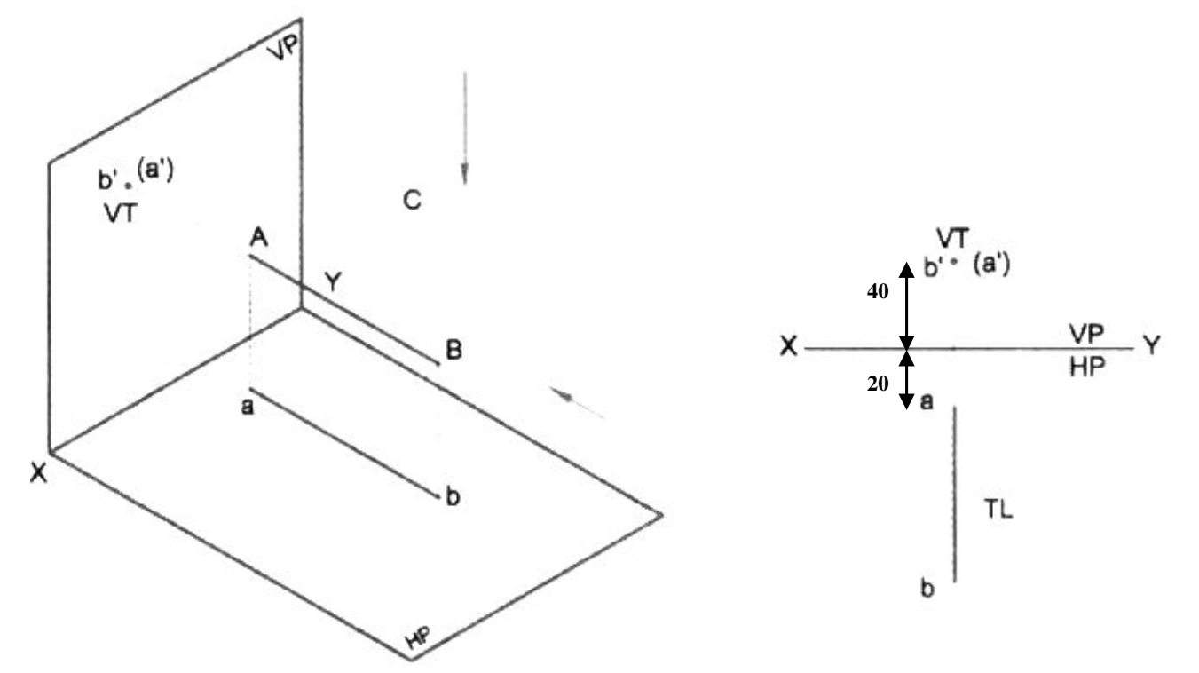  - Line inclined to H.P and parallel to V.P  A 80mm long line AB has the end A at a distance of 20mm above HP and 40mm in front of V.P. The line is inclined at 30 deg to H.P and parallel to V.P, draw the projection of the line.  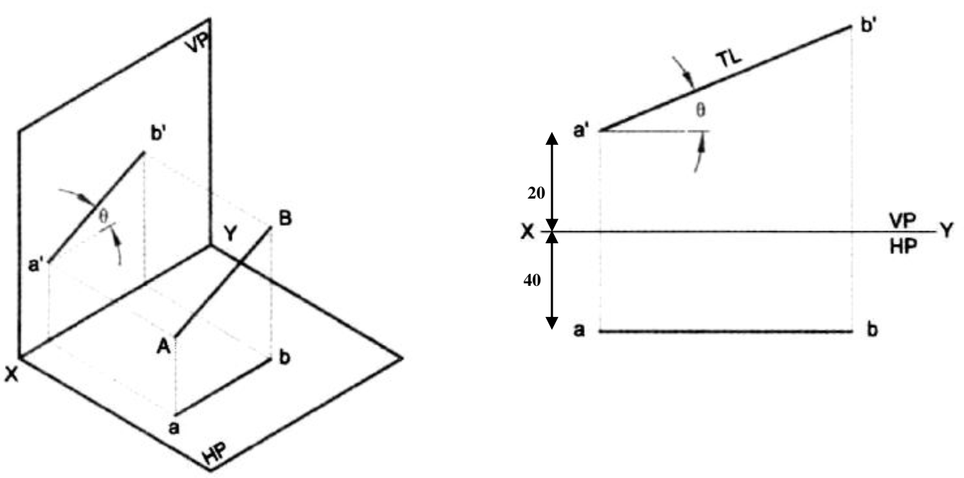  - Line inclined to V.P and parallel to H.P  An 80mm long line AB is inclined at 30 deg to V.P and is parallel to H.P. The end A is 20mm above the H.P and 20mm in front of the V.P, draw the projection of the line.  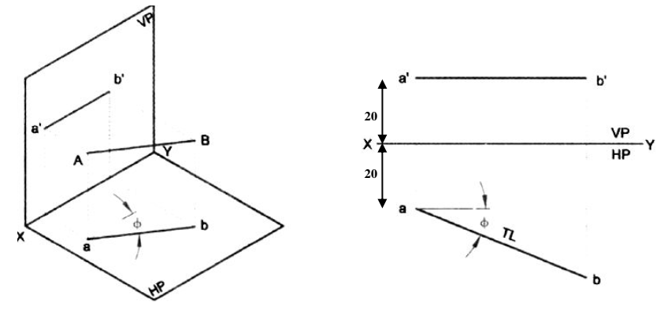  - Line situated in H.P  A line AB 60mm long is situated in H.P and inclined to V.P at 30 deg. The end A is 20mm in front of V.P, draw the projection of line  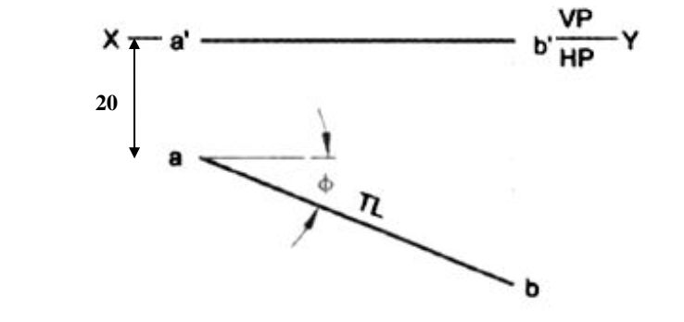  - Line situated in V.P  Draw the projections of 70mm long line AB situated in the V.P and inclined at 30 deg to H.P. The end A is 25 mm above H.P.  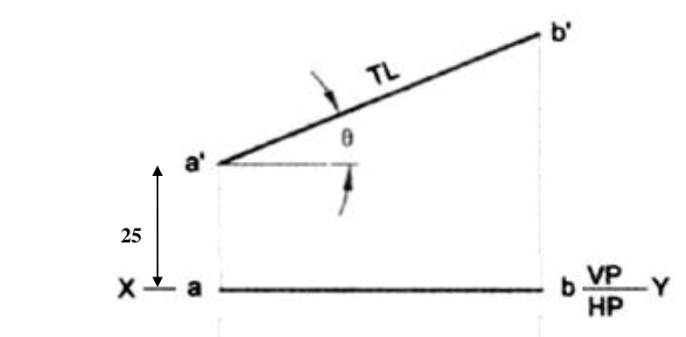  - Lines inclined to both the reference planes.  A 70mm long line AB has an end A at 20mm above H.P and 30mm in front of V.P. The line is inclined at 45 deg to the H.P and 30 deg to V.P, draw the projections.  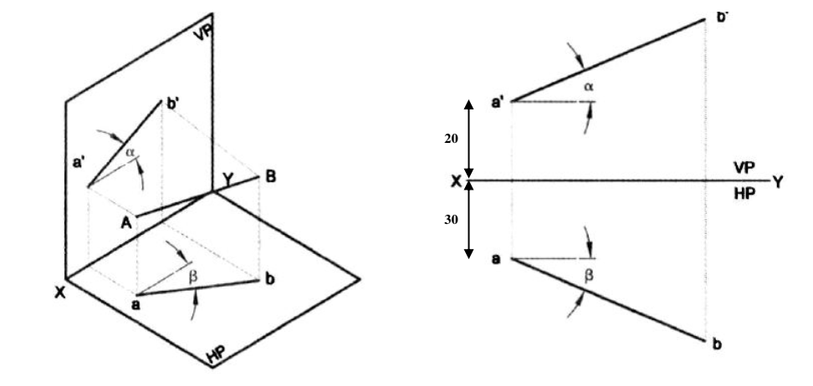  https://www.youtube.com/watch?v=6ycUjo0dMZs&list=PLgwJf8NK-2e5glnKO4gTQCVufyg_Gbx7C&index=2&ab_channel=EngineeringFunda
Projection of lines and finding the true length
- To find the true length of a line that is not parallel to any of the principal planes and to find the angle that the line makes with the FVP
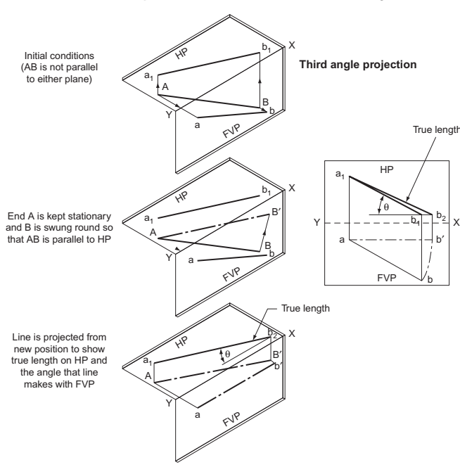
The line is AB. On the FVP it is seen as ab and on the HP as a1b1. One end of the line A is kept stationary whilst B is swung round so that AB is parallel to the HP. B is now at B, and on the FVP, b is now at b. Since the line is parallel to the HP it will project its true length onto the HP. This is shown as a1b2.
Note that b1 and b2 are the same distance from the line XY. Since AB (and ab) are parallel to the HP, the angle that AB makes with the FVP can be measured. This is shown as θ.
- To find the traces of a straight line given the plan and elevation of the line
The line is AB. If the line is produced it will pass through both planes, giving traces T_{v} and T_{h}.
ab is produced to meet the XY line. This intersection is projected down to meet a₁b₁ produced in T_{h}. b₁a₁ is produced to meet the XY line. This intersection is projected up to meet ba produced in T_{v}.
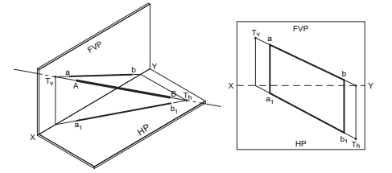

- A line AB, 70mm long, has its end A 15mm above HP and 20mm in front of VP. It is inclined at 30° to HP and 45°to VP. Draw its projections and mark its traces

Solution
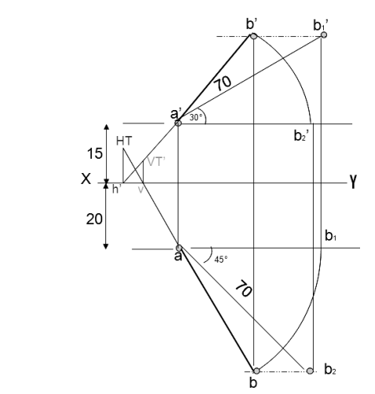
- The top view of a 75mm long line AB measures 65mm, while its front view measures 50mm. Its one end A is in HP and12mm in front of VP. Draw the projections of AB and determine its inclination with HP and VP
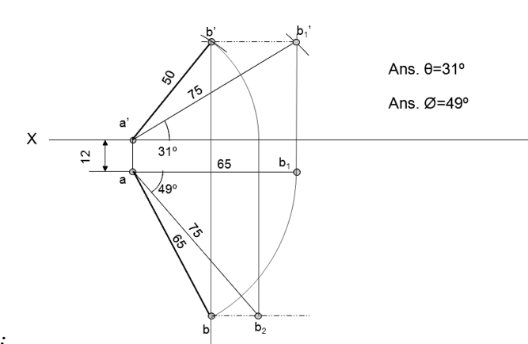
- A line AB, 90mm long, is inclined at 45 to the H.P. and its top view makes an angle of 60 with the V.P. The end A is in the H.P. and 12mm in front of V.P. Draw its front view and finds its true inclination with the V.P.
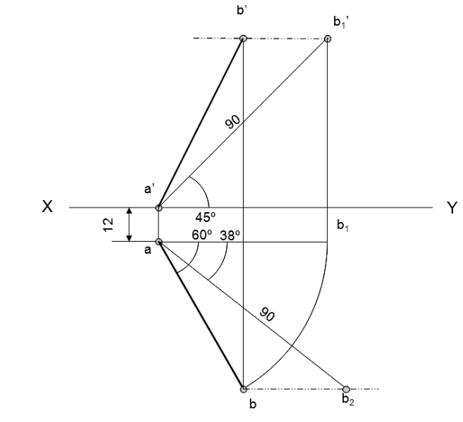

ACTIVITY 7: Learner practice sessions | Draw the orthographic projections of the following points?  (a.) Point P is 30 mm. above H.P and 40 mm. in front of VP  (b.) Point Q is 25 mm. above H.P and 35 mm. behind VP  (c.) Point R is 32 mm. below H.P and 45 mm behind VP  (d.) Point Sis 35 mm. below H.P and 42 mm in front of VP  (e.) Point T is in H.P and 30 mm behind VP  (f.) Point U is in V.P and 40 mm. below HP  (g.) Point V is in V.P and 35 mm. above H.P  (h.) Point W is in H.P and 48 mm. in front of VP
ASSESSMENT OF PRACTICAL SKILL: | You are required to reconstruct the above scenarios and then upload your drawings on the e-portfolio
LEARNING OUTCOME 4: KEY/TRANSFERABLE SKILLS | Morling K. (2010) Geometric and Engineering Drawing,2nd Ed, Butterworth-Heinemann, London ISBN: 978-0-080-96768-4 (hbk); ISBN 13: 978-0-415-53619-6 (pbk) chapter 13
ACTIVITY 8 | Read the materials provided and attempt questions below. Upload your finished work in the wiki portal to allow review by your course mates. You are required to review at least 3 drawings from your course mates
QUIZZ:   | (1) A line PS 65mm has its end P 15mm above the HP and 15mm in front of the VP. It is inclined at 55 deg to the HP and 35 deg to the VP. Draw its projections.  (2) A line CD, inclined at 25deg to the HP, measures 80mm in top view. The end C is in the first quadrant and 25mm and 15mm from the HP and the VP respectively. The end D is at equal distance from the both the reference planes. Draw the projections, fine true length and true inclination with the VP.  (3) A straight line ST has its end S, 10mm in front of the VP and nearer to it. The mid-point M line is 50mm in front of the VP and 40mm above HP. The front and top view measure 90mm and 120mm respectively. Draw the projection of the line. Also find its true length and true inclinations with the HP and VP.  (4) A line PQ has its end P, 10mm above the HP and 20mm in front of the VP. The end Q is 85mm in front of the VP. The front view of the line measures 75mm. the distance between the end projectors is 50mm. Draw the projections of the line and find its true length and its true inclinations with the VP and HP.
TAKE HOME MESSAGE | Learner to state the take home message from their learning experience.
Reference list | Branoff, T. (2015). Interpreting engineering drawings. Cengage Learning.  Giesecke, F. E., Mitchell, A., Spencer, H. C., Hill, I., Dygdon, J., Novak, J., ... & Johnson, L. (2016). Technical drawing with engineering graphics (Vol. 15). Prentice Hall.  Madsen, D. A., & Madsen, D. P. (2016). Engineering drawing and design. Cengage Learning.  Morling K. (2010) Geometric and Engineering Drawing,2nd Ed, Butterworth-Heinemann, London ISBN: 978-0-080-96768-4 (hbk); ISBN 13: 978-0-415-53619-6 (pbk)  Morling, K., & Danjou, S. (2022). Geometric and engineering drawing. Taylor & Francis.

