iiTHE OPEN UNIVERSITY OF KENYA
MODULE TEMPLATE
Programme title | Bachelor of Technology Education
Course title | TED 123 Technical Drawing I
Learning Module number | TED 123-11
Learning module title | FREE HAND SKETCHING
Module Developer | Kinuthia Mugi
Module duration in hours | 8 hrs
Instructional Hour Equivalent (Divide duration by 2) | 3 hrs
Reviewed by
Vision | The Innovative University for Inclusive Prosperity
Audience description | This module is designed for technology students intending to gain a deep understanding of technical drawing for engineering purposes.
Instructions to learners   | Welcome to this module. This is the last module of the first technical drawing Course for the students pursuing Bachelor of Technology Education.  The module contains core reading material references and videos which you are required to read and watch after which, you will have an opportunity to test your understanding of the material through quizzes and assignments. The quizzes and assignments form the basis of progression from one stage of the module to the next. These activities will help you gauge your progress and identify areas where you may need further review.  You will require, drawing instruments such as assorted pencils, drawing board, T-square, compass set, set square set, eraser, A2 drawing paper, internet connectivity, computing device(s), the required plug-in tools for successful completion of this module.
Learning module description | The module provides a brief overview of the freehand sketching in engineering drawing. Although the module is learned last in application it may be the first module, especially when a drafts person is trying to interpret a drawing from a customer.
Module objectives | The module seeks to facilitate learning of:  - The different freehand sketches used in engineering drawing  - Fundamental concepts of freehand drawing  - Construction of freehand drawing  - Application of freehand drawing
Module learning outcomes | By the end of the module, you should be able to:  - To identify and describe different types of freehand sketches and tools  - Comprehend the fundamental concepts of freehand drawing  - Construct freehand drawings of engineering shapes  - Apply the learned freehand drawing skills in the context of engineering drawing
Planned Learning Resources | Drawing board Assorted pencils, eraser, A2 drawing paper, isometric grid paper
ACTIVITY 1: INTRODUCTION  VIDEO 1: Pre-recorded lecture on topic emphasizing LEARNING OUTCOME 1:  Factual knowledge.   | Introduction to Freehand sketching  The ability to sketch neatly and accurately is one of the most useful attributes that a draughtsperson can have. Freehand drawing is done on many occasions: to explain a piece of design quickly to a colleague; to develop a design; and even to draw a map showing someone how to get from one place to another.  Technical sketching is a disciplined form of art. Objects must be drawn exactly as they are seen, not as one would like to see them. Neat, accurate sketches are only achieved after plenty of practice, but there are some guiding rules. Most engineering components have outlines composed of straight lines, circles and circular arcs: if you can sketch these accurately, you are halfway towards producing good sketches. You may find the method illustrated below helpful. When drawing straight lines, as on the left, rest the weight of your hand on the backs of your fingers. When drawing curved lines, as on the right, rest the weight on that part of your hand between the knuckle of your little finger and your wrist. This provides a pivot about which to swing your pencil. Always keep your hand on the inside of the curve, even if it means moving the paper around.  Sketching or freehand is a first step to the preparation of a scale-drawing, i.e., a drawing drawn with the aid of instruments. A designer records his ideas initially in the form of sketches which are later converted into drawings. Similarly, views of actual objects are in the first instance, sketched freehand. Scale-drawings are then prepared from these sketches. Ideas and objects can be described in words, but the description is made more expressive with the aid of sketches. Thus sketching is of great importance in engineering practice. Sketching is always done freehand. It is in fact a freehand drawing made in correct proportions, but not to scale. A sketch should be so prepared as to give to others a clear idea, complete information and true impression of the object to be constructed. It should never be drawn too small. The size of a sketch should be such that all the features of the object, together with their dimensions, explanatory notes etc. are clearly incorporated in it. Proficiency in sketching can be achieved with constant practice only.  Designer: Create a video based on the script below  Video Script: Introduction to Freehand Sketching in Engineering Drawing]  [Opening Scene: A close-up shot of a pencil drawing smooth, flowing lines on a blank sheet of paper. The camera then zooms out to reveal an engineer's drafting table with various drafting tools and a computer screen displaying an engineering software interface.]  Narrator (Voiceover):  "Welcome to our video tutorial on freehand sketching in engineering drawing! As engineers, we often need to communicate our ideas and designs visually, and freehand sketching is an essential skill for this purpose. In this video, we will explore the basics of freehand sketching and its importance in engineering drawing."  [Cut to the host, an experienced engineer, standing in front of a whiteboard with a marker in hand.]  Host:  "Hello, and thank you for joining us today. Freehand sketching is a valuable tool in the field of engineering, allowing us to quickly and efficiently communicate ideas, concepts, and designs. Whether it's brainstorming ideas, creating concept sketches, or communicating design changes, freehand sketching is a versatile skill that every engineer should have in their toolkit. Let's dive in and learn more about it!"  [Cut to a sequence of animated visuals illustrating the benefits of freehand sketching, including brainstorming, concept development, and design iteration.]  Narrator (Voiceover):  "Freehand sketching provides numerous benefits in engineering drawing. It allows engineers to quickly generate ideas and concepts, explore different design options, and make design iterations in a flexible and efficient manner. Freehand sketches are also a useful communication tool, enabling engineers to effectively convey their ideas to clients, colleagues, and manufacturers. Moreover, freehand sketching encourages creativity, fosters problem-solving skills, and enhances spatial visualization abilities, which are critical in the field of engineering."  [Cut back to the host, who is now holding a pencil and a blank sheet of paper.]  Host:  "Now, let's talk about the basics of freehand sketching. The first step is to choose the right tools. Typically, you will need a pencil, eraser, and paper. You can also use markers or pens depending on your preference. The key is to select tools that are comfortable for you to use and allow you to create smooth lines and curves."  [The host begins to demonstrate basic freehand sketching techniques, such as straight lines, curves, and shading, on the blank sheet of paper.]  Host:  "Next, let's talk about some fundamental techniques for freehand sketching. Start with light, loose strokes, and gradually build up the lines as you gain confidence. Use your whole arm to create smooth and flowing lines, and try to keep your sketches proportional and neat. Experiment with different pencil pressures to create various line weights and use shading techniques to add depth and dimension to your sketches."  [Cut to a sequence of examples showing different types of engineering drawings, such as isometric, orthographic, and perspective views, and how freehand sketching can be used to create them.]  Narrator (Voiceover):  "Freehand sketching can be used to create a wide range of engineering drawings, including isometric, orthographic, and perspective views. By mastering different techniques, such as constructing geometric shapes, creating projections, and using vanishing points, you can create accurate and professional-looking sketches that effectively convey your design ideas."  [Cut back to the host, who is now holding a finished freehand sketch of an engineering part.]  Host:  "Finally, it's important to practice and refine your freehand sketching skills regularly. The more you practice, the better you will become at visualizing and expressing your ideas through sketches. So, grab your pencil, paper, and start sketching!"  [Closing Scene: The host smiles at the camera, holding up
Functions of Freehand sketching
- Transferring information, obtained in the field or shop, to the engineering office.
- Conveying the ideas of the designer to the draftsman.
- Making studies of the layout of the views required in an instrumental drawing.
- A means of making preliminary studies of a design to show how it functions.
- Furnishing a three-dimensional picture of an object; this will help to interpret the orthographic views.
ACTIVITY 2: READING  READING MATERIAL 1  ( | Morling, K., & Danjou, S. (2022). Geometric and engineering drawing. Taylor & Francis.
ACTIVITY 3: Comprehension questions:   | Draw sketches of the following items and upload your sketches on your e-portfolio  - A house  - A car  - A table
LEARNING OUTCOME 2: Conceptual knowledge  ACTIVITY 4: Video to be used. | Fundamentals of sketching  The chief difference between an instrumental drawing and a freehand sketching lies in the characteristics of the technique of the lines. A good freehand line should not be rigidly straight or exactly uniform, as an instrumental line. The effectiveness of an instrumental line lies in exacting uniformity, while the quality of freehand lines lies in its freedom and variety.  Good sketches constitute the following techniques:  - When sketching hold the pencil loosely and at a greater distance from the pencil point than in normal writing. This distance may range from about 3 to 5cm. Eye-hand coordination and muscle control are important and come with practice.  - During sketching short lines, use finger movement keeping the wrist stationary.  - When sketching longer lines, use less finger action with a stiffer arm movement  - Whenever possible sketch lines in a direction away from the body.  - As you sketch, rotate the pencil slightly between the thumb and fingers. This helps to preserve the sharpness of the pencil point and to make uniformly thick lines.  - Because more freedom of movement is necessary when sketching, avoid fastening the paper to the working surface. The paper should be free to move across the working surface as the sketch is developed.  - Final lines on sketches should be bold, dark, and clean-cut.  - Straight lines should be drawn with minimum waviness. When sketching, avoid using ragged, overlapping strokes.  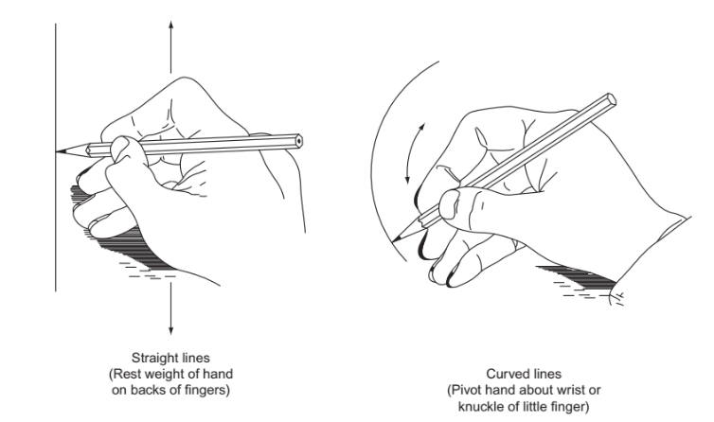  https://www.youtube.com/watch?v=WJkkpN7TZt0&ab_channel=ArtLessonsOnline  https://www.youtube.com/watch?v=GuULwiz_mKU&ab_channel=Bembli  https://www.youtube.com/watch?v=Ess0dmJB2lo&t=2587s&ab_channel=1stYearEngineeringDrawing  Sketching lines  - Straight lines  The following steps are recommended for sketching straight line:  Step 1: Mark the end points  Step 2: Make a few trial motions between the marked points to adjust the eye and hand to the contemplated line.  Step 3: Sketch a very light line between the points by moving the pencil in two or three sweeps. When sketching the trial line, the eye should be on the point toward which the movement is directed.  Step 4: Darken the finished line, keeping the eye on the pencil point on the trial line. The final line, replacing the trial line, should be distinct, black, uniform, and straight.  Sketching curves lines  Circles can be sketched by using light guidelines along with centerlines. Since it is difficult to draw a freehand circle in one continuous line, short arcs are drawn using the guidelines.  The recommended steps to draw circles are given below.  Small sizes lip to 25 mm diameters  Step 1: Sketch a center line by drawing a horizontal and a vertical line that intersect at the center of the desired circle. Estimate and mark off the  radius distance from the centerpoint on each side of the centerline as shown below  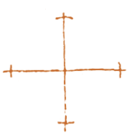  Step 2: Sketch one quarter of the circle lightly and then sketch  the other quarter of the circle as shown in the diagrams below  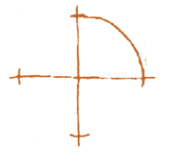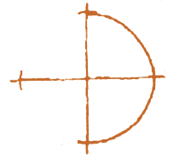  Step 3: Sketch the other half of the circles in the same manner.  Darken the finale circle and change the light horizontal and vertical construction lines intersecting at the center of the circle into centerlines as shown  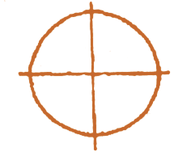  Pictorial Sketching  Although drawing is a continuous process, the work can be divided into three basic stages.  Stage 1: Construction  This should be done with a hard pencil (6H), used lightly, and the strokes with the pencil should be rapid. Slow movements produce wavy, uncertain lines. Since these constructed lines are very faint, errors can easily be erased.  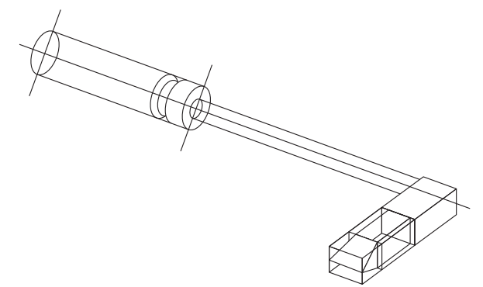  Stage 2: Lining in  Carefully line in with a soft pencil (HB), following the construction lines drawn in stage 1. The completion of stage 2 should give a drawing that shows all the details and you may decide, particularly in an examination, not to proceed to stage 3.  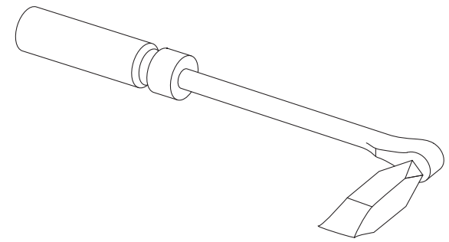  Shading brings a drawing to life. It is not necessary on most sketches, and in some cases it may tend to hide details that need to be seen. If the drawings are to be displayed, however, some shading should certainly be done.  Shading is done with a soft pencil (HB). It is very easy to overshade, so be careful. For the smooth merging of shading, the dry tip of a finger can be gently rubbed over the area  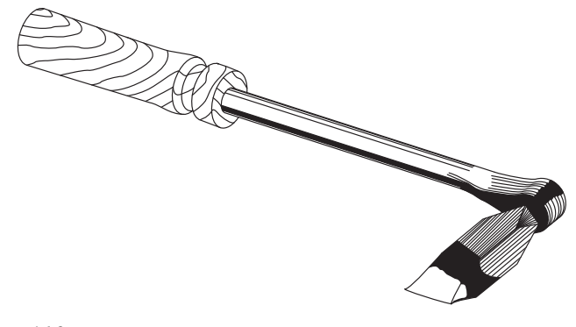  https://www.youtube.com/watch?v=SAOvF-wPAlM&ab_channel=TTAD%26T  Drawing Borderlines  Border lines are a combination of vertical and horizontal lines. Therefore, they can be sketched in the manner discussed before  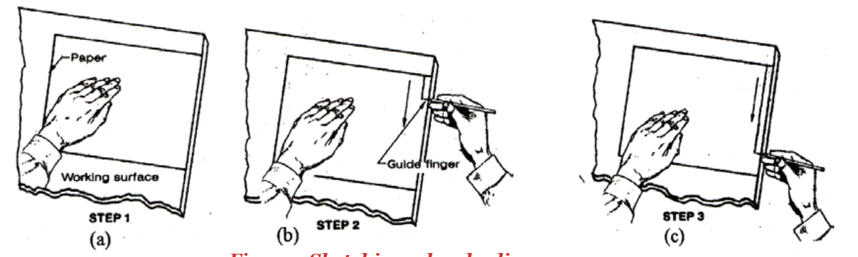
ACTIVITY 5: READING MATERIAL | Morling, K., & Danjou, S. (2022). Geometric and engineering drawing. Taylor & Francis.
ACTIVITY 6: ONLINE DISCUSSION   | Activities based on reading Material 5.  Use chats, discussion forum, question/answer, message my teacher to engage others.  Show how participation will be assessed.
LEARNING OUTCOME 3: PRACTICAL SKILLS  VIDEO 3:  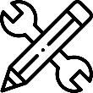. | 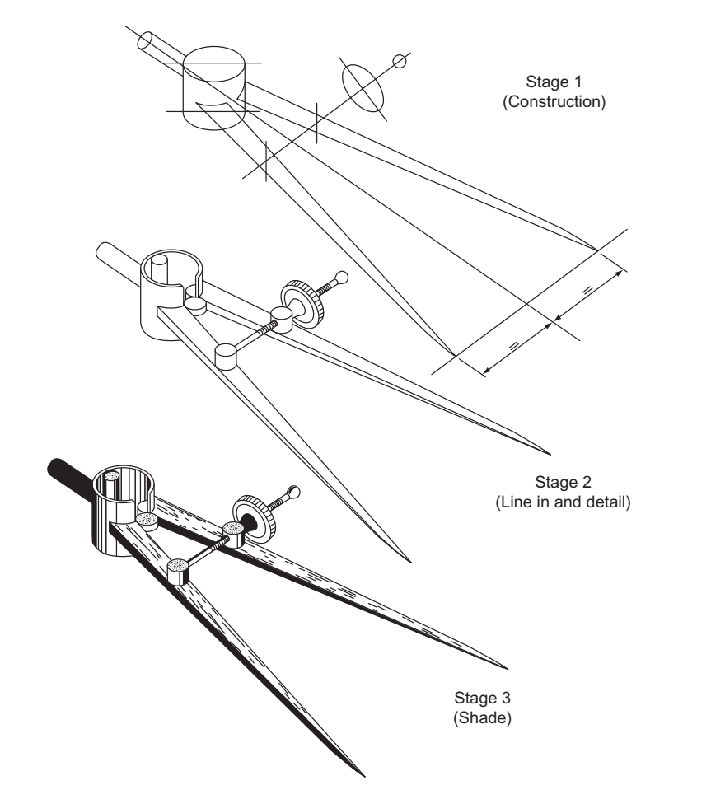  Draw the above drawing of a divider following steps illustrated earlier and upload your drawing in the assignment wiki for reviews by your course mates.
ACTIVITY 7: Learner practice sessions | Using the freehand sketching skills gained draw the figure below in freehand and isometric and upload it in your e-portfolio.  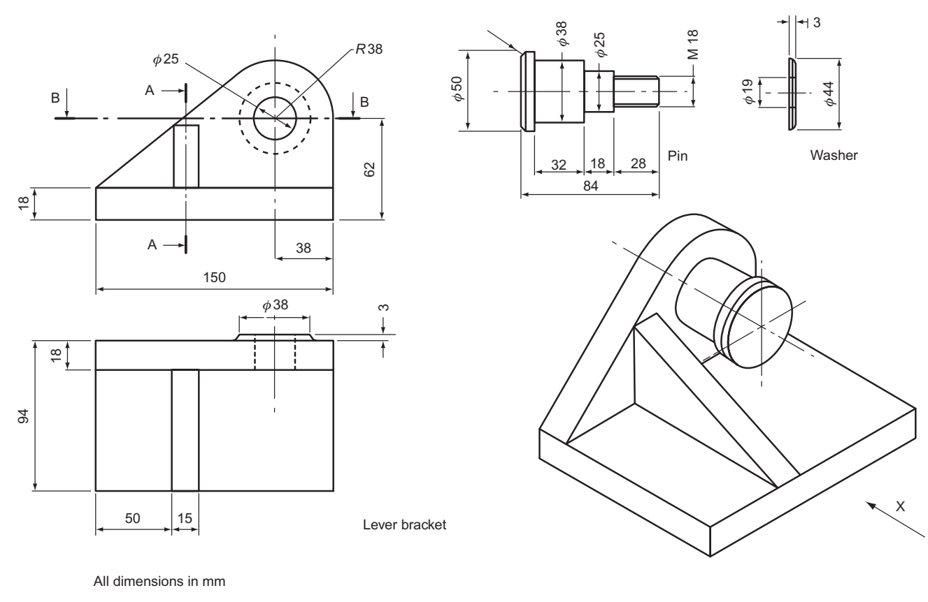
ASSESSMENT OF PRACTICAL SKILL: | Access the e-portfolios of your classmates and comment on 3 drawings from your course mates for you to proceed to the next step of your study
LEARNING OUTCOME 4: KEY/TRANSFERABLE SKILLS | The learner to have a wiki discussion with course mates on the advantages and disadvantages of free hand sketching in comparison with the instrumental drawing.  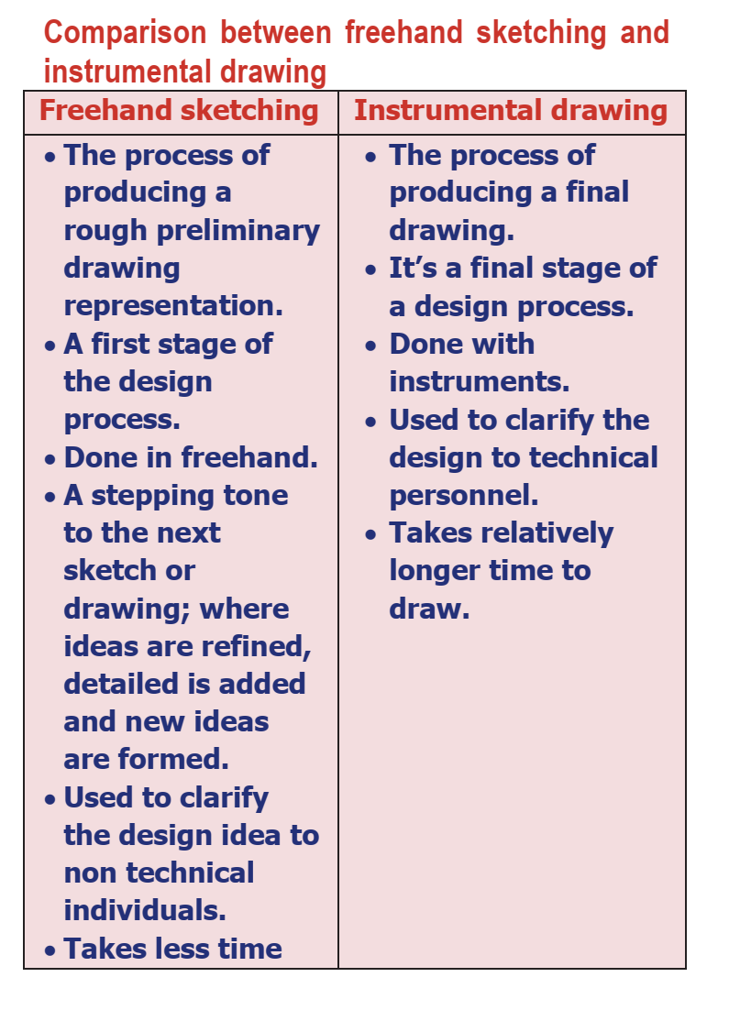
ACTIVITY 8 | Draw the camera drawing below and upload you drawing in the e-portfolio  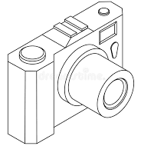
QUIZZ:   | Sure, here are some multiple choice questions with answers on freehand sketching:  What is freehand sketching?  A. Sketching with a pencil  B. Sketching with a ruler  C. Sketching without any tools or aids  D. Sketching using a compass  Answer: C  Which of the following is an advantage of freehand sketching?  A. Precise measurements can be made  B. It takes less time than other methods  C. It allows for greater creativity and expression  D. It produces cleaner lines than other methods  Answer: C  Which of the following is a common use for freehand sketching?  A. To create technical drawings  B. To produce digital art  C. To plan a garden layout  D. To design a building's electrical system  Answer: C  What is the purpose of using light lines in freehand sketching?  A. To indicate areas that need to be erased  B. To emphasize important features of the sketch  C. To help guide the placement of final lines  D. To create shading and depth in the sketch  Answer: C  Which of the following is a technique commonly used in freehand sketching?  A. Cross-hatching  B. Stippling  C. Blending  D. Masking  Answer: A  Which of the following is a characteristic of a good freehand sketch?  A. Perfect symmetry  B. Precise measurements  C. Accurate perspective  D. Creativity and expression  Answer: D  Which of the following is a common mistake to avoid when freehand sketching?  A. Using too much pressure on the pencil  B. Using a ruler or other tools  C. Erasing mistakes immediately  D. Rushing through the sketch  Answer: D  What is the purpose of sketching lightly at first when freehand sketching?  A. To make the sketch more accurate  B. To create depth and shading  C. To guide the placement of final lines  D. To create an overall impression of the subject  Answer: C  Which of the following is an important skill to develop for freehand sketching?  A. Color theory  B. Perspective drawing  C. Digital software proficiency  D. 3D modeling  Answer: B  Which of the following is a benefit of practicing freehand sketching regularly?  A. Increased speed and efficiency  B. More precise lines and measurements  C. Improved creativity and expression  D. Enhanced ability to use digital tools  Answer: C
TAKE HOME MESSAGE | Learner to state the take home message from their learning experience.
Reference list | Branoff, T. (2015). Interpreting engineering drawings. Cengage Learning.  Giesecke, F. E., Mitchell, A., Spencer, H. C., Hill, I., Dygdon, J., Novak, J., ... & Johnson, L. (2016). Technical drawing with engineering graphics (Vol. 15). Prentice Hall.  Madsen, D. A., & Madsen, D. P. (2016). Engineering drawing and design. Cengage Learning.  Morling K. (2010) Geometric and Engineering Drawing,2nd Ed, Butterworth-Heinemann, London ISBN: 978-0-080-96768-4 (hbk); ISBN 13: 978-0-415-53619-6 (pbk)  Morling, K., & Danjou, S. (2022). Geometric and engineering drawing. Taylor & Francis.

