THE OPEN UNIVERSITY OF KENYA

DESIGN PLAN

The Design Plan presented below reflects the CUE suggested Plan but goes beyond that to specify how each outcome will be handled. All modules are based on this Design Plan.
Note: The principle of constructive alignment informs this Design Plan.

Programme title | COMMON COURSE
Course title | PHL 111: INTRODUCTION TO PHILOSOPHY AND CRITICAL THINKING
Learning Module number | #3
Learning module title | Development of Human Thought (History of Philosophy)
Module Developer | Musi Philip N.
Module duration in hours | 8 hours
Instructional Hour Equivalent (Divide duration by 2) | 3 hours
Reviewed by
Vision | The innovative university for inclusive prosperity
Audience description | Prepared for learners who have joined the Open University of Kenya to pursue various degree courses. These are candidates being prepared for leadership roles in various sectors of the global community. Thus the program is for holistically nurturing thinkers, doers and leaders for the globe at large.
Instructions to learners   | Welcome to the third module in the Introduction to Philosophy and Critical Thinking Course. In this module, we will learn about the historical development of human thought, which is also called the History of Philosophy. Attend to all the assignments, tasks and activities. All the module activities will be graded.
Learning module description | Development of human Thought from the earliest recorded times of human existence. They are divided into four periods: Ancient, Medieval, Modern and Contemporary. Leading ideas and personalities of these epochs will be discussed in brief.
Module objectives: | In this course you will be expected to learn about:  1.The epochs of the development of Human Thought  2. Leading ideas and personalities in the various epoch  3. Interaction of ideas of different epochs  4. Relevance of the history of development of human thought
Module learning outcomes: | By the end of this course, you should be able to:  1. Outline the epochs of the development of Human Thought  2. Explain the leading ideas and personalities in the various epoch  3. Compare of ideas of different epochs  4. elaborate the relevance of the history of development of human thought
Planned Learning Resources
ACTIVITY 1: INTRODUCTION  VIDEO 1: Pre-recorded lecture on topic emphasizing LEARNING OUTCOME 1:  Factual knowledge.   | DEVELOPMENT OF HUMAN THOUGHT.  The development of human thought is conceptualized into for epochs:  - Ancient period (7th century B.C. to 5th century A.D.)  - Medieval period (500 to 1500)  - Modern period (16th to 19th centuries)  - Postmodern or Contemporary period (20th century to present)  Logocentrism?  Anthropocentrism  Cosmocentrism  Theocentrism  Logocentrism?  Philosophy is perhaps the most “open” of all subjects, since no question or point of view is off limits.  The history of philosophy has been described as “the history of heresy,” since it challenges us to question even our most cherished beliefs.  As one famous philosopher put it, “I do not know how to teach philosophy without becoming a disturber of the peace.” – Baruch Spinoza  .  ANCIENT Thought  Marked by the departure from myth to reason. They were daring and some of their thoughts bizarre.  Sparked of by wonder about nature (cosmos) and offering a rational response to the wonder/curiosity. Their thoughts are regarded as cosmocentric.  What’s the ultimate composition of things/nature?  Addressed three basic concerns:  - Problem of one and many  - Problem of change and permanence  - Relativism  In addressing these issues, they explored virtually any explanation of things that seemed reasonable, and because of this there is a richness and diversity to their views that we have not since seen.  Thales – Water,  Anaximander – the Boundless  Anaximenes – Fire  Pythagoras – Numbers  - Heraclitus – flux/change concept (change is the only constant)  - Parmenides – Change is an illusion (Zeno’s paradoxes)  - Sophists – Protagoras – ‘Man is the measure of all things’ – relativism  Gorgias- Denied existence of reality… cannot know, communicate  - Socrates – Universality of virtue, self-examination, ethical intellectualism  - Plato’s Dualism – The World of Ideas/Form. The world of Shadows (Opinion)  - Aristotle: Act and Potency; In respect to being as being, its perfection is that it is or exists; The limitation is that, it is this or that type of being  - They were not bound by tradition (myths)  - They were constantly in touch with science and speculation to explain phenomenon (reason)  - They were open to intellectual innovation and speculation (critical thinkers)  MEDIEVAL Thought  The origin of medieval thought lies in the period of early Christianity.  The identifier of medieval thought was its close relationship with Christianity. Christianity became the dominant worldview in Western Europe at that period of history  Through the relation "God - man" addressed the structure of the world, man's place, and the system of moral values. Therefore, medieval thought had theocentric character (the Greek word - theos - God)  The main function of medieval thought was justification of religious precepts. According to many historians, the philosophy of the period turned into a “servant of theology” There were two main periods in the development of medieval thought in Europe: the patristic and scholastic  Patristics (Latin word “pater” – “father”) - a set of theological and philosophical doctrines of Christian thinkers of 2nd - 8th centuries  Scholastics (Latin word “scholastica” – “school”, “scholar”) defines a central role in the justification of the theological philosophy of dogmas (9th-12th centuries)  Opposing positions to patristicism and scholasticism appeared in realism and nominalism. At the heart of these conflicts was the confrontation of faith and knowledge.  Medieval philosophy was characterized by:  - Providence - The method of examination of historical events from the point of view of providence and salvation of man  - Creationism (from lat. creatio - race, creationis - creation) - The concept of creation of the world by God from "nothing" within a limited period of time  - Traditionalism - This is the concept of the superiority of tradition over mind. This concept is closed to conservatism.  St. Augustine (354-430)  The prominent thinker of MA. His ideas have determined the further development of European thought. He was born in North Africa, in the Roman province. He received an excellent education. He creatively developed the ideas of Plato and Neo-Platonists.  The philosopher focused on issues of God and the world, life and times, faith and reason, truth, and knowledge of good and evil. The main direction of the teachings of Augustine was the relation of God and the world. This attitude is characterized as creationism, it recognized of the creation of the world by God from "nothing" in a limited period of time. Augustine denies the presence of any "material", "building bricks" to create the world.  Thomas Aquinas (1225-1274)  He’s leading and influential thinker of medieval Western Europe. After his death he was canonized to the saints Thomas Aquinas was the author of numerous works. His basic work was "Summa Theological" (1273). He formed ethical doctrine of Catholicism. Its main purpose, as Augustine, was the contemplation of God and preparing for the afterlife.  Moral and practical human actions are determined by the mind through the choice between good and evil. Thus emphasizes human responsibility for their actions and activities.  State, according to Thomas Aquinas, was to prepare its members to comprehend the sacred truths of heavenly life. Civil society must be subordinated to the church and state. God's representative on earth is the Pope. The teaching of Thomas Aquinas became the official philosophy of the Roman Catholic Church.  MODERN Thought (MT)  - “Moderna” means “new” and “now”. Modern is a temporal orientation to ‘here and now’ [not ‘there and past” of the medieval mentality]  - The term relates to the concept of time: linear progress  - Key concepts of the modernity: “technological progress”, “revolution”, “economic growth”  Renaissance and Humanism: Ultimate paradigm shift  Main characteristics of MT  1. Centers on the problem of consciousness or subjectivity [contrary to theocentrism]  2. Radicalization of the epistemological concept of critique [contrary to dogmatism]  3. Teleological Concept of historical progress of mankind [contrary to status quo]  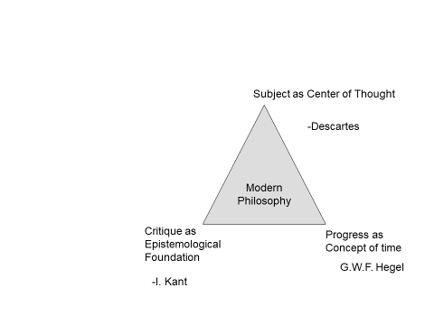  Critique is a means of the processes of emancipation; it functions as:  1. Self-reflection of knowledge (critique of knowledge or epistemology)  2. Barrier breaker of ideological manipulations (critique of ideology or enlightenment)  3. Struggle against political injustice (critique of regime or revolution)  Note: Critique isn’t a mere refusal against something, but a reasonable negation with a complex epistemological conditions. It originates during the rise of modern natural sciences those are very skeptical against the medieval metaphysical thought. Critique is an advocate of the factual.  The mainstreams of Modern Thought are:  - Humanism (Machiavelli)  - Rationalism (Descartes, Spinoza, Leibniz, Malebranche, Pascal)  - Empiricism (Hobbes, Locke, Berkeley, Hume)  - Criticism (Kant)  - Idealism (Fichte, Schelling, Hegel, Schoppenhauer)  - Materialism (Feuerbach, Marx)  - Positivism (Comte, Mach)  - Existentialism (Kierkegaard and Nietzsche)  - Pragmatism (William James, Charles S P.,  CONTEMPORARY Thought  It’s the current era of philosophy, generally dealing with thinkers from the late 19th century through to the 21st. the main characteristic of Contemporary thought was analysis., especially of language.  There are two main traditions of Contemporary philosophy: Analytic philosophy and Continental philosophy.  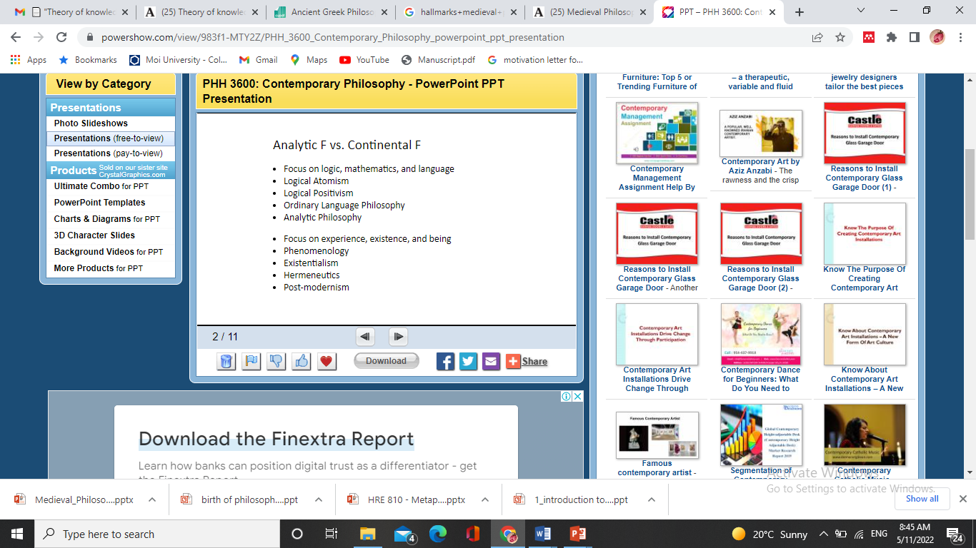  A short video should be provided to support the lecture content.
ACTIVITY 2: READING  READING MATERIAL 1  ( | Read the notes provided in Activity 1 above an make your own short notes on the various epochs of the development of Human Thought
ACTIVITY 3: Comprehension questions:   | Questions are based on the lecture and reading material.  - State the epochs into which the development of human thought is divided into.  - Briefly illustrate how human thought developed from relying on myth for explanation of reality to reason.  - State the main features/characteristics of each epoch  - state how earlier epochs influenced subsequent ones  - Name influential personalities from each of the epochs whose ideas impressed you.
LEARNING OUTCOME 2: Conceptual knowledge  ACTIVITY 4: Video to be used. | Learner is required to use factual knowledge acquired to answer question “Why”?  The technical team to provide a video about an explanation of the origins of a given ethnic community.  Watch the video provided and answer the following questions in your e-portfolio:  - Which aspects of the story are mythical and why?  - If the selected community if not yours, does the story have any commonality with one that you know? How?  - Are such explanations of the origin of things satisfactory? Explain your answer.
CASE 1:   | Describe case here.  The myth of the origin a selected community in Activity 4 above is our Case in this module.
ACTIVITY 5: READING MATERIAL | Kenny, A. (2018). An Illustrated Brief History of Western Philosophy, 20th Anniversary Edition. United Kingdom: Wiley.  Read the introduction section of the above book and make short notes in your blog about the main ideas in each epoch.
ACTIVITY 6: ONLINE DISCUSSION   | Activities based on reading Material 5.  Post on the group discussion group one leading personality in each epoch and their ideas. This post will form part of your formative assessment.
LEARNING OUTCOME 3: PRACTICAL SKILLS  VIDEO 3:  . | Show video which displays practical use of knowledge acquired.  https://www.youtube.com/watch?v=GMDvkuXsi4E video showing History of Philosophy  Watch the video and write in your e-portfolio how your area of specialization stemmed from Sphilosophy. Briefly indicate how the history of philosophy is relevant to your area of study.
ACTIVITY 7: Learner practice sessions | Prepare a short video of about 7-10 mins on your understanding of the development of human though. Do this on your Zoom or Google meet videos and post it on your e-portfolio
ASSESSMENT OF PRACTICAL SKILL: | Learner records practiced skill and uploads video on E-Portfolio  OR  As directed in Activity 7 above.
LEARNING OUTCOME 4: KEY/TRANSFERABLE SKILLS | Comprehensive History of Philosophy in infographics  https://visual.ly/community/infographic/education/comprehensive-history-philosophy  Look for and scan through the above infographic of the history of Philosophy. The material will help you visualize the relationship between ideas of different epochs and the personalities involved.
ACTIVITY 8 | Choose one idea, say politics, and draw a concept map of how it developed from Ancient times to date. Post the same on the e-portfolio
QUIZZ:   | Respond to the following short questions in wiki:  - Name the philosophers of the Early Greek period and the years they lived  - Mention the reason Modern philosophy became popular  - What was the undoing of Medieval period?  - Give names of five philosopher of the contemporary period.
TAKE HOME MESSAGE | What’s the most interesting thing that this module has introduced you to. Post your response in the group chats..
Reference list | Grayling, A. C. (2019). The history of philosophy. Penguin UK.  Kenny, A. (2018). An Illustrated Brief History of Western Philosophy, 20th Anniversary Edition. United Kingdom: Wiley.  Comprehensive History of Philosophy in infographics  https://visual.ly/community/infographic/education/comprehensive-history-philosophy  Russell, B. (1967). A history of western philosophy. United Kingdom: Touchstone.  https://www.google.com/books/edition/_/l_LK3VeG55oC?hl=en&sa=X&ved=2ahUKEwim2oeWp63-AhVEOHoKHaJQAZsQ8fIDegUIMRCqAQ

