THE OPEN UNIVERSITY OF KENYA
MODULE TEMPLATE
Programme title | Bachelor of Technology Education
Course title | TED 123 Technical Drawing I
Learning Module number | TED 123-06
Learning module title | ISOMETRIC, OBLIQUE AND PERSPECTIVE DRAWINGS
Module Developer | Kinuthia Mugi
Module duration in hours | 8 hrs
Instructional Hour Equivalent (Divide duration by 2) | 4 hrs
Reviewed by
Vision | The Innovative University for Inclusive Prosperity
Audience description | This module is designed for technology students intending to gain a deep understanding of technical drawing for engineering purposes.
Instructions to learners   | Welcome to the module  This is a very interesting module for Bachelor of Technology students. In order for you to benefit from this module, you should dedicate sufficient time to study and complete the course materials.  You should participate actively in all aspects of the module, including discussions and assignments. There will be tutorials organized during the module engagement.  Keep on checking in the LMS for the announcement section and on the LMS dashboard.  The live session will be made available in the recorded session folder you are also expected to review the learning objectives and outcomes before beginning the module.  You are expected to engage in all activities as they are presented to achieve the intended learning outcomes.  You will require, drawing instruments such as assorted pencils, drawing board, T-square, compass set, set square set, eraser, A2 drawing paper, internet connectivity, computing device(s), the required plug-in tools for successful completion of this module.
Learning module description | The module introduced the learner isometric drawing
Module objectives | The module seeks to facilitate learning of:  - Rules of and principles of isometric drawing  - Concepts of isometric drawing  - Construction of isometric drawing  - Application of isometric drawing in engineering drawing
Module learning outcomes | By the end of the module the you should be able to:  - Describe the rules of isometric drawing  - Explain the concepts of isometric drawing  - Construct isometric drawings  - Apply isometric drawings rules to come up with accurate isometric drawings
Planned Learning Resources | Drawing board Assorted pencils, T-square, compass set, set square set, eraser, A2 drawing paper, masking tape, paper clips, Engineering drawing Drafter, Roll and draw Scale and protractor
ACTIVITY 1: INTRODUCTION  VIDEO 1: Pre-recorded lecture on topic emphasizing LEARNING OUTCOME 1:  Factual knowledge.   | Designer: Create a video based on the script below  Video Script: Introduction to Freehand Sketching in Engineering Drawing]  [Opening Scene: A close-up shot of a pencil drawing smooth, flowing lines on a blank sheet of paper. The camera then zooms out to reveal an engineer's drafting table with various drafting tools and a computer screen displaying an engineering software interface.]  Narrator (Voiceover):  "Welcome to our video tutorial on freehand sketching in engineering drawing! As engineers, we often need to communicate our ideas and designs visually, and freehand sketching is an essential skill for this purpose. In this video, we will explore the basics of freehand sketching and its importance in engineering drawing."  [Cut to the host, an experienced engineer, standing in front of a whiteboard with a marker in hand.]  Host:  "Hello, and thank you for joining us today. Freehand sketching is a valuable tool in the field of engineering, allowing us to quickly and efficiently communicate ideas, concepts, and designs. Whether it's brainstorming ideas, creating concept sketches, or communicating design changes, freehand sketching is a versatile skill that every engineer should have in their toolkit. Let's dive in and learn more about it!"  [Cut to a sequence of animated visuals illustrating the benefits of freehand sketching, including brainstorming, concept development, and design iteration.]  Narrator (Voiceover):  "Freehand sketching provides numerous benefits in engineering drawing. It allows engineers to quickly generate ideas and concepts, explore different design options, and make design iterations in a flexible and efficient manner. Freehand sketches are also a useful communication tool, enabling engineers to effectively convey their ideas to clients, colleagues, and manufacturers. Moreover, freehand sketching encourages creativity, fosters problem-solving skills, and enhances spatial visualization abilities, which are critical in the field of engineering."  [Cut back to the host, who is now holding a pencil and a blank sheet of paper.]  Host:  "Now, let's talk about the basics of freehand sketching. The first step is to choose the right tools. Typically, you will need a pencil, eraser, and paper. You can also use markers or pens depending on your preference. The key is to select tools that are comfortable for you to use and allow you to create smooth lines and curves."  [The host begins to demonstrate basic freehand sketching techniques, such as straight lines, curves, and shading, on the blank sheet of paper.]  Host:  "Next, let's talk about some fundamental techniques for freehand sketching. Start with light, loose strokes, and gradually build up the lines as you gain confidence. Use your whole arm to create smooth and flowing lines, and try to keep your sketches proportional and neat. Experiment with different pencil pressures to create various line weights and use shading techniques to add depth and dimension to your sketches."  [Cut to a sequence of examples showing different types of engineering drawings, such as isometric, orthographic, and perspective views, and how freehand sketching can be used to create them.]  Narrator (Voiceover):  "Freehand sketching can be used to create a wide range of engineering drawings, including isometric, orthographic, and perspective views. By mastering different techniques, such as constructing geometric shapes, creating projections, and using vanishing points, you can create accurate and professional-looking sketches that effectively convey your design ideas."  [Cut back to the host, who is now holding a finished freehand sketch of an engineering part.]  Host:  "Finally, it's important to practice and refine your freehand sketching skills regularly. The more you practice, the better you will become at visualizing and expressing your ideas through sketches. So, grab your pencil, paper, and start sketching!"  [Closing Scene: The host smiles at the camera, holding up
ACTIVITY 2: READING  READING MATERIAL 1  ( | Learners engage in self-directed learning of an article, a book chapter or whatever other material assigned.
ACTIVITY 3: Comprehension questions:   | Questions are based on the lecture and reading material.  1  2  3  4  5
LEARNING OUTCOME 2: Conceptual knowledge  ACTIVITY 4: Video to be used. | Learner is required to use factual knowledge acquired to answer question “Why”?  The Case Method, (E-Case or written case) role play or any other visual aid to be used. An E-Case of a situation for the learner to solve possible problems using facts acquired.  Learners will engage in online discussion either live or on forum to answer ‘Why’ questions.
CASE 1:   | Describe case here.
ACTIVITY 5: READING MATERIAL | Material to reinforce the Learning Outcome 2  Learner writes blog. Others respond
ACTIVITY 6: ONLINE DISCUSSION   | Activities based on reading Material 5.  Use chats, discussion forum, question/answer, message my teacher to engage others.  Show how participation will be assessed.
LEARNING OUTCOME 3: PRACTICAL SKILLS  VIDEO 3:  . | Show video which displays practical use of knowledge acquired.
ACTIVITY 7: Learner practice sessions | Learner practices the learnt skills. Learner to be given task to demonstrate mastery of the skill.
ASSESSMENT OF PRACTICAL SKILL: | Learner records practiced skill and uploads video on E-Portfolio  OR  Learner engages in original creative /design activity to demonstrate practical application of knowledge.  Assessment of tasks described.
LEARNING OUTCOME 4: KEY/TRANSFERABLE SKILLS | Provide reading material which emphasizes reinforcement of topic learnt. How to communicate or share acquired knowledge
ACTIVITY 8 | Learner to engage in communication, collaboration, problem solving, research, leadership activities. Examples, preparation of a poster to communicate new knowledge acquired, written essay, debate, audio recording …etc.
QUIZZ:   | Short questions to put knowledge to the test.  Make it game like  Challenge learners  Questions of MCQ, T/F, short answer questions etc.
TAKE HOME MESSAGE | Learner to state the take home message from their learning experience.
Reference list
Reference list | Branoff, T. (2015). Interpreting engineering drawings. Cengage Learning.  Giesecke, F. E., Mitchell, A., Spencer, H. C., Hill, I., Dygdon, J., Novak, J., ... & Johnson, L. (2016). Technical drawing with engineering graphics (Vol. 15). Prentice Hall.  Madsen, D. A., & Madsen, D. P. (2016). Engineering drawing and design. Cengage Learning.  Morling K. (2010) Geometric and Engineering Drawing,2nd Ed, Butterworth-Heinemann, London ISBN: 978-0-080-96768-4 (hbk); ISBN 13: 978-0-415-53619-6 (pbk)
ACTIVITY 5: PRACTICAL SKILLS: Demonstration of practical use of knowledge acquired  . | Exercises: Construct the exercises below and upload your answer on the e-portfolio  - Construct and Isometric cube of sides 70 mm  - Construct isometric shaped blocks shown below  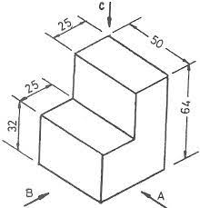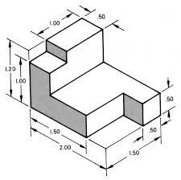
ACTIVITY 6: DEMONSTRATION ON CONSTRUCTION OF ISOMETRIC CIRCLES | Isometric circles  There several methods of constructing Isometric circles on isometric planes. In this activity we will demonstrate one of them  Example  Drawing the isometric view of a Circle lamina with a 60mm Diameter on all three Principle Planes using for center methods  Solution:  Construction:  - Draw a Rhombus ABCD of 60mm side to represent isometric view of a square  - Mark 1,2,3 and 4 as a midpoints of the sides AB,BC,CD and DA respectively join (the ends of the minor diagonals) B to meet points 3 & 4 and D to meet points 1 & 2.  - Let B4 and D1 intersect at point E and B3 and D2 intersect at a point F. then B,E,D and F are the Four centers for drawing the ellipse  - With center B and radius B3 draw Arc 3-4. With center D and Radius D1 draw Arc 1-2. With center E and radius E1 draw Arc 1-4. With centre F and radius F2 draw Arc 2-3.  - These Arcs join in the form of an Ellipse which represents the required isometric as shown in figure (a)(b)(c)  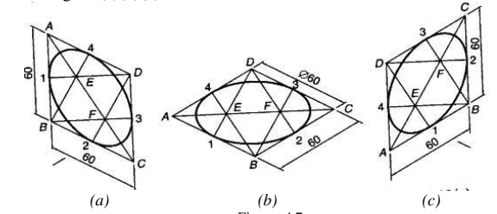  The video below further demonstrates how to draw Isometric circles  https://www.youtube.com/watch?v=Hg16J_4tmPk  https://www.youtube.com/watch?v=AiIUpRpEeGc  https://www.youtube.com/watch?v=LfDdwFP_Yws
ACTIVITY 7: PRACTICAL SKILLS: Demonstration of practical use of knowledge acquired  . | Exercises: Construct the exercises below and upload your answer on the e-portfolio  - Construct and Isometric cube of length 80 mm and inscribe isometric circles on the three principal faces of the cube  - Construct the following isometric views using the dimensions given  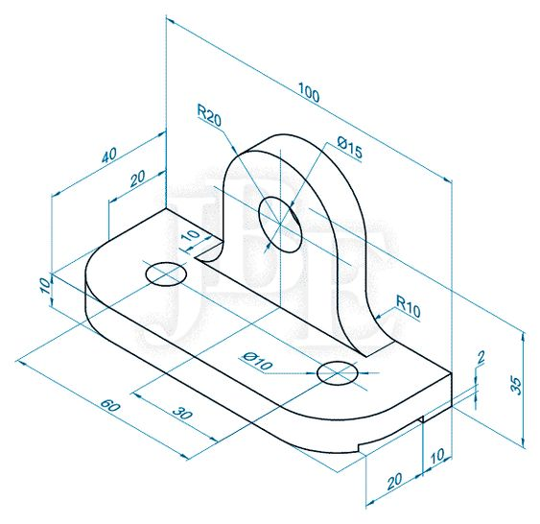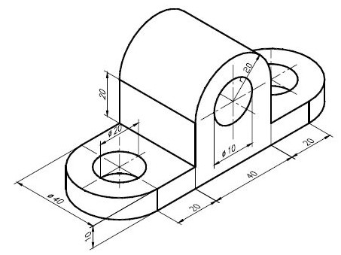
ACTIVITY 8: INTRODUCTION TO CONSTRUCTION OF OBLIQUE PROJECTIONS | Oblique Projections  Oblique projection is another method of pictorial drawing. It is simpler than isometric but it does not present so realistic a picture.  The figures below shows a shaped block drawn in oblique projection.  There are three drawings of the same block in They all show the front face of the block drawn in the plane of the paper and the side and top faces receding at 30º, 45º and 60º on the three drawings. An oblique line is one which is neither vertical nor horizontal, and the receding lines in oblique projection can be at any angle other than 0º or 90º as long as they remain parallel in any one drawing. In practice, it is usual to keep to the set square angles and of the three to choose from, but 45º is the most widely used.  If you check the measurement on the oblique drawings with those on the isometric sketch, you will find that the measurements on the front and oblique faces are all true lengths. This gives rise to a distorted effect. The drawings of the block in the oblique view appear to be cut out of proportion, particularly when compared with the isometric view.  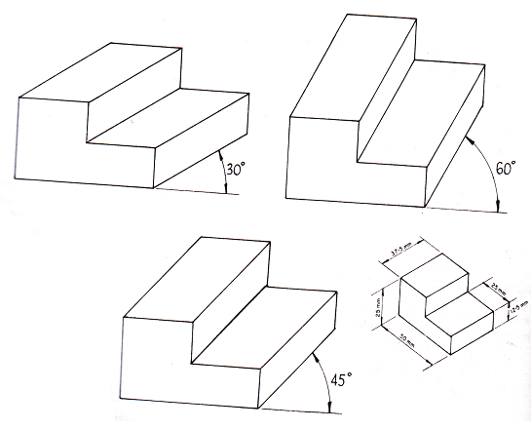  According to oblique conventional rules, the oblique lengths have the following dimensions compared to the true length:
  Oblique Angle | Oblique length compared the true length
  30⁰ | ⅔ of the true length
  45⁰ | ½ of the true length
  60⁰ | ⅓ of the true length
ACTIVITY 9: PRACTICAL SKILLS: Demonstration of practical use of knowledge acquired  . | Exercises: Construct the exercises below and upload your answer on the e-portfolio  Construct the drawings below in oblique projections using following oblique angles 30⁰, 45⁰ and 60⁰  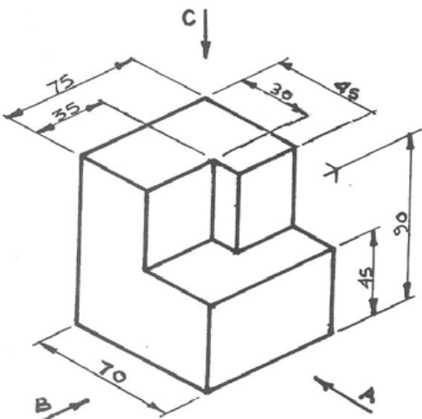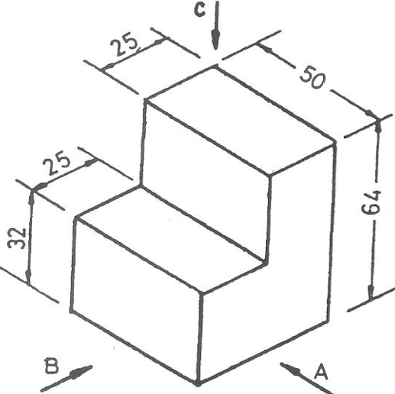
ACTIVITY 10: INTRODUCTION TO CONSTRUCTION OF OBLIQUE PROJECTIONS | Perspective Drawing  Perspective drawings are design drawings that convey more or less the actual appearance of the building or object and are therefore of considerable value in enabling layman to appreciate points of design which are not easily understood by them from autographic projections. There are a number of ways of setting up perspectives and the underlying theories are complex.  - One Point Perspective  Using one point perspective as shown in the figure below, parallel lines converge to one point somewhere in the distance. This point is called the vanishing point (VP). This gives objects an impression  of depth. The sides of an object diminish towards the vanishing point. All vertical and horizontal lines are drawn with no perspective i.e. face on.  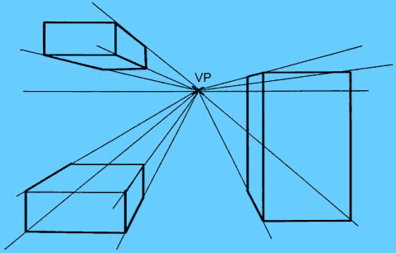  One point perspective though is of limited use, the main problem being that the perspective is too pronounced for small products making them looking bigger than they actually are.  Although it is possible to sketch products in one point perspective, the perspective is too aggressive on the eye making products look bigger than they actually are.  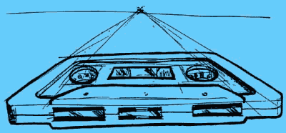  - Two point perspective  Two Points Perspective is a much more useful drawing system than the simpler One Point Perspective. Objects drawn in two point perspective have a more natural look.  In two point perspective the sides of the object vanish to one of two vanishing points on the horizon. Vertical lines in the object have no perspective applied to them.  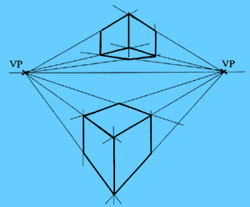  By altering the proximity of the vanishing points to the object, you can make the object look big or small  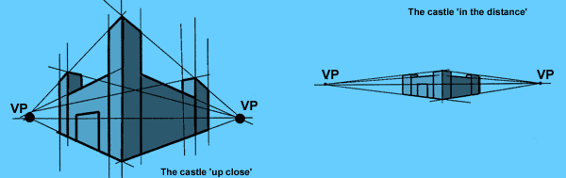
Exercise
Reconstruct the figures shown in activity 10 on One-point perspective and Two-point perspective
TAKE HOME MESSAGE | The aspect of pictorial drawing gives the ability to a designer to communicate his/her ideas to a viewer who is not professional. Since drawing is a ‘language’ of communication, clarity of the drawings information ensure interpretation is not vague.
Reference list | Designer: Kindly create a link to the following reading materials  Branoff, T. (2015). Interpreting engineering drawings. Cengage Learning.  Giesecke, F. E., Mitchell, A., Spencer, H. C., Hill, I., Dygdon, J., Novak, J., ... & Johnson, L. (2016). Technical drawing with engineering graphics (Vol. 15). Prentice Hall.  Madsen, D. A., & Madsen, D. P. (2016). Engineering drawing and design. Cengage Learning.  Morling K. (2010) Geometric and Engineering Drawing,2nd Ed, Butterworth-Heinemann, London ISBN: 978-0-080-96768-4 (hbk); ISBN 13: 978-0-415-53619-6 (pbk)
Programme title
Course title
Learning Module number
Learning module title
Module Developer
Module duration in hours
Instructional Hour Equivalent (Divide duration by 2)
Reviewed by
Vision
Audience description
Instructions to learners
Learning module description
Module objectives: | 1. Based on Factual knowledge  2. Based on Conceptual knowledge  3. Based on Practical/professional/procedural knowledge  4. Based on Key/transferable skills
Module learning outcomes: | 1. Based on Factual knowledge  2. Based on Conceptual knowledge  3. Based on Practical/professional/procedural knowledge  4. Based on Key/transferable skills
Planned Learning Resources
ACTIVITY 1: INTRODUCTION  VIDEO 1: Pre-recorded lecture on topic emphasizing LEARNING OUTCOME 1:  Factual knowledge. | Topic content is fully presented here. The lecture will deal with factual knowledge, expounding on threshold concepts, if any.  A video should be provided to support the lecture content.
ACTIVITY 2: READING  READING MATERIAL 1  ( | Learners engage in self-directed learning of an article, a book chapter or whatever other material assigned.
ACTIVITY 3: Comprehension questions: | Questions are based on the lecture and reading material.  1  2  3  4  5
LEARNING OUTCOME 2: Conceptual knowledge  ACTIVITY 4: Video to be used. | Learner is required to use factual knowledge acquired to answer question “Why”?  The Case Method, (E-Case or written case) role play or any other visual aid to be used. An E-Case of a situation for the learner to solve possible problems using facts acquired.  Learners will engage in online discussion either live or on forum to answer ‘Why’ questions.
CASE 1: | Describe case here.
ACTIVITY 5: READING MATERIAL | Material to reinforce the Learning Outcome 2  Learner writes blog. Others respond
ACTIVITY 6: ONLINE DISCUSSION | Activities based on reading Material 5.  Use chats, discussion forum, question/answer, message my teacher to engage others.  Show how participation will be assessed.
LEARNING OUTCOME 3: PRACTICAL SKILLS  VIDEO 3:  . | Show video which displays practical use of knowledge acquired.
ACTIVITY 7: Learner practice sessions | Learner practices the learnt skills. Learner to be given task to demonstrate mastery of the skill.
ASSESSMENT OF PRACTICAL SKILL: | Learner records practiced skill and uploads video on E-Portfolio  OR  Learner engages in original creative /design activity to demonstrate practical application of knowledge.  Assessment of tasks described.
LEARNING OUTCOME 4: KEY/TRANSFERABLE SKILLS | Provide reading material which emphasizes reinforcement of topic learnt. How to communicate or share acquired knowledge
ACTIVITY 8 | Learner to engage in communication, collaboration, problem solving, research, leadership activities. Examples, preparation of a poster to communicate new knowledge acquired, written essay, debate, audio recording …etc.
QUIZZ: | Short questions to put knowledge to the test.  Make it game like  Challenge learners  Questions of MCQ, T/F, short answer questions etc.
TAKE HOME MESSAGE | Learner to state the take home message from their learning experience.
Reference list

