THE OPEN UNIVERSITY OF KENYA
MODULE TEMPLATE
Programme title | Bachelor of Technology Education
Course title | TED 123 Technical Drawing I
Learning Module number | TED 123-06
Learning module title | OBLIQUE AND PERSPECTIVE DRAWINGS
Module Developer | Kinuthia Mugi
Module duration in hours | 8 hrs
Instructional Hour Equivalent (Divide duration by 2) | 3 hrs
Reviewed by
Vision | The Innovative University for Inclusive Prosperity
Audience description | This module is designed for technology students intending to gain a deep understanding of technical drawing for engineering purposes.
Instructions to learners   | Welcome to the module  This is a very interesting module for Bachelor of Technology students. In order for you to benefit from this module, you should dedicate sufficient time to study and complete the course materials.  You should participate actively in all aspects of the module, including discussions and assignments. There will be tutorials organized during the module engagement.  Keep on checking in the LMS for the announcement section and on the LMS dashboard.  The live session will be made available in the recorded session folder you are also expected to review the learning objectives and outcomes before beginning the module.  You are expected to engage in all activities as they are presented to achieve the intended learning outcomes.  You will require, drawing instruments such as assorted pencils, drawing board, T-square, compass set, set square set, eraser, A2 drawing paper, internet connectivity, computing device(s), the required plug-in tools for successful completion of this module.
Learning module description | The module introduced the learner isometric drawing
Module objectives | The module seeks to facilitate learning of:  - Rules of and principles of oblique and perspective drawing  - Construction of oblique and perspective drawing  - Concepts of oblique and perspective drawing  - Application of oblique and perspective drawing in engineering drawing
Module learning outcomes | By the end of the module the you should be able to:  - Describe the rules of oblique and perspective drawing  - Explain the concepts of oblique and perspective drawing  - Construct oblique and perspective drawing  - Apply isometric drawings rules to come up with accurate oblique and perspective drawing
Planned Learning Resources | Drawing board Assorted pencils, T-square, compass set, set square set, eraser, A2 drawing paper, masking tape, paper clips, Engineering drawing Drafter, Roll and draw Scale and protractor
ACTIVITY 1: INTRODUCTION  VIDEO 1: Pre-recorded lecture on topic emphasizing LEARNING OUTCOME 1:  Factual knowledge.   | Designer: Create a video based on the script below  [Opening scene: An engineer or designer at a drafting table, drawing tools in hand, with various engineering drawings and illustrations in the background.]  Voiceover (VO): Welcome to our introduction to oblique and perspective projection in engineering drawing. In this video, we will explore the fundamental concepts and techniques behind these two important methods of representing three-dimensional objects in two-dimensional drawings.  [Cut to graphics or animations illustrating oblique and perspective projection techniques.]  VO: Oblique and perspective projections are widely used in engineering drawing to create realistic and visually appealing representations of complex objects. These methods allow engineers and designers to communicate their design ideas clearly and accurately.  [Cut to an engineer or designer explaining oblique projection.]  Engineer/Designer (on-screen): Let's start with oblique projection. In oblique projection, the object is shown with one face of the object parallel to the picture plane, and the other two faces are shown at an angle. This creates a three-dimensional effect with a sense of depth.  [Cut to illustrations or diagrams showing examples of oblique projection with different angles and orientations.]  VO: Oblique projection is often used for objects with rectangular or prismatic shapes, where one face is easily visible and the other two faces are shown as parallel lines at an angle.  [Cut to an engineer or designer explaining perspective projection.]  Engineer/Designer (on-screen): Now, let's talk about perspective projection. Perspective projection is a more realistic method of representing three-dimensional objects in a drawing. It mimics the way our eyes perceive objects in the real world, with objects appearing smaller as they recede into the distance.  [Cut to illustrations or diagrams showing examples of perspective projection with different vanishing points and foreshortening.]  VO: Perspective projection creates a sense of depth and spatial relationships in a drawing, making it useful for representing complex objects or scenes with varying depths and angles.  [Cut to an engineer or designer discussing the advantages and limitations of oblique and perspective projection.]  Engineer/Designer (on-screen): Both oblique and perspective projections have their advantages and limitations. Oblique projection is relatively simple and easy to draw, making it useful for quick sketches and initial design concepts. Perspective projection, on the other hand, provides a more realistic representation of three-dimensional objects, but it requires more skill and practice to draw accurately.  [Cut to examples of engineering drawings or illustrations that use oblique and perspective projection, showing their real-world applications.]  VO: Oblique and perspective projections are widely used in engineering and design fields, including architecture, industrial design, and mechanical engineering, to create accurate and visually appealing drawings for communication and documentation purposes.  [Closing scene: The engineer or designer at the drafting table, finishing up a drawing with a satisfied expression.]  VO: And that's our introduction to oblique and perspective projection in engineering drawing. We hope this video has provided you with a basic understanding of these important methods of representing three-dimensional objects in two-dimensional drawings. Thank you for watching!  [Fade out with closing graphics or animations, and end with contact information or a call-to-action for further inquiries or learning opportunities.]
Oblique Projections
Oblique projection is another method of pictorial drawing. It is simpler than isometric but it does not present so realistic a picture.
The figures below shows a shaped block drawn in oblique projection.
There are three drawings of the same block in They all show the front face of the block drawn in the plane of the paper and the side and top faces receding at 30º, 45º and 60º on the three drawings. An oblique line is one which is neither vertical nor horizontal, and the receding lines in oblique projection can be at any angle other than 0º or 90º as long as they remain parallel in any one drawing. In practice, it is usual to keep to the set square angles and of the three to choose from, but 45º is the most widely used.
Depending on the angle the lines of sight make with the picture plane and their extensive use, oblique drawing is generally classified as cavalier, cabinet and general oblique. The general oblique drawing is not discussed in detail because of its rare application.
Cavalier Oblique drawing: is a type of oblique drawing in which the same full scale is used along all the three axes.
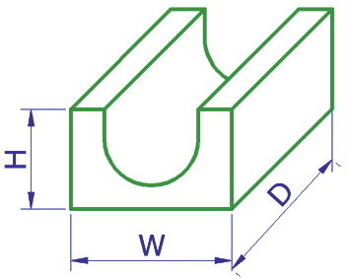
Cabinet Oblique drawing: is the second type of oblique drawing in which the scale along the receding axis is reduced by one half of that used on the front face to compensate for distortion and to approximate more closely what the human eye would see.
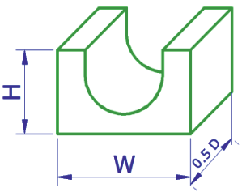
General oblique drawing: is a type of oblique drawing in which the scale along the receding axis is reduced between one half and full size e.g. three-fourth of the true length is commonly used.
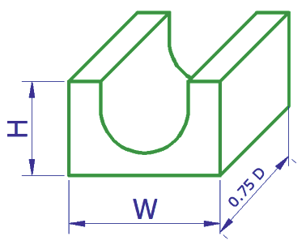
If you check the measurement on the oblique drawings with those on the isometric sketch, you will find that the measurements on the front and oblique faces are all true lengths. This gives rise to a distorted effect. The drawings of the block in the oblique view appear to be cut out of proportion, particularly when compared with the isometric view.
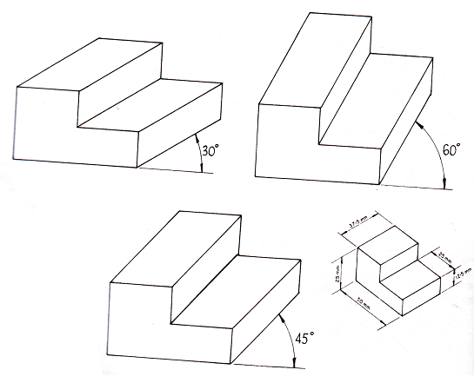
According to oblique conventional rules, the oblique lengths have the following dimensions compared to the true length:
Oblique Angle | Oblique length compared the true length
30⁰ | ⅔ of the true length
45⁰ | ½ of the true length
60⁰ | ⅓ of the true length

ACTIVITY 2: READING  READING MATERIAL 1  ( | Learners engage in self-directed learning of an article, a book chapter or whatever other material assigned.  Morling K. (2010) Geometric and Engineering Drawing,2nd Ed, Butterworth-Heinemann, London ISBN: 978-0-080-96768-4 (hbk); ISBN 13: 978-0-415-53619-6 (pbk) pp 67-74
LEARNING OUTCOME 2: Conceptual knowledge  ACTIVITY 4: Video to be used. | Principle of Oblique Projection  In axonometric projection, the lines of sights (projectors) are assumed to be at a right angle to the picture plane. But, in oblique projection, the lines of sight are at an angle different from 90⁰ to the picture plane.  In both axonometric and oblique projections, the lines of sight are parallel to each other, i.e, the station point is assumed to be at infinity. Therefore, in both projection methods, a line that is parallel to the picture  plane will project in its true length. Consequently, any face that is parallel to the picture plane will project in its true size and shape as shown below.  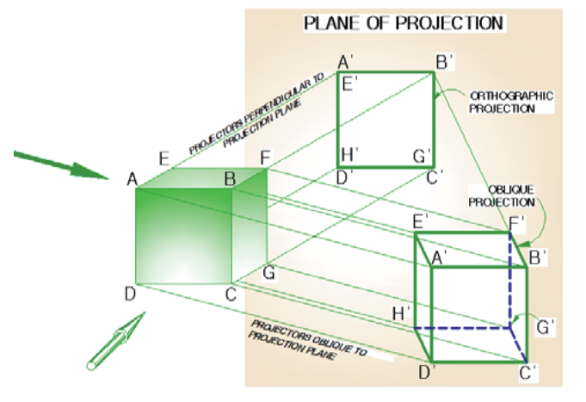  In this figure observe that both the orthographic and oblique projections of the front face ABCD are identical. They both represent the true size and shape of the front face. This is because the front face ABCD is parallel to the picture plane.  Unlike orthographic projection, for a given position of an object, it is possible to produce infinite number of oblique projections by simply changing the angle the lines of sight make with the picture plane. However, for practical reasons, only some standard angles like 30⁰, 45⁰ and 60⁰ are selected, but commonly a 45⁰ is used  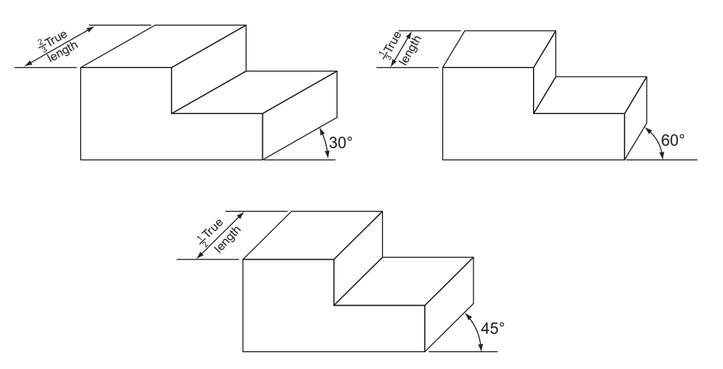  Circles and curves in oblique projection  Oblique projection has one very big advantage over isometric projection. Since the front face is drawn in the plane of the paper, any circles on this face are true circles and not ellipses as was the case with isometric projection. Figure below shows an oblique drawing of a bolt. If the bolt had been drawn in isometric projection, it would have been a long and tedious drawing to make.  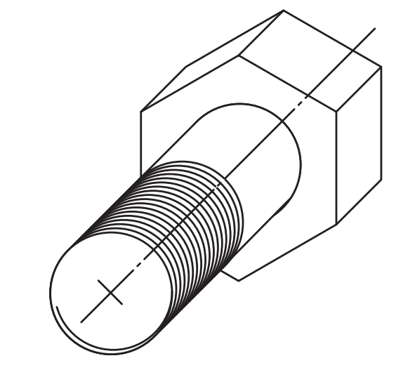  There are occasions when there are curves or circles on the oblique faces. When this arises, they may be drawn using the ordinate method that was used for circles on isometric drawings. If the oblique length has been scaled down, then the ordinates on the oblique lengths must be scaled down in the same proportions. The figure below shows an example of this.  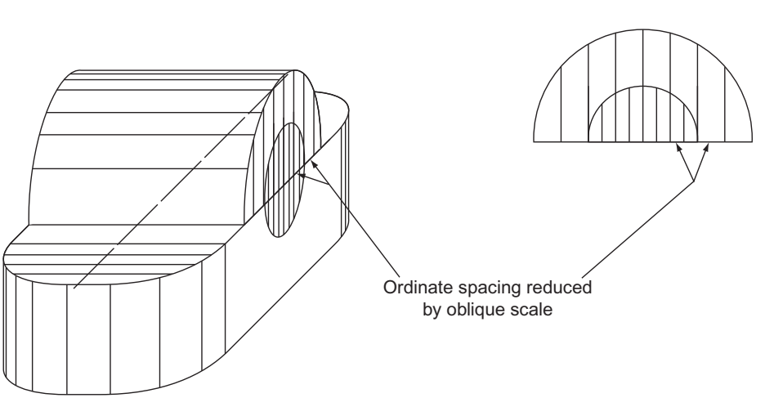
Perspective Drawing
Perspective drawings are design drawings that convey more or less the actual appearance of the building or object and are therefore of considerable value in enabling layman to appreciate points of design which are not easily understood by them from autographic projections. There are a number of ways of setting up perspectives and the underlying theories are complex.
- One Point Perspective
Using one point perspective as shown in the figure below, parallel lines converge to one point somewhere in the distance. This point is called the vanishing point (VP). This gives objects an impression
of depth. The sides of an object diminish towards the vanishing point. All vertical and horizontal lines are drawn with no perspective i.e. face on.
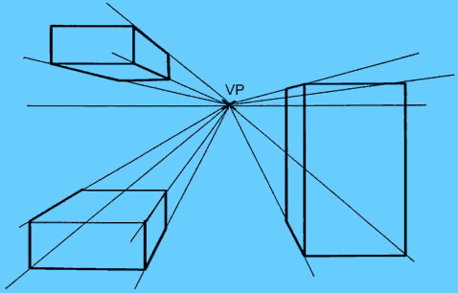
One point perspective though is of limited use, the main problem being that the perspective is too pronounced for small products making them looking bigger than they actually are.
Although it is possible to sketch products in one point perspective, the perspective is too aggressive on the eye making products look bigger than they actually are.
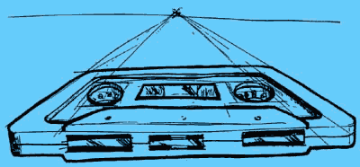

- Two point perspective
Two Points Perspective is a much more useful drawing system than the simpler One Point Perspective. Objects drawn in two point perspective have a more natural look.
In two point perspective the sides of the object vanish to one of two vanishing points on the horizon. Vertical lines in the object have no perspective applied to them.
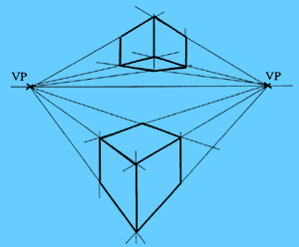
https://www.youtube.com/watch?v=ir_ziMv5wjg&ab_channel=TheDTcompanion

By altering the proximity of the vanishing points to the object, you can make the object look big or small
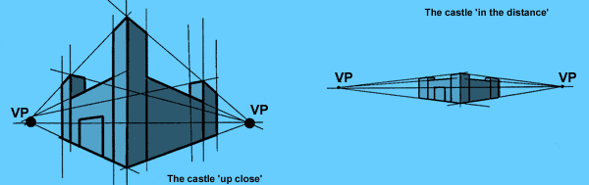
CASE 1:   | Watch the video below and construct the oblique drawing as demonstrated in the video  https://www.youtube.com/watch?v=ACHyDeFoILM&ab_channel=folakemiogunmuyiwa
ACTIVITY 5: READING MATERIAL | Material to reinforce the Learning Outcome 2  Learner writes blog. Others respond  Morling K. (2010) Geometric and Engineering Drawing,2nd Ed, Butterworth-Heinemann, London ISBN: 978-0-080-96768-4 (hbk); ISBN 13: 978-0-415-53619-6 (pbk) pp 67-74
LEARNING OUTCOME 3: PRACTICAL SKILLS  VIDEO 3:  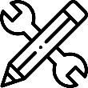. | Oblique Projections  Watch the videos below for further understanding of oblique projections  https://www.youtube.com/watch?v=RkheWIH_odM&ab_channel=Jimola  https://www.youtube.com/watch?v=uRv9rWsCu6w&ab_channel=TechnicalDrawing
ACTIVITY 7: Learner practice sessions | Exercises: Construct the exercises below and upload your answer on the e-portfolio  - Construct the oblique shaped block using the exact dimensions used in the video below  https://www.youtube.com/watch?v=uRv9rWsCu6w&ab_channel=TechnicalDrawing  - The figure below shows a small stepped pulley drawn twice in oblique projection. Redraw the oblique shapes as demonstrated .
ASSESSMENT OF PRACTICAL SKILL: | In one of the tasks above record yourself drawing the objects in a video of not more than 5 minutes and upload the video in your e-portfolio portal
LEARNING OUTCOME 4: KEY/TRANSFERABLE SKILLS | Provide reading material which emphasizes reinforcement of topic learnt. How to communicate or share acquired knowledge
ACTIVITY 8 | Exercises: Construct the exercises below and upload your answer on the e-portfolio  Construct the drawings below in oblique projections using following oblique angles 30⁰, 45⁰ and 60⁰  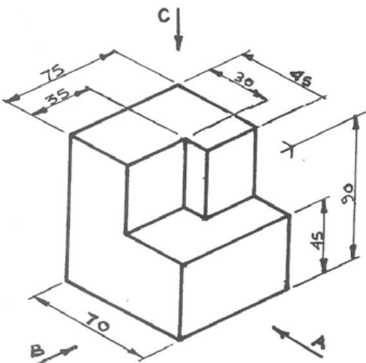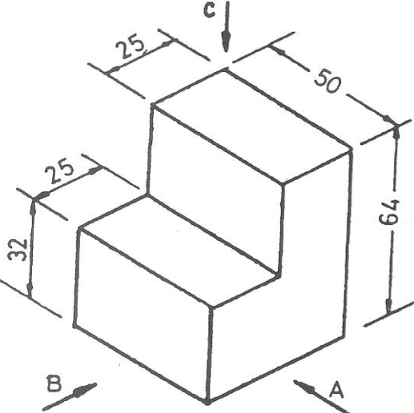  Draw the figure below with both the circular end and the other end as the front view as shown in the diagrams  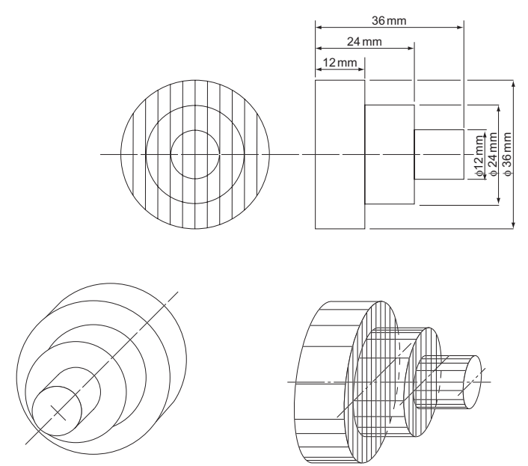
TAKE HOME MESSAGE | Learner to state the take home message from their learning experience.
Exercise
Reconstruct the figures shown in activity 10 on One-point perspective and Two-point perspective
TAKE HOME MESSAGE | The aspect of pictorial drawing gives the ability to a designer to communicate his/her ideas to a viewer who is not professional. Since drawing is a ‘language’ of communication, clarity of the drawings information ensure interpretation is not vague.
Reference list | Designer: Kindly create a link to the following reading materials  Branoff, T. (2015). Interpreting engineering drawings. Cengage Learning.  Giesecke, F. E., Mitchell, A., Spencer, H. C., Hill, I., Dygdon, J., Novak, J., ... & Johnson, L. (2016). Technical drawing with engineering graphics (Vol. 15). Prentice Hall.  Madsen, D. A., & Madsen, D. P. (2016). Engineering drawing and design. Cengage Learning.  Morling K. (2010) Geometric and Engineering Drawing,2nd Ed, Butterworth-Heinemann, London ISBN: 978-0-080-96768-4 (hbk); ISBN 13: 978-0-415-53619-6 (pbk)

