ATF 108: ATF 108 Principles of Animal Production
Module 6: Principles of Livestock Nutrition
Programme title | Bachelor of Science in Agri-technology and Food Systems
Course title | ATF 108: ATF 108 Principles of Animal Production
Learning Module number | 6 of 10
Learning module title | Principles of livestock nutrition
Module developers | Prof. Cecilia M. Onyango
Module duration in hours | 8 hours
Instructional hour equivalent | 4 hours
Module reviewers
Vision | The Innovative University for Inclusive prosperity
Learning module description | Welcome to module 6 on Principles of livestock nutrition. This module will deal with definition of feed and nutrient as used in animal nutrition, types of nutrients required by livestock, feed resources and classification of feeds  Best of luck!
Audience description | This module is to be undertaken by learners who are interested in acquiring knowledge in transforming food waste to make products and generate income (profits)
Instructions to learner   | Dear learner, in order to complete the module on ‘Principles of livestock nutrition’, you are expected to adhere and follow instructions listed below:  We have provided reading materials with contents of this module. You are expected to read these articles and specific book chapters or pages in order to enrich your knowledge on specific topics that contribute towards completion of the module.  You may access your Facilitator via the Learning Management System (LMS), to assist you with questions or sections of the materials that you have read but did not understand very well. You can also access pre-recorded videos embedded in the LMS explaining different aspects of the module.  During the course of this module, you will be expected to do continuous assessment tasks and tests in order to assess your understanding of the module. This will be done through group discussions and quizzes on the LMS. There will be assessments after every activity.  You are expected to create an e-portfolio to document your learning journey in this module and other modules you might undertake. The content of your e-portfolio could include experiences, artefacts, records of your essays, photos, exercises, assignments and practicals. The e-portfolio will be useful for your self assessment and will also be marked as part of assessment.  Continuous Assessment tests (quizzes, discussion forum, activities and e-portfolio assessments) will constitute 50% of the pass mark while end of course assessment will constitute 50% to make a total of 100 %.  Finally, this module contributes towards attainment of either a Certificate, a Diploma or a Bachelor’s degree in Agri-technology & Food Systems.  We wish you a happy and fulfilling learning experience.
Module objectives | This module will enable learning about:  - Basic terms used in animal nutrition  - Types of nutrients required by livestock  - Feed resources  - Feed classification
Module Expected Learning Outcomes | By the end of this module, you should be able to:  1. Define feed and nutrient as used in animal nutrition  2. Explain the types of nutrients required by livestock  3. Formulate the feed resources for a nutritious animal diet  4. Develop an animal feeding regime using the different Feed classes
Planned learning resources | 1. Selected textbook chapters on Principles of livestock nutrition  2. Selected textbook on Principles of livestock nutrition  3. Selected video on Principles of livestock nutrition
LEARNING OUTCOME 1 AND 2:  ACTIVITY 1: PREPARATION    VIDEO 1:: | Introduction: Welcome to module 6 on Principles of livestock nutrition. Livestock play an important role in most small-scale farming systems throughout the world. They provide traction to cultivate fields, manure to maintain crop productivity, and nutritious food products for human consumption and income-generation.  • Despite the importance of livestock, inadequate livestock  nutrition is a common problem especially in the developing world, and a major factor affecting the development of viable livestock enterprises in poor countries. Thus feed resources for nutrition play a major role in farm animals.  What is nutrition!  Nutrition is the study of how food is utilized by body processes that convert food into body tissues and energy.  Nutrients are utilized by the animals for:  - Maintenance  - Growth  - Production  - Reproduction  - Health control  What is a Nutrient?  A single food class or group of similar foods that contributes to the survival of life and allows animals to grow or provide energy for physiological processes.  The Six Nutrients Needed by animals for growth and production are:  • Protein  • Carbohydrates  • Fats  • Minerals  • Vitamins  • Water  The video provide in this link describes the materials used to make own feed for livestock  Watch: https://www.youtube.com/watch?v=BxSTpy6-ESU&t=76s  Why do you think it is prudent for farmers to make their own feed for the livestock?  Answers:  1. one is sure of the quality of material used  2. Reduces the cost of feed  3. Ensures continuous supply of feed  4. High returns
ACTIVITY 1: READING   | Feed resources: The diagram below illustrates the different feed resources:  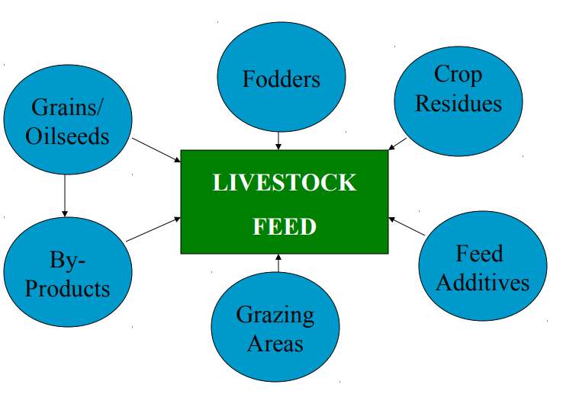  Get more information on feed resources here: http://www.lrrd.org/lrrd23/5/luku23112.htm. Focus on the section, ‘“On farm feed resources”  Classification of feedstuff  Livestock feeds are generally classified according to the amount of a specific nutrient they furnish in the ration. They are divided into two main classes.  - Roughages  - Concentrates  Other classes are mineral supplement, vitamin supplement and non-nutritive feed additives  Read Chapter on XX. Measurement of Feed and Nutrient Utilization in Food-Producing Animals the sections on basic concepts of nutrition, essential nutrients in animal diets and why nutrition is important in livestock here: https://open.oregonstate.education/animalnutrition/chapter/chapter-1/  This information should enable you to answer the questions under the Quiz section.  Feed formulation: An example is provided on Chicken Feed Formulation in this video but the basics apply to all the other livestock feed formulation  Watch here: https://www.youtube.com/watch?v=Jxfzo9pfTRI&t=17s  Question: What are the key considerations in feed formulation?  Answer: The feed resources and their nutrient contents or what is termed nutritional value
LEARNING OUTCOME 3:  Comprehension questions:   | With reference to the materials you have read and the videos you have watched, you are required to answer the following questions:  Question: Would you recommend fermenting feed for commercial layers?  Answer  Feed fermentation aids digestibility and makes nutrients readily available to livestock, but it involves a lot of technicalities that requires a professional. If you do not get the fermentation process right, it can harm the animals if they consume such feed. Hence, if you are not a professional or you do not have a professional on your farm, feed your livestock without fermenting the feed.  Question: should weather conditions be considered in feed formulation?  Answer  Weather conditions can’t affect feed formulation but the storage of the finished feeds.  Question: Is the cost of formulation the same as purchasing from the market?  Answer  No. Sometimes, the price is lower or higher depending on your formula. However, it’s always easier to reduce cost when you formulate the feed by yourself rather than buying from the market.  Submit the answers on LMS quiz section for assessment
LEARNING OUTCOME 4:  ACTIVITY 3: ONLINE DISCUSSION  Use chats, forum, question/answer, message my teacher to engage others.   | Join the discussion forum:  Operating rules:  - Participate: This is a shared learning environment. ...  - Report Glitches: Discussion forums are electronic. ...  - Help Others: You may have more experience with online discussion forums than your colleagues  - Be Patient: Read everything in the discussion thread before replying  Join the discussion forum on the following topic:  Discuss the main challenges facing the livestock industry in relation to animal nutrition  Instructions:  You should be able to post at least two comments on the forum
ACTIVITY 4: PRACTICAL SKILLS  VIDEO : Demonstration of practical use of knowledge acquired.   | Using the locally available materials, develop a sketch on how you will go about mixing the different feed resources to ensure a quality feed for animals. Take photos of the process and upload to your e-portfolio
ACTIVITY 4: Reflection on learnt experiences | Document your educational journey in the module using an e-portfolio  The e-portfolio will be assessed
QUIZ: Short questions to put knowledge to the test  Make it game like  Challenge learners   | Review questions:  1. How would you define “nutrition”?  2. Why is nutrition important in today’s livestock production?  3. What are the six major classes of nutrients?  Upload your write-up on LMS quiz section for assessment
TAKE HOME MESSAGE | What is your take home message from this module?  You need to reflect on all possible materials available locally that you use to formulate animal feeds that’s are of high nutritional quality
Reference list | Books:  1. Gita C. (2019). A Guide to the Principles of Animal Nutrition. Oregon State University. ISBN 978-1-955101-12-7.  2. Perry, T.W., Cullison, A.E. & Lowrey, R.S. (1999). Feeds and Feeding. 5th Ed. Prentice Hall, New Jersey, USA.  3. Lander, P.E. (2001). The Feeding of Farm Animals in India. Biotech Books, New Delhi, India.  4. Ensminger, M.E., Oldfield, J.E. & Heinemann, W.W. (1990). Feeds and Nutrition Digest (2nd Ed). The Ensminger Publishing Co., Clovis, California, USA.

