THE OPEN UNIVERSITY OF KENYA
MODULE TEMPLATE
Programme title | Bachelor of Technology Education
Course title | TED 123 Technical Drawing I
Learning Module number | TED 123-04
Learning module title | DIMENSIONING TECHNIQUES IN DRAWING
Module Developer | Kinuthia Mugi
Reviewed by
Vision | The Innovative University for Inclusive Prosperity
Audience description | This module is designed for technology students intending to gain a deep understanding of technical drawing for engineering purposes.
Instructions to learners   | Welcome to the module  This is a very interesting module for Bachelor of Technology students. In order for you to benefit from this module, you should dedicate sufficient time to study and complete the course materials.  You should participate actively in all aspects of the module, including discussions and assignments. There will be tutorials organized during the module engagement.  Keep on checking in the LMS for the announcement section and on the LMS dashboard.  The live session will be made available in the recorded session folder you are also expected to review the learning objectives and outcomes before beginning the module.  You are expected to engage in all activities as they are presented to achieve the intended learning outcomes.  You will require, drawing instruments such as assorted pencils, drawing board, T-square, compass set, set square set, eraser, A2 drawing paper, internet connectivity, computing device(s), the required plug-in tools for successful completion of this module.
Learning module description | The module introduced the learner dimensioning and dimensioning techniques that facilitates accurate communication of drawing sizes
Module objectives | The module seeks to facilitate learning of:  - Types and parts of dimensions  - Fundamental principles and concepts of dimensioning  - Construction of dimensions  - Application of dimensioning in in drawings
Module learning outcomes | By the end of the module the you should be able to:  - Identify and define different types and parts of dimensions  - Explain Fundamental principles and concepts of dimensioning  - Construct different dimensions from give data  - Apply dimensioning skills accurately on drawn projects
ACTIVITY 1: INTRODUCTION  VIDEO 1:   | - Introduction to Drawing Projections  Designer: Include a Video whose script is as below  Title: Mastering Dimensioning in Drawing  [Opening shot: A close-up of a drafting board with a drawing in progress. The camera zooms out to reveal a skilled draftsman at work, using various tools to create precise dimensions on the drawing.]  Voiceover (VO): "Dimensioning is a crucial skill in technical drawing. It provides accurate measurements and specifications for objects or structures, allowing them to be built or manufactured with precision."  [Cut to the draftsman using a ruler to measure the length of a line on the drawing.]  VO: "In this video, we will cover the basics of dimensioning, including the types of dimensions, the best practices for dimensioning, and some tips for creating clear and accurate dimensions on your drawings."  [Cut to a split screen showing a drawing on one side and a demonstration on the other side, as the draftsman explains the different types of dimensions.]  VO: "There are three main types of dimensions: linear dimensions, angular dimensions, and radial dimensions. Linear dimensions measure the length, width, or height of an object, while angular dimensions measure angles, and radial dimensions measure radii or diameters of circles or arcs."  [Cut to the draftsman adding linear dimensions to a drawing, using arrows and dimension lines.]  VO: "When adding linear dimensions, it's important to follow some best practices. First, always place dimensions outside the object, preferably with arrows pointing to the feature being dimensioned. Avoid placing dimensions inside the object or crossing over other lines. Use dimension lines that are evenly spaced and extend beyond the object being dimensioned, with arrows at the ends."  [Cut to the draftsman adding angular dimensions to a drawing, using a protractor and dimension lines.]  VO: "Angular dimensions require special consideration. Use a protractor to measure the angle accurately, and place the dimension line outside the angle with arrows pointing to the lines that define the angle. Use the correct units of measurement, such as degrees, minutes, and seconds, or decimal degrees, depending on the requirements of your drawing."  [Cut to the draftsman adding radial dimensions to a drawing, using a compass and dimension lines.]  VO: "Radial dimensions are used to specify the size of circles or arcs. Use a compass to measure the radius or diameter accurately, and place the dimension line outside the circle or arc with arrows pointing to the feature being dimensioned. Include the correct units of measurement, such as inches or millimeters."  [Cut to the draftsman adding additional dimensions to the drawing, such as tolerances, hole callouts, and centerlines.]  VO: "In addition to linear, angular, and radial dimensions, you may need to add other types of dimensions depending on the requirements of your drawing. This may include tolerances, which specify the allowable variation in the size or location of a feature, hole callouts, which provide information about holes, and centerlines, which indicate the center of a circular feature."  [Cut to the draftsman reviewing the completed drawing, ensuring that all dimensions are clear, accurate, and properly placed.]  VO: "Finally, always double-check your dimensions to ensure they are accurate and clearly communicated. Use the correct units of measurement, follow best practices for dimensioning, and be mindful of the requirements of your drawing."  [Closing shot: The draftsman puts down their tools and looks satisfied with the completed drawing, while the camera zooms out.]  VO: "Mastering dimensioning in drawing is essential for creating precise and professional technical drawings. With practice and attention to detail, you can create clear and accurate dimensions that convey the necessary information for the construction or manufacture of objects or structures."  [Fade out with the video's title displayed on the screen: "Mastering Dimensioning in Drawing."]  [End of script]
ACTIVITY 1:  INTRODUCTORY NOTES :  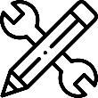 | The purpose of dimensioning is to provide a clear and complete description of an object.A complete set of dimensions will permit only one interpretation needed to construct the part. Dimensioning should follow these guidelines.  - Accuracy: correct values must be given.  - ¨Clearness: dimensions must be placed in appropriate positions.  - ¨Completeness: nothing must be left out, and nothing duplicated.  - Readability: the appropriate line quality must be used for legibility.  Dimensions serve two important functions. First, they limit the size of the part shown on the drawing. Second, they define the limits within which the parts will be acceptable.  When an engineering drawing is made, dimensioning is of vital importance. All the dimensions necessary to make the articles drawn must be on the drawing and they must be presented so that they can be easily read, easily found and not open to misinterpretation. A neat drawing can be spoilt by bad dimensioning.  There are many rules about how to dimension a drawing properly, but it is unlikely that two people will dimension the same drawing in exactly the same way. However, remember when dimensioning that you must be particularly neat and concise, thorough and consistent. The following rules must be adhered to when dimensioning:  - Projection lines should be thin lines and should extend from about 1 mm from the outline to 3 mm to 6 mm past the dimension line.  - The dimension line should be a thin line and terminate with arrowheads at least 3mm long and these arrowheads must touch the projection lines.  - The dimension may be inserted within a break in the dimension line or be placed on top of the dimension line.  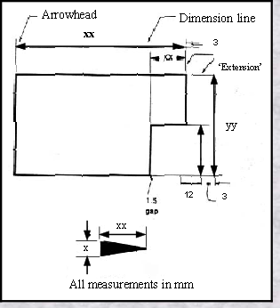  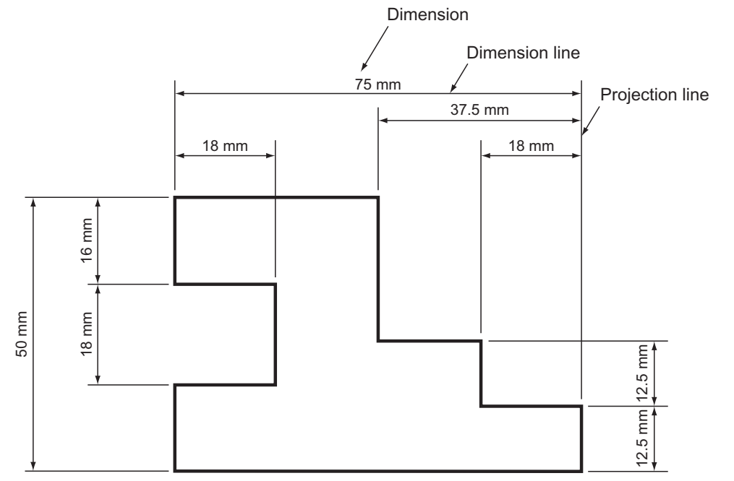  - The dimensions should be placed so that they are read from the bottom of the paper or from the right-hand side of the paper.  - Dimension lines should be drawn outside the outline, whenever possible, and should be kept well clear of the outline.  - Overall dimensions should be placed outside the intermediate dimensions.  - Centre lines must never be used as dimension lines. They may be used as projection lines ( Fig. 18.19 ).  - Diameters may be dimensioned in one of two ways. Either dimension directly across the circle (not on a centre line), or project the diameter to outside the outline. ‘ Diameter ’ is denoted by the symbol φ placed in front of the dimension.  - When dimensioning a radius, you must, if possible, show the centre of the radius. The actual dimension for the radius may be shown either side of the outline but should, of course, be kept outside if possible. The word radius must be abbreviated to R and placed in front of the dimension.  - When a diameter or a radius is too small to be dimensioned by any of the above methods, a leader may be used. The leader line should be a thin line and should terminate on the detail that it is pointing to with an arrowhead or, within an outline, with a dot. Long leader lines should be avoided even if it means inserting another dimension. The leader line should always meet another line at an acute angle.  - Dimensions should not be repeated on a drawing. It is necessary to put a dimension on only once, however many views are drawn. There is one exception to this rule. If, by inserting one dimension, it saves adding up lots of small dimensions then this is allowed. These types of dimensions are called ‘ auxiliary dimensions ’ and are shown to be so either by underlining the dimensions or putting it in brackets.  - Unless unavoidable, do not dimension hidden detail. It is usually possible to dimension the same detail on another view
ACTIVITY 2: INTRODUCTION  VIDEO 1: | Designer: Include a Video whose script is as below  Title: Introduction to Isometric Projections  (Opening shot: A graphic of a cube)  Voiceover: Have you ever tried to draw a three-dimensional object, only to find that it doesn't look quite right? Maybe the angles are off, or the proportions don't seem to match up. This is where isometric projections come in.  (Cut to a shot of an isometric projection drawing of the same cube)  Voiceover: Isometric projections are a way of representing three-dimensional objects on a two-dimensional surface, such as a piece of paper. By using a specific set of rules and guidelines, you can create drawings that accurately represent the size, shape, and orientation of an object.  (Cut to a shot of a person drawing an isometric projection of a cube)  Voiceover: The key to isometric projections is that all three axes are equally angled. This means that the horizontal, vertical, and depth axes are all at 120-degree angles from each other.  (Cut to a shot of an isometric grid)  Voiceover: To create an isometric projection, you can use an isometric grid, which is a grid of lines that are evenly spaced at 120-degree angles. This grid can help you keep your drawing proportional and accurate.  (Cut to a shot of a person drawing on an isometric grid)  Voiceover: Once you've drawn your object on the isometric grid, you can add shading, color, or other details to make it look more realistic.  (Cut to a shot of a finished isometric projection drawing of a cube)  Voiceover: Isometric projections are commonly used in fields such as engineering, architecture, and design to create technical drawings and plans. They are also used in video games and other digital media to create three-dimensional graphics.  (Closing shot: A graphic of an isometric projection of a building or other complex object)  Voiceover: With isometric projections, you can create accurate and detailed drawings of three-dimensional objects, helping you communicate your ideas more effectively and make your designs come to life.  (Closing title: Introduction to Isometric Projections)
ACTIVITY 3: INTRODUCTION: Demonstration of practical use of knowledge acquired  . | Isometric Drawing  Literally the term "isometric" is a combination of two words "iso" and "metric" which means 'equal measures'. It is the simplest and most popular type of axonometric projection, because the three principal edges of a cube make equal angles with the projection plane, and hence will be foreshortened equally on the isometric projection. These principal edges are usually referred to as isometric axis.  Figure 1 on activity 3 below shows a shaped block drawn in conventional isometric projection. You will note that there are three isometric axes. These are inclined at 120° to each other. One axis is vertical and the other two axes are therefore at 30° to the  horizontal. Dimensions measured along these axes, or parallel to them, are true  lengths.  The faces of the shaped block are all at 90° to each other. The result of this is that all of the lines in the isometric drawing are parallel to the isometric axes. If the lines are not parallel to any of the isometric axis, they are no longer true lengths  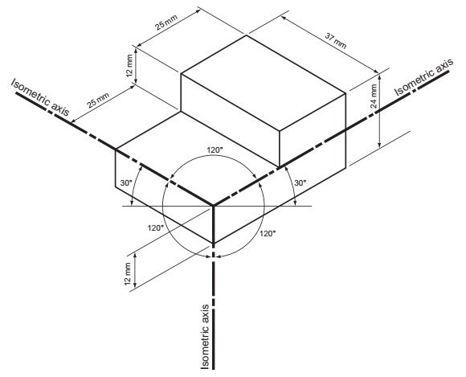  Figure 1: Conventional Isometric Drawing  The characteristics of an Isometric drawing are as illustrated in the figure 2 below  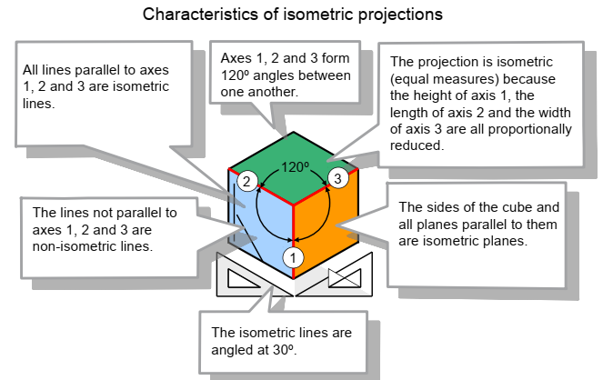  Figure 2: Characteristics of Isometric Drawings
ACTIVITY 4: DEMOSNTRATION OF TRAINGLE CONSTRUCTION   | Watch the videos below that introduces construction of isometric drawing  https://www.youtube.com/watch?v=JqiDTQaP0x8  https://www.youtube.com/watch?v=8j7l1OWhMlE  https://www.youtube.com/watch?v=o3kA8yAw9So
ACTIVITY 5: PRACTICAL SKILLS: Demonstration of practical use of knowledge acquired  . | Exercises: Construct the exercises below and upload your answer on the e-portfolio  - Construct and Isometric cube of sides 70 mm  - Construct isometric shaped blocks shown below  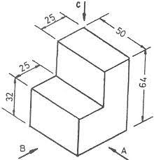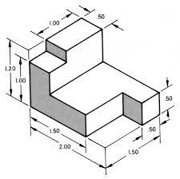
ACTIVITY 6: DEMONSTRATION ON CONSTRUCTION OF ISOMETRIC CIRCLES | Isometric circles  There several methods of constructing Isometric circles on isometric planes. In this activity we will demonstrate one of them  Example  Drawing the isometric view of a Circle lamina with a 60mm Diameter on all three Principle Planes using for center methods  Solution:  Construction:  - Draw a Rhombus ABCD of 60mm side to represent isometric view of a square  - Mark 1,2,3 and 4 as a midpoints of the sides AB,BC,CD and DA respectively join (the ends of the minor diagonals) B to meet points 3 & 4 and D to meet points 1 & 2.  - Let B4 and D1 intersect at point E and B3 and D2 intersect at a point F. then B,E,D and F are the Four centers for drawing the ellipse  - With center B and radius B3 draw Arc 3-4. With center D and Radius D1 draw Arc 1-2. With center E and radius E1 draw Arc 1-4. With centre F and radius F2 draw Arc 2-3.  - These Arcs join in the form of an Ellipse which represents the required isometric as shown in figure (a)(b)(c)  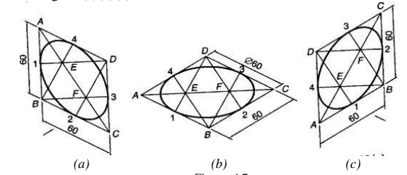  The video below further demonstrates how to draw Isometric circles  https://www.youtube.com/watch?v=Hg16J_4tmPk  https://www.youtube.com/watch?v=AiIUpRpEeGc  https://www.youtube.com/watch?v=LfDdwFP_Yws
ACTIVITY 7: PRACTICAL SKILLS: Demonstration of practical use of knowledge acquired  . | Exercises: Construct the exercises below and upload your answer on the e-portfolio  - Construct and Isometric cube of length 80 mm and inscribe isometric circles on the three principal faces of the cube  - Construct the following isometric views using the dimensions given  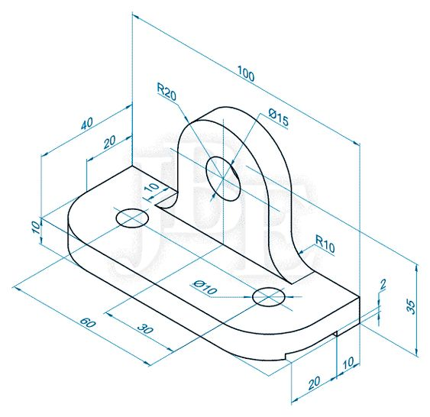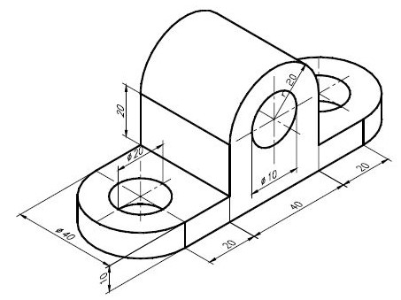
ACTIVITY 8: INTRODUCTION TO CONSTRUCTION OF OBLIQUE PROJECTIONS | Oblique Projections  Oblique projection is another method of pictorial drawing. It is simpler than isometric but it does not present so realistic a picture.  The figures below shows a shaped block drawn in oblique projection.  There are three drawings of the same block in They all show the front face of the block drawn in the plane of the paper and the side and top faces receding at 30º, 45º and 60º on the three drawings. An oblique line is one which is neither vertical nor horizontal, and the receding lines in oblique projection can be at any angle other than 0º or 90º as long as they remain parallel in any one drawing. In practice, it is usual to keep to the set square angles and of the three to choose from, but 45º is the most widely used.  If you check the measurement on the oblique drawings with those on the isometric sketch, you will find that the measurements on the front and oblique faces are all true lengths. This gives rise to a distorted effect. The drawings of the block in the oblique view appear to be cut out of proportion, particularly when compared with the isometric view.  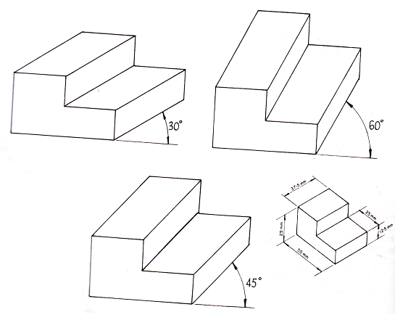  According to oblique conventional rules, the oblique lengths have the following dimensions compared to the true length:
  Oblique Angle | Oblique length compared the true length
  30⁰ | ⅔ of the true length
  45⁰ | ½ of the true length
  60⁰ | ⅓ of the true length
ACTIVITY 9: PRACTICAL SKILLS: Demonstration of practical use of knowledge acquired  . | Exercises: Construct the exercises below and upload your answer on the e-portfolio  Construct the drawings below in oblique projections using following oblique angles 30⁰, 45⁰ and 60⁰  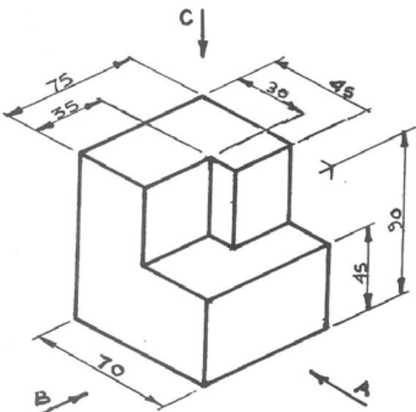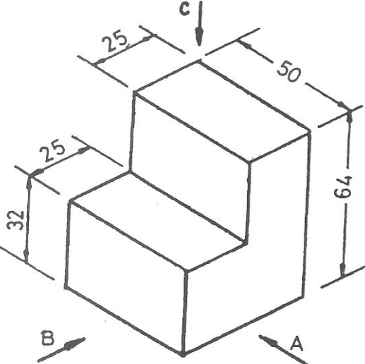
ACTIVITY 10: INTRODUCTION TO CONSTRUCTION OF OBLIQUE PROJECTIONS | Perspective Drawing  Perspective drawings are design drawings that convey more or less the actual appearance of the building or object and are therefore of considerable value in enabling layman to appreciate points of design which are not easily understood by them from autographic projections. There are a number of ways of setting up perspectives and the underlying theories are complex.  - One Point Perspective  Using one point perspective as shown in the figure below, parallel lines converge to one point somewhere in the distance. This point is called the vanishing point (VP). This gives objects an impression  of depth. The sides of an object diminish towards the vanishing point. All vertical and horizontal lines are drawn with no perspective i.e. face on.  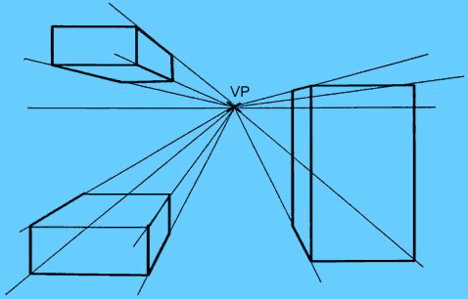  One point perspective though is of limited use, the main problem being that the perspective is too pronounced for small products making them looking bigger than they actually are.  Although it is possible to sketch products in one point perspective, the perspective is too aggressive on the eye making products look bigger than they actually are.  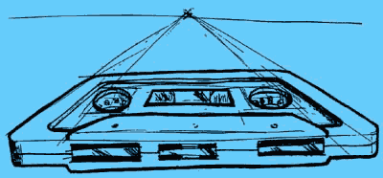  - Two point perspective  Two Points Perspective is a much more useful drawing system than the simpler One Point Perspective. Objects drawn in two point perspective have a more natural look.  In two point perspective the sides of the object vanish to one of two vanishing points on the horizon. Vertical lines in the object have no perspective applied to them.  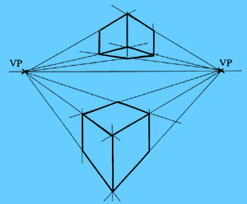  By altering the proximity of the vanishing points to the object, you can make the object look big or small  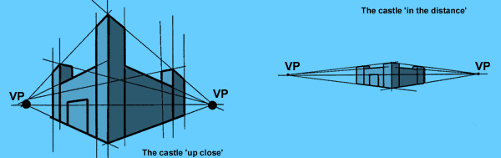
Exercise
Reconstruct the figures shown in activity 10 on One-point perspective and Two-point perspective
TAKE HOME MESSAGE | The aspect of pictorial drawing gives the ability to a designer to communicate his/her ideas to a viewer who is not professional. Since drawing is a ‘language’ of communication, clarity of the drawings information ensure interpretation is not vague.
Reference list | Designer: Kindly create a link to the following reading materials  Branoff, T. (2015). Interpreting engineering drawings. Cengage Learning.  Giesecke, F. E., Mitchell, A., Spencer, H. C., Hill, I., Dygdon, J., Novak, J., ... & Johnson, L. (2016). Technical drawing with engineering graphics (Vol. 15). Prentice Hall.  Madsen, D. A., & Madsen, D. P. (2016). Engineering drawing and design. Cengage Learning.  Morling K. (2010) Geometric and Engineering Drawing,2nd Ed, Butterworth-Heinemann, London ISBN: 978-0-080-96768-4 (hbk); ISBN 13: 978-0-415-53619-6 (pbk)

